
How to spot a Zelle or Cash App payment scam
https://cyberguardlab.com/blog/zelle-cash-app-payment-scam
Independent US household comparison site. Not the vendor. Paid links below may earn a commission. Confirm first-year price, renewal, device limit, and refund terms at checkout.
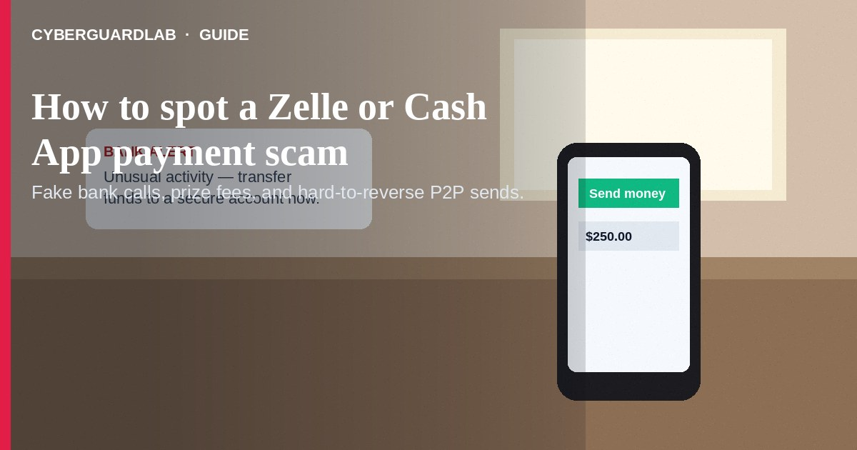
A Zelle, Cash App, Venmo, or similar P2P payment scam is when someone tricks you into sending money through a payment app or bank transfer — then the money is gone. The FTC treats these sends like cash: once they leave your account, they are hard to reverse. This guide covers payment-app and Zelle P2P scams (fake bank calls, fake buyers/sellers, “send money to receive money”). It is not about gift card payment pressure or fake check overpayment. No software purchase required.

1. How these scams usually work
From FTC payment-app guidance:
Paid link
Norton 360 | See the Norton first-year offer

See the Norton first-year offer
Offer page: https://cyberguardlab.com/norton
Ad link: https://trysecurities.com/offer/norton?dtm=gg&cid=
- Fake bank / “protect your account” — Someone posing as your bank says there is a problem, then walks you through transferring money “into a new account in your name.” That account belongs to the scammer (FTC payment apps alert).
- Fake emergency / loved one — A text or call claims a family member needs money fast via Zelle or Cash App.
- Prize / fee / “send to receive” — You “won” something or must send a fee / “verification” payment to unlock money coming your way.
- Buyer or seller script — A Marketplace-style buyer sends a fake payment screenshot; or a seller demands you pay only by payment app outside any protected checkout.
- Hard-to-reverse rail — Payment apps, bank transfers, wires, crypto, or gift cards — methods reports to the FTC show scammers push because money is hard to get back (FTC how someone asks you to pay).

2. Red flags before you tap Send
- Anyone who says you can only pay by payment app, bank transfer, wire, crypto, or gift card — the FTC says that pattern is a scam signal (FTC payment method alert).
- Your “bank” calls or texts you to transfer money to protect it, or asks for passcodes / one-time codes. Real banks will not walk you through sending money to “save” your account (FTC payment apps alert).
- Pressure to decide right now, move the chat off-platform, or ignore a second family check-in.
- A payment “confirmation” that exists only as a screenshot or alert the other person controls — not as cleared funds in your real balance.
- Overlap with phone scripts like tech support scam calls or phishing emails that push you into the payment app.

3. Safer habits (buy-nothing)
- Know the person — Treat payment-app sends like handing over cash. Only send to people you know and can verify by a channel you already trust.
- Hang up and call back — If “your bank,” a business, or a relative contacts you, hang up. Call the person or bank using a number you already know is real — not the number in the message (FTC payment apps alert).
- Prefer credit card when a real merchant accepts it — cards usually offer stronger dispute options than payment-app cash-like sends (FTC payment method alert).
- Family rule: no Zelle / Cash App / Venmo sends for “account protection,” prizes, or strangers; no sharing payment-app PINs or one-time codes.
- Turn on app security features you already have (lock screen, strong unique password, two-factor where available). That does not replace judgment — it only slows account takeover.

4. If you already sent money
- Report it to your bank or credit union (Zelle / bank transfer) or the payment app (Venmo, Cash App, PayPal, etc.) immediately and ask them to reverse or refund the payment (FTC what to do if you were scammed).
- Save screenshots, chat logs, phone numbers, and transaction IDs.
- Change passwords and turn on two-factor authentication on the payment app and related email if you shared login details.
- If the bank account itself looks compromised, follow bank account hacked — first hour.
- Report at ReportFraud.ftc.gov — see also report a scam to the FTC.

FAQ

Is Zelle or Cash App itself a scam?
No. Real households use these tools every day. Scammers abuse the speed and the cash-like nature of the transfer.

Why can’t I get the money back easily?
The FTC compares payment-app and many bank transfers to sending cash. Always ask the bank or app to reverse it, but do not assume a refund is guaranteed (FTC what to do if you were scammed).

Will my bank ever tell me to move money to a “safe” account?
Per FTC guidance: no. Hang up and call the bank at a number from your card or statement.

What if someone says I must pay only by Cash App or Zelle?
That payment-method demand is a classic scam signal. Walk away or insist on a safer method for a real merchant (FTC payment method alert).

Do I need paid antivirus to avoid payment-app scams?
No. Verification habits and refusing hard-to-reverse payment pressure are enough. Buy-nothing is valid.

If you still want a paid suite
Avoiding a Zelle / Cash App scam does not require paid antivirus. Cautious payment habits are a valid buy-nothing stack. If you want multi-device paid protection, use only these on-site paid links: TotalAV (paid link), Norton (paid link), Bitdefender (paid link), McAfee (paid link), Avast (paid link).

Sources
- Do you use payment apps like Venmo, CashApp, or Zelle? Read this (FTC)
- A way to spot scams: how someone asks you to pay (FTC)
- What To Do if You Were Scammed (FTC)
- ReportFraud.ftc.gov

Also read
- How to spot a gift card scam
- How to spot a fake check scam
- How to spot a tech support scam phone call
- How to report a scam to the FTC
- How to spot a phishing email
- Bank account hacked: first hour

