
How to spot a wire transfer romance or advance-fee scam
https://cyberguardlab.com/blog/wire-transfer-romance-advance-fee-scam
Independent US household comparison site. Not the vendor. Paid links below may earn a commission. Confirm first-year price, renewal, device limit, and refund terms at checkout.
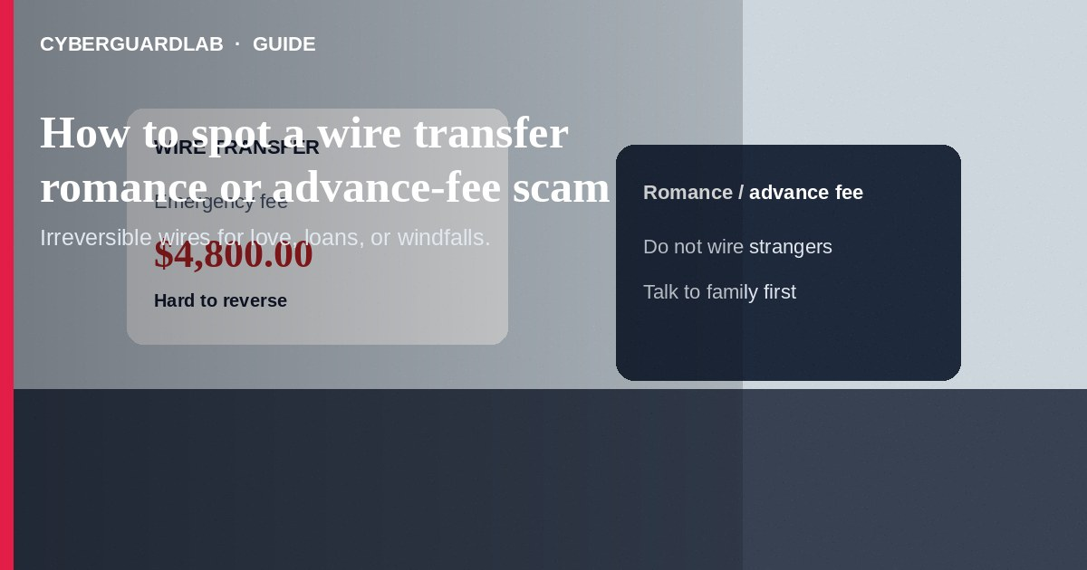
A wire transfer romance or advance-fee scam pushes you to send bank wires for love, a windfall, a loan, or an emergency that is not real. Once wired, money is extremely hard to get back. Do not wire funds to someone you have not met in person and fully verified. Do not pay “taxes,” “customs,” “lawyer fees,” or “release fees” to collect a prize, inheritance, or loan.
This guide is about irreversible wires—not gift-card romance plays covered in our gift card scam guide, and not peer-app sends like Zelle or Cash App payment scams. Criminals may mix channels over time. No software purchase required.
Paid link
Norton 360 | See the Norton first-year offer

See the Norton first-year offer
Offer page: https://cyberguardlab.com/norton

1. How wire romance and advance-fee scripts work
- Romance trust building — Dating apps or social media contacts avoid video, invent travel or military stories, then need a wire for tickets, medical bills, crypto “investments,” or customs holds (FTC romance scam guidance).
- Advance-fee windfall — A loan, grant, lottery, or inheritance is promised if you first wire a processing fee (FTC fake loan guidance).
- Secrecy and urgency — “Don't tell your family,” shifting excuses after each payment, and forged bank or shipping documents keep you paying.
- Payment rail choice — Scammers prefer wires because funds move fast and reversals are limited (CFPB wire transfer basics).
- Channel switching — Later asks may move to gift cards, crypto, or money-mule instructions after the first wire succeeds.

2. Red flags before you wire
Cue | Likely legitimate | Likely scam
Relationship proof | Video calls, shared contacts, meetups you initiate | Excuses forever; refuses live video; moves chat off-platform fast
Money ask | Rare; transparent shared expenses with people you know | Wires for emergencies, investments, or “temporary” fees
Advance-fee promise | Real lenders do not require upfront wire fees to release loans | “Pay $2,000 to unlock your $50,000 loan or prize”
Secrecy | Open to family review | “Keep this between us” or insults if you hesitate
Documents | Verifiable on official sites you type yourself | PDFs and photos only; pressure to wire same day
Payment type | Traceable methods with consumer protections when appropriate | Bank wire, crypto, or money-mule instructions

3. Safer habits (buy-nothing)
- Stop and talk to a trusted person before any wire.
- Reverse-search profiles and demand a live video call you schedule.
- Remember: you do not pay fees to collect lottery winnings, grants, or loan funds from strangers.
- Answer bank staff honestly when they ask why you are sending money—their warnings matter.
- Do not “test” with a small wire. Scammers use small wins to unlock larger ones.
- If gift cards appear later in the story, read gift card scam warning signs too.

4. If you already wired money
- Call your bank's fraud line immediately and ask whether a recall is possible. Speed matters.
- Save wire receipts, chat logs, profiles, and any documents they sent.
- Report at ReportFraud.ftc.gov and to the FBI Internet Crime Complaint Center (IC3).
- If you shared ID images or account numbers, monitor accounts and consider IdentityTheft.gov steps.
- End contact. Anyone promising recovery for another upfront fee is often a second scam (FTC guidance if you were scammed).
- If you shared remote access or clicked files, remove unknown apps and change passwords on a clean device.

FAQ

Why do scammers insist on wires?
Wires move quickly and are difficult to reverse, especially after funds leave the receiving bank.

Is a romance scam only about love?
The emotional story is the tool. The goal is money—often via wire, crypto, or later gift cards.

A lender emailed that my loan is approved after I wire an insurance fee. Real?
Treat upfront wire fees to release a consumer loan as a major red flag. Verify any lender independently.

How is this different from a gift-card romance scam?
Payment method. This article targets bank wires and advance-fee wires. Gift-card romance uses retail cards; see how to spot a gift card scam.

Can I get a wire back after 24 hours?
Sometimes banks can attempt a recall, but success is not guaranteed. Contact the bank as soon as you suspect fraud.

Do I need paid antivirus to avoid a wire romance scam?
No. Slowing down, talking to family, and refusing upfront fees are enough. Buy-nothing is valid.

If you still want a paid suite
Avoiding a wire romance or advance-fee scam does not require paid antivirus. Caution, family checks, and official bank paths are a valid buy-nothing stack. If you want multi-device paid protection later, use only these on-site paid links: TotalAV (paid link), Norton (paid link), Bitdefender (paid link), McAfee (paid link), Avast (paid link).

Sources
- What To Do About Romance Scams (FTC)
- Fake Loan and Advance-Fee Loan Scams (FTC)
- What is a wire transfer? (CFPB)
- ReportFraud.ftc.gov
- FBI Internet Crime Complaint Center (IC3)

Also read
- How to spot a gift card scam
- How to spot an online romance scam
- How to spot a Zelle or Cash App payment scam
- How to spot a government grant scam
- How to report a scam to the FTC

