
How to turn on SmartScreen for apps and files
https://cyberguardlab.com/blog/windows-smartscreen-apps-files
Independent US household comparison site. Not the vendor. Paid links below may earn a commission. Confirm first-year price, renewal, device limit, and refund terms at checkout.
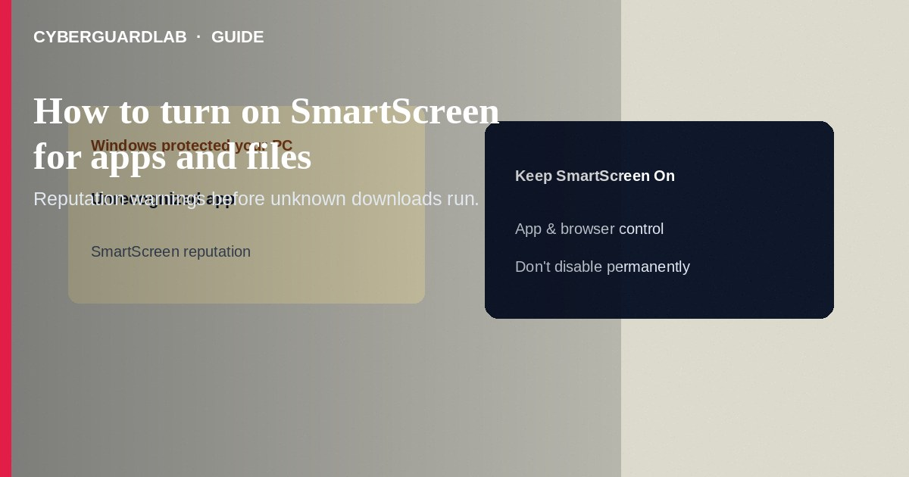
Microsoft Defender SmartScreen for apps and files uses reputation data to warn you before running unrecognized or known-malicious downloads—separate from Controlled Folder Access and from browser-only checks. Turn on reputation-based protection in Windows Security → App & browser control. This how-to is about SmartScreen for apps and files—not Controlled Folder Access, not memory integrity, and not protection history alone.

1. When SmartScreen helps
Keep it on for everyday PCs that install software from the web. SmartScreen reduces drive-by and “cracked tool” risk; it does not replace reading the publisher name or avoiding pirated installers. Enterprise admins may manage the same controls with policy—home steps below use the Windows Security app.
Paid link
Norton 360 | See the Norton first-year offer

See the Norton first-year offer
Offer page: https://cyberguardlab.com/norton
Video guides that tell you to disable SmartScreen via registry edits so pirated games install are a common malware funnel. Leave reputation checks on; if a game needs an exception, use a vendor-signed build or an allowed path—not a global off switch.

2. SmartScreen vs CFA vs memory integrity
Control | Moment it acts | Typical user action
SmartScreen apps/files | Before/when launching an unrecognized download | Warn / block run
Controlled Folder Access | When any untrusted app tries to change protected files | Block writes; allow specific apps
Memory integrity | Kernel driver load / code integrity | Block vulnerable or malicious drivers

3. Steps: turn on SmartScreen for apps and files
- Open Windows Security.
- Select App & browser control.
- Open Reputation-based protection (or Reputation-based protection settings).
- Turn Check apps and files to On (wording may show as Microsoft Defender SmartScreen for apps and files).
- Optionally enable related toggles on the same page when offered: SmartScreen for Microsoft Edge, Potentially unwanted app blocking, and SmartScreen for Microsoft Store apps—each covers a different surface.
- If a known-good utility is blocked, prefer downloading a fresh copy from the vendor site over permanently disabling SmartScreen. Use More info → Run anyway only when you trust the file and source.
- After a scareware pop-up or forced installer, review Protection history and run a full Defender scan.
- Keep one primary real-time antivirus—Defender or a trusted suite such as Norton or Bitdefender. Avoid stacking full suites. TotalAV, McAfee, and Avast are other on-site comparison options.

4. If SmartScreen blocks a file you need
- Verify the download URL is the vendor’s real site (bookmark), not a look-alike ad.
- Check the file’s digital signature and size against vendor documentation when available.
- Re-download; avoid “bypass SmartScreen” crack tools—those are often malware.
- If your organization requires an internal tool, ask IT for an approved installer rather than turning SmartScreen off globally.

FAQ

Is Edge SmartScreen the same toggle?
Related but not identical. Apps-and-files protection covers programs you run; Edge has its own SmartScreen for sites and downloads inside the browser. Enable both when available.

Does SmartScreen replace Controlled Folder Access?
No. Turn on both for layered protection: reputation at launch plus folder-write restrictions.

Why did a brand-new legitimate app warn me?
New or rarely downloaded binaries lack reputation. Confirm the publisher, then proceed cautiously.

Can I rely on SmartScreen alone on a shared PC?
Also use a standard (non-admin) daily account so malware that slips through gains fewer privileges.

If you still want a paid suite
Avoiding how to turn on SmartScreen for apps and files does not require paid antivirus. Careful habits and official support paths are a valid buy-nothing stack. If you want multi-device paid protection later, use only these on-site paid links: TotalAV (paid link), Norton (paid link), Bitdefender (paid link), McAfee (paid link), Avast (paid link).

Sources
- Microsoft Support: App & browser control
- Microsoft Learn: Microsoft Defender SmartScreen overview
- CISA: Protecting against malicious downloads (home/small office hygiene)
- FTC: How to secure your computer

Also read
- How to turn on Controlled Folder Access in Windows
- How to turn on core isolation memory integrity
- How to check Windows Security protection history
- How to create a Windows local standard user for daily use
- How to check a download before opening an EXE

