
How to reset Windows 11 while keeping your files
https://cyberguardlab.com/blog/windows-11-reset-keep-files
Independent US household comparison site. Not the vendor. Paid links below may earn a commission. Confirm first-year price, renewal, device limit, and refund terms at checkout.
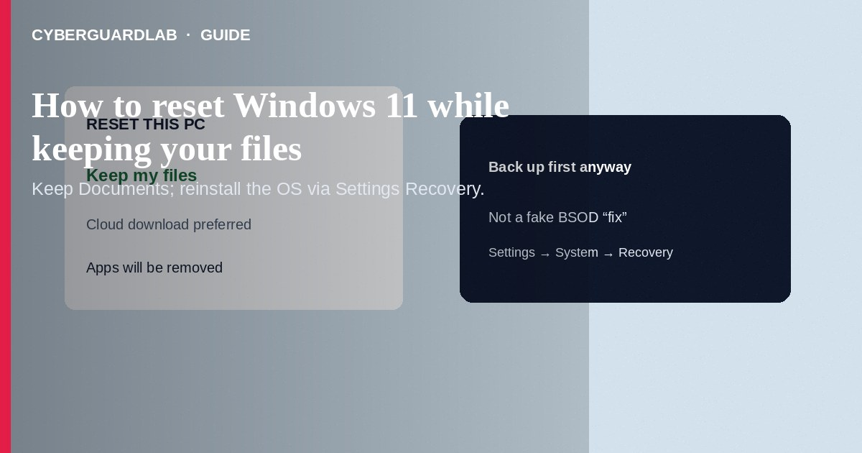
Resetting Windows 11 while keeping your files reinstalls Windows and removes apps and many settings, but leaves personal files in place—useful when the PC is slow, corrupted, or after stubborn malware, without wiping Documents and Photos. Use Settings → System → Recovery → Reset this PC → Keep my files, preferably with a Microsoft cloud download when offline media is outdated. This how-to is about the official keep-files reset—not a fake Windows blue screen support scam, not removing a browser hijacker alone, and not BitLocker or Windows Sandbox.

1. When a keep-files reset helps
Choose Keep my files when Windows boots but apps crash, startup is broken, or you want a cleaner OS after adware without deleting personal data. It is not a substitute for offline backups: cloud sync and an external copy still matter before you start. If the PC will not reach Settings, use Windows Recovery Environment (WinRE) reset options instead.
Paid link
Norton 360 | See the Norton first-year offer

See the Norton first-year offer
Offer page: https://cyberguardlab.com/norton
Anyone who cold-calls and demands remote access to “reset Windows for you” is not Microsoft. Start Reset this PC yourself from Settings or WinRE. If a full-screen warning forces a phone call, treat it as a BSOD support scam, not a legitimate recovery path.

2. Keep my files vs other options
Choice | What it does | When to use
Keep my files | Reinstalls Windows; removes apps/settings; keeps personal files | OS repair without wiping Documents/Pictures
Remove everything | Full wipe of the Windows drive (options for cloud/local and cleaning) | Selling/giving away the PC or severe compromise
System Restore | Rolls settings/apps to a restore point; not a full OS reinstall | Recent bad driver/update when restore points exist
Fake “call Microsoft” BSOD page | Scareware, not recovery | Never—see fake BSOD support scam

3. Steps: Reset this PC and keep files
- Back up critical folders to an external drive or trusted cloud anyway—reset can fail mid-way.
- Sign in with an administrator account.
- Open Settings → System → Recovery.
- Under Recovery options, select Reset this PC → Reset PC.
- Choose Keep my files (not Remove everything unless you intend a full wipe).
- Choose Cloud download if your local install files are damaged or very old; otherwise Local reinstall is fine when healthy.
- Review the list of apps that will be removed; note anything you must reinstall from official sources later.
- Confirm and let the PC restart. Do not interrupt power. After sign-in, reinstall needed apps and turn real-time protection back on. A trusted suite such as Norton or Bitdefender can be your primary AV—avoid stacking full suites. TotalAV, McAfee, and Avast are other on-site comparison options.

4. What to do after the reset
- Install Windows updates immediately.
- Reinstall browsers and Office only from official sites or Microsoft Store.
- Re-enable drive encryption if you use it and confirm recovery keys are saved (see BitLocker on a Windows home PC).
- If malware was the reason, run a full Defender scan afterward.
- Do not “fix” a scary fake BSOD by calling a number on screen—that is a different problem: fake Windows BSOD support scam.

FAQ

Will Keep my files preserve installed programs?
No. Apps are removed; you reinstall them. Personal files in typical user folders are kept.

Is Cloud download safer than Local reinstall?
Cloud download pulls current Windows files from Microsoft when local recovery media is incomplete. Use it when Microsoft recommends or local reinstall fails.

Does reset remove BitLocker encryption?
Behavior depends on options and edition. Save your BitLocker or device-encryption recovery key before any major reinstall; confirm status in encryption settings if unsure.

Can I reset from a blue screen that never reaches the desktop?
Often yes via WinRE (interrupt boot a few times or use installation media). That is still Microsoft recovery—not a phone number painted on a fake full-screen “virus” page.

If you still want a paid suite
Avoiding how to reset Windows 11 while keeping your files does not require paid antivirus. Careful habits and official support paths are a valid buy-nothing stack. If you want multi-device paid protection later, use only these on-site paid links: TotalAV (paid link), Norton (paid link), Bitdefender (paid link), McAfee (paid link), Avast (paid link).

Sources
- Microsoft Support: Recovery options in Windows
- Microsoft Support: Reset this PC
- FTC: How to secure your computer
- CISA: Understanding and protecting against malicious code

Also read
- How to spot a fake Windows blue screen support scam
- How to remove a browser hijacker from Windows
- How to turn on BitLocker on a Windows home PC
- How to use Windows Sandbox to open a risky file
- How to check Windows Security protection history

