
How to spot a WhatsApp account takeover scam
https://cyberguardlab.com/blog/whatsapp-account-takeover-scam
Independent US household comparison site. Not the vendor. Paid links below may earn a commission. Confirm first-year price, renewal, device limit, and refund terms at checkout.
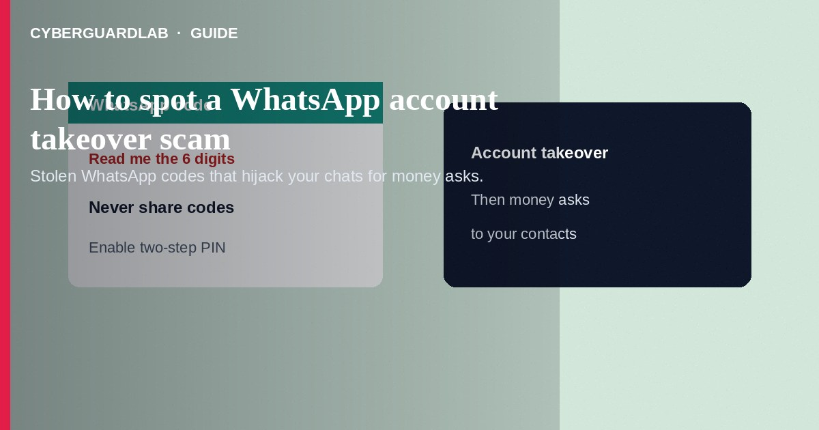
A WhatsApp account takeover scam tricks you into sharing a verification code—or uses other social engineering—so attackers register your number on their device, then message your contacts for money. Do not share WhatsApp codes with anyone. Do not approve unexpected device logins. If your account was taken, use WhatsApp’s official re-verification flow, warn contacts, and report fraud. This guide is about hijacking WhatsApp itself—not Discord Nitro giveaways, and not fake friend Facebook emergencies (though hijacked WhatsApp chats often send similar emergency asks to your friends).

1. How this scam works
You receive a call, SMS, or chat: “Did you try to log in to WhatsApp? Tell me the code.” Or a “friend” asks you to read them a six-digit code to help with their account. Once they control your WhatsApp, they message your family: “I’m in a meeting—send money on this wallet.” Some variants use fake WhatsApp Support numbers or phishing pages that mimic registration screens.
Paid link
Norton 360 | See the Norton first-year offer

See the Norton first-year offer
Offer page: https://cyberguardlab.com/norton
Unlike Discord giveaway scams that lure you to token-stealing sites, WhatsApp takeover centers on SMS/registration codes and then fraud against your contacts.

2. Red flags before you pay

3. Safer habits (buy-nothing)
- Never share WhatsApp verification codes—WhatsApp will not call to ask for them.
- Enable two-step verification (PIN) in WhatsApp Settings so registration alone is harder to abuse.
- Ignore “WhatsApp Support” cold calls and unofficial APKs.
- If a friend asks for a code, confirm by phone call using a number you already know.
- Verify any money request through a second channel before sending.
- For emergency money asks that arrive after a possible hijack, see also fake friend Facebook emergencies for similar social patterns.
Attackers recruit victims to collect codes from others. If anyone asks you to “help verify” their WhatsApp by reading a code, refuse. Household shared SIMs are high risk—know who controls the phone number tied to WhatsApp.

4. If you already paid
- If your account was taken: reconnect with your SIM, open WhatsApp, complete verification, and set a new two-step PIN.
- Message contacts from another channel that your WhatsApp was compromised—ask them to ignore payment requests.
- Report fraud to your bank or payment provider if money moved; file at ReportFraud.ftc.gov.
- Report the abusive accounts through WhatsApp’s in-app tools when you regain access.
- Change email passwords if you reused them elsewhere; enable two-factor authentication.
- If you typed credentials or opened attachments on a fake page, change passwords, enable two-factor authentication, and scan your device with a trusted tool such as Norton or Bitdefender. Keep one primary real-time antivirus—avoid stacking full suites. TotalAV, McAfee, and Avast are other on-site comparison options.

FAQ

WhatsApp sent me a code I did not request. What should I do?
Do not share it. Someone may be attempting registration. Enable two-step verification and monitor the app.

How is this different from a Discord giveaway scam?
Discord giveaways often steal tokens via fake claim sites. WhatsApp takeover typically steals SMS registration codes, then abuses your chat graph for money.

Can two-step verification stop every takeover?
It raises the bar but you must still protect the PIN and avoid phishing. Do not disable it for strangers.

My contact sent a payment request after a code chat with me. What now?
Assume compromise. Call them, tell mutual contacts, and do not send money until verified offline.

If you still want a paid suite
Avoiding a a WhatsApp account takeover scam does not require paid antivirus. Careful habits and official support paths are a valid buy-nothing stack. If you want multi-device paid protection later, use only these on-site paid links: TotalAV (paid link), Norton (paid link), Bitdefender (paid link), McAfee (paid link), Avast (paid link).

Sources
- FTC ReportFraud
- IdentityTheft.gov
- FTC: How to recognize phishing
- WhatsApp Help
- FBI IC3

Also read
- How to spot a fake friend emergency Facebook message
- How to spot a Discord nitro or crypto giveaway scam
- How to spot a phishing email
- How to report a scam to the FTC
- How to spot a gift card scam

