
How to spot a vacation rental scam
https://cyberguardlab.com/blog/vacation-rental-scam
Independent US household comparison site. Not the vendor. Paid links below may earn a commission. Confirm first-year price, renewal, device limit, and refund terms at checkout.
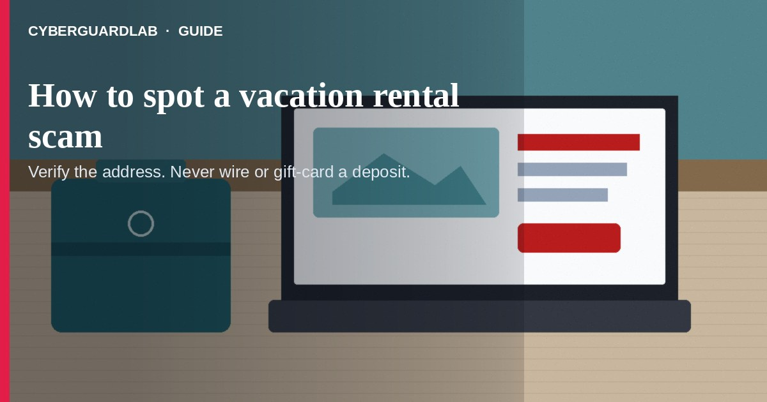
A vacation rental scam is when a listing looks like a cabin, condo, or beach house — but the “host” takes your deposit and there is no place waiting for you. Per the FTC, scammers hijack real listings, invent places that aren’t for rent, and push wire, gift card, payment-app, or crypto deposits. This guide is about short-term / vacation rental ads, not fake car dealership sites or gift card payment pressure in other contexts. You do not need to buy antivirus to walk away from a bad listing.

1. How the scam usually works
From FTC rental listing / vacation rental guidance:
Paid link
Norton 360 | See the Norton first-year offer
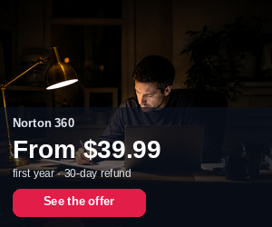
See the Norton first-year offer
Offer page: https://cyberguardlab.com/norton
Ad link: https://trysecurities.com/offer/norton?dtm=gg&cid=
- Too-good listing — Premium place at a suspiciously low rate, or amazing amenities.
- Hijacked or invented ad — Stolen photos/descriptions with the scammer’s contact info, or a place that isn’t actually for rent.
- Rush to pay — Application fee, deposit, or full rent before you see the property or a real contract.
- Hard-to-reverse payment — Wire (Western Union / MoneyGram), gift cards, crypto, or some payment apps.
- Excuses — “I’m out of the country,” “I’ll mail the keys,” “pay now or lose the dates.”

2. What to do before you send any money
- Search the address + owner/company name — FTC: other ads for the same address with different owners are a warning sign.
- Check the company’s own site — If the property isn’t listed there, treat the ad as suspicious.
- Get the contract first — Read names, address, dates, and refund terms before a deposit.
- Prefer credit card — FTC: cards usually offer better dispute options than wires/gift cards/crypto.
- Don’t pay for a place you’ve never seen — If you can’t visit, have someone you trust verify, or keep looking.
- Ignore pressure to decide “right now” by email or text.

3. If you already sent money
- Contact your bank, card issuer, wire service, gift-card company, or payment app immediately and report fraud.
- Save the listing URL, screenshots, emails, and payment receipts.
- Report the ad to the website or app where you found it.
- Report at ReportFraud.ftc.gov and local law enforcement.
- If you clicked a weird “booking” link on a PC, run a normal Windows Security scan — see also phishing email.

4. Household habits that cut risk (no software purchase required)
- Book through platforms/companies you can verify, not cold social posts alone.
- Family rule: no vacation deposits by wire, gift card, or crypto — see gift card scams and cryptocurrency scams.
- Compare prices for the same zip code — far-below-market premium rentals need extra checks.
- Use a shared checklist (address search, contract, payment method) before anyone pays.
- Teach teens booking their first trip the same red flags.

FAQ

How do I spot a vacation rental scam?
Bargain premium listing + pressure to pay deposit by wire/gift card/crypto + inability to see the place or verify the owner matches FTC rental-scam patterns.

Is paying with Zelle or crypto safer?
FTC warns scammers prefer hard-to-reverse methods. Prefer credit card when possible.

What if the photos look real?
Scammers steal real photos. Verify address and owner independently.

Is Microsoft Defender required here?
No. This is a listing/payment scam. Defender is optional if you also opened a suspicious booking attachment — see Is Microsoft Defender enough?.

Where do I report it?
ReportFraud.ftc.gov, the listing site, and local law enforcement. Also see how to report a scam to the FTC.

If you still want a paid suite
Avoiding a fake rental deposit does not require paid antivirus. Microsoft Defender is a valid buy-nothing choice for many Windows households. If the household later wants multi-device paid protection, use only these on-site paid links: TotalAV (paid link), Norton (paid link), Bitdefender (paid link), McAfee (paid link), Avast (paid link).

Sources
- Rental Listing Scams (FTC)
- Getting a vacation rental? Watch out for scams. (FTC)
- Avoiding rental listing scams (FTC)
- What To Know Before You Wire Money (FTC)
- ReportFraud.ftc.gov (FTC)
- What To Do if You Were Scammed (FTC)

Also read
- How to spot a fake car dealership website scam
- How to spot a gift card scam
- How to spot a fake check scam
- How to spot a cryptocurrency scam
- How to report a scam to the FTC
- How to spot a phishing email

