
How to spot a fake unpaid internship fee scam
https://cyberguardlab.com/blog/unpaid-internship-fee-scam
Independent US household comparison site. Not the vendor. Paid links below may earn a commission. Confirm first-year price, renewal, device limit, and refund terms at checkout.
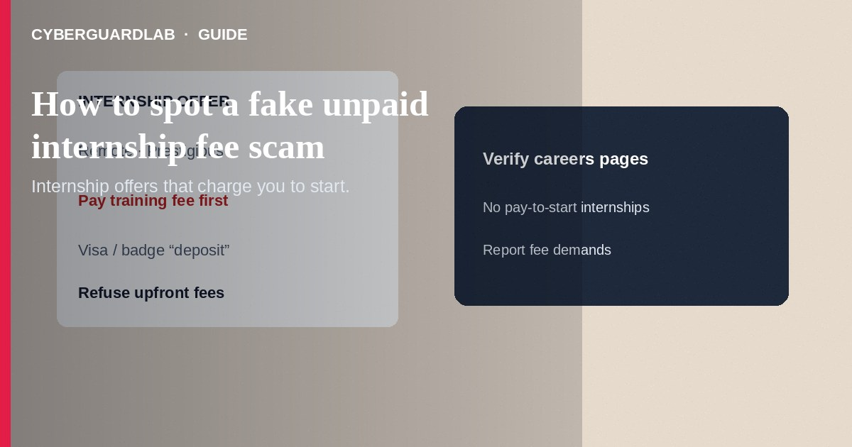
A fake unpaid internship fee scam offers a prestigious remote or “partner company” internship, then demands payment for training, background checks, equipment deposits, visa paperwork, or “placement guarantees” before any real work begins. Legitimate unpaid internships do not charge students upfront fees to start. Do not wire, crypto-pay, or gift-card “onboarding” costs to someone who contacted you on social media or a career site. If you already paid, stop contact, save receipts, and report to the FTC. This guide is about fee-first fake internships—not mystery shopper checks, not MLM pressure pitches, and not LinkedIn recruiter phishing that steals logins without an internship story.

1. How fake internship fee scams work
A recruiter praises your résumé and offers an unpaid internship with a well-known brand—or a vague “Fortune 500 partner.” After excitement builds, they invoice a “refundable deposit,” software license, uniform, certification course, or foreign-placement fee. Payment must be fast via wire, crypto, gift cards, or a look-alike careers portal. Some send fake offer letters on stolen letterhead.
Paid link
Norton 360 | See the Norton first-year offer

See the Norton first-year offer
Offer page: https://cyberguardlab.com/norton
After payment, the internship never materializes, or you are pushed into endless upsells. Others harvest passport scans and Social Security numbers under “HR onboarding,” then disappear. Unpaid internships that are lawful still do not require you to pay the employer to participate.
Scammers invent foreign internship visas that require “embassy processing fees” paid to personal accounts. Real consular fees go through official government channels you open yourself. Share this pattern with classmates applying to remote prestige programs.

2. Red flags before you pay
Cue | Likely legitimate | Likely scam
Money direction | Employer pays you, or truly unpaid with no fee to join | You must pay to unlock training, placement, or a laptop
Hiring path | Official careers site, campus portal, or known nonprofit program | Cold DM, WhatsApp-only “HR,” or mismatched email domains
Documents | Standard applications; you verify the company independently | Instant offer letter before interviews; pressure to pay same day
Payment method | None required to start an unpaid role | Wire, crypto, gift cards, or unknown payment links
Brand claims | Role listed on the company’s real careers page | “Partner of” a famous brand with no listing you can find
Data requests | Minimal data after a verified offer | Passport, SSN, and bank details before any verifiable start date

3. Safer habits (buy-nothing)
- Assume any “pay us to intern” pitch is fraud until you verify the employer on its official site.
- Open the company’s careers page yourself—do not use links from the message.
- Refuse wires, crypto, gift cards, and “refundable” deposits for internship access.
- Ask campus career services or a trusted adviser to review the offer.
- Do not send passport or SSN images to a recruiter you cannot independently confirm.
- For job phishing that targets passwords more than fees, see LinkedIn recruiter phishing.

4. If you already paid
- Stop further payments. Screenshot chats, invoices, wallet addresses, and offer letters.
- Contact your bank, card issuer, or wire service the same day to report fraud.
- If you bought gift cards, call the issuer’s fraud line with numbers and receipts.
- Report at ReportFraud.ftc.gov; notify your school’s career office if students are being targeted.
- If you shared ID or SSN, use IdentityTheft.gov and consider a credit freeze.
- If you typed credentials on a fake portal, change passwords, enable two-factor authentication, and scan your device with a trusted tool such as Norton or Bitdefender. Keep one primary real-time antivirus—avoid stacking full suites. TotalAV, McAfee, and Avast are other on-site comparison options.

FAQ

Can a real unpaid internship ever charge for something?
Some programs involve third-party tuition for academic credit you choose—but an “employer” demanding gift cards or wires to start is a scam pattern. Verify through official school or company channels.

How is this different from an MLM pitch?
MLM pressure pushes you to buy inventory or recruit friends for “business ownership.” Internship fee scams sell access to a fake prestigious placement.

They said the deposit is fully refundable after week one.
Refund promises are common bait. Once crypto or gift cards move, recovery is unlikely.

The email used a real company’s logo. Is that enough?
No. Logos are copied easily. Check the careers URL and HR domain yourself.

If you still want a paid suite
Avoiding how to spot a fake unpaid internship fee scam does not require paid antivirus. Careful habits and official support paths are a valid buy-nothing stack. If you want multi-device paid protection later, use only these on-site paid links: TotalAV (paid link), Norton (paid link), Bitdefender (paid link), McAfee (paid link), Avast (paid link).

Sources
- FTC: Job scams
- FTC ReportFraud
- IdentityTheft.gov
- FTC: What to do if you were scammed

Also read
- How to spot a LinkedIn recruiter phishing scam
- How to spot a multi-level marketing pressure pitch
- How to spot a work-from-home package reshipping scam
- How to spot a scholarship application fee scam
- How to report a scam to the FTC

