
How to spot a fake unemployment benefits scam
https://cyberguardlab.com/blog/unemployment-benefits-scam
Independent US household comparison site. Not the vendor. Paid links below may earn a commission. Confirm first-year price, renewal, device limit, and refund terms at checkout.
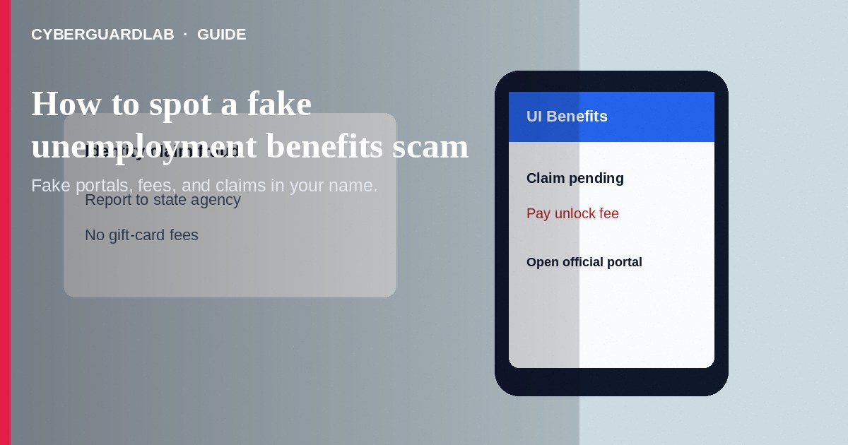
A fake unemployment benefits scam steals money or identity by posing as a state workforce agency—or by filing claims in your name. You may get texts about “unclaimed benefits,” locked accounts, or refunds that need a fee. Do not tap surprise links. Do not pay gift cards to unlock benefits.
This differs from DMV renewal texts and from IRS garnishment calls, though all can use phishing links like those in how to spot a phishing email. Peer-app pressure overlaps with Zelle and Cash App payment scams. No software purchase required.
Paid link
Norton 360 | See the Norton first-year offer

See the Norton first-year offer
Offer page: https://cyberguardlab.com/norton

1. How fake unemployment benefits scripts work
- Phishing or fee track — Messages say benefits are ready, suspended, or overpaid. Links harvest logins or demand a “verification fee,” sometimes via gift cards or peer apps (FTC government impersonation guidance).
- Identity claim track — You receive a 1099-G, approval letter, prepaid card, or employer notice about a claim you never filed. Criminals already used your SSN to collect benefits (FTC identity theft guidance).
- Spoofed agency branding — Call centers and fake sites copy logos and ask for driver's license uploads.
- Fake invoice language — Some mixes in “benefit tax processing” bills adjacent to fake invoice patterns.
- Stress timing — During layoffs and economic stress, people expect agency contact—so scammers blend in.

2. Red flags before you tap or pay
Cue | Likely legitimate | Likely scam
Account access | You open your state's official unemployment site or app yourself | Cold link in SMS or email claiming “update payment method”
Fees | States do not require gift cards to release benefits | Pay a fee to unlock, verify, or stop an overpayment by gift card
Unexpected claim mail | Investigate through official state contact channels | Click links in the same envelope insert from a stranger site
Payment apps | Official direct deposit you set inside the real portal | Send money via Cash App or Venmo to an “agent”
Data requests | Through authenticated state portals | Full SSN over text; photos of documents to a random number
Tone | Procedural deadlines inside your real account | Immediate suspension threats with a shortened URL

3. Safer habits (buy-nothing)
- Do not use links in unexpected benefit texts. Type your state workforce site address yourself.
- If you never applied, still check whether a claim exists when notices arrive.
- Never pay to “release” unemployment funds with gift cards, crypto, or wires.
- Protect your SSN and driver's license images.
- Tell your employer's HR if they flag a claim you did not make.
- For peer-app payment pressure, see Zelle and Cash App payment scams.

4. If you already paid—or a claim used your identity
- Contact your bank or card issuer about scam payments.
- Report the fake claim to your state unemployment fraud unit using phone numbers from the official site.
- File at ReportFraud.ftc.gov and start IdentityTheft.gov for tax and credit follow-through.
- Change passwords on email and any state accounts; enable multifactor authentication.
- Watch for IRS notices about unemployment income you did not receive; keep copies of fraud reports.
- Ask HR whether a claim appeared against your wage record and keep any fraud affidavits the state asks you to sign (FTC guidance if you were scammed).

FAQ

I got a prepaid card for unemployment I did not claim. What now?
Contact the state unemployment agency through its official site immediately. Do not activate and spend the card as if it were a windfall—report it.

A text says my weekly benefit is pending after I click. Safe?
No. Open the official portal yourself. Unexpected benefit links are high-risk phishing.

How is this different from a DMV text scam?
DMV scams threaten driving privileges. Unemployment scams target benefits logins, fees, or identity-based claims. Both use urgent official-looking messages. See DMV license renewal text scams.

Will I owe taxes on fraudulently claimed benefits?
Fraudulent claims can create tax headaches. Keep state fraud reports and follow IRS and IdentityTheft.gov guidance if a 1099-G appears for wages you did not receive.

Can freezing my credit help?
A credit freeze will not stop all unemployment identity fraud, but broader identity theft steps on IdentityTheft.gov still matter when SSNs are exposed.

Do I need paid antivirus to avoid an unemployment benefits scam?
No. Official portals and refusing unlock fees are enough. Buy-nothing is valid.

If you still want a paid suite
Avoiding a fake unemployment benefits scam does not require paid antivirus. Official portals and cautious habits are a valid buy-nothing stack. If you want multi-device paid protection later, use only these on-site paid links: TotalAV (paid link), Norton (paid link), Bitdefender (paid link), McAfee (paid link), Avast (paid link).

Sources
- What To Do if You're a Victim of Identity Theft (FTC)
- IdentityTheft.gov
- ReportFraud.ftc.gov
- Government Impersonation Scams (FTC)

Also read
- How to spot a phishing email
- How to spot a DMV or license renewal text scam
- How to report identity theft on IdentityTheft.gov
- How to spot a Zelle or Cash App payment scam
- How to report a scam to the FTC

