
How to turn off iMessage on a lost iPhone from another device
https://cyberguardlab.com/blog/turn-off-imessage-lost-iphone
Independent US household comparison site. Not the vendor. Paid links below may earn a commission. Confirm first-year price, renewal, device limit, and refund terms at checkout.
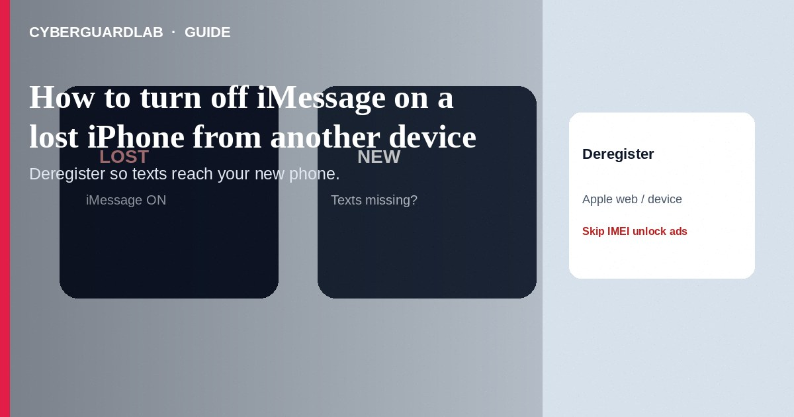
If your iPhone is lost or stolen and texts still route to that device as iMessage (blue bubbles) instead of reaching a new Android phone or temporary handset, deregister iMessage with Apple and secure the Apple Account from another device or browser. Also use Find My to Mark as Lost when you can. This how-to is about stopping iMessage on a missing iPhone from elsewhere—not recovering an Apple ID without SMS, and not a fake Apple Support screen-share scam.

1. When you need this
Common case: you switched to Android or a loaner phone, but friends’ iMessages still deliver only to the lost iPhone. Another case: the thief still has network access and you want to cut Continuity messaging while you wipe remotely. You need the Apple Account password (and ideally a trusted device or recovery path). If you cannot sign in at all, fix account access first.
Paid link
Norton 360 | See the Norton first-year offer

See the Norton first-year offer
Offer page: https://cyberguardlab.com/norton
After a loss, search ads push paid tracking sites that steal Apple Account passwords. Stick to Find My and Apple Support URLs you type yourself. Nobody needs App Store gift cards to deregister iMessage.

2. iMessage off vs account recovery vs scam help
Goal | Use | Avoid
Stop blue-bubble routing to lost phone | Apple iMessage deregister + Find My | Paid “iMessage unlock” Telegram sellers
Cannot sign in / no SMS codes | Apple account recovery | Caller offering to screen-share “activation”
Locate or wipe device | Find My Mark as Lost / Erase | Apps that demand gift cards to “track IMEI”

3. Steps: turn off iMessage from another device or web
- From any browser, open Apple’s official self service iMessage / FaceTime deregistration page (search Apple Support for “If you don't have your Apple device” / deregister iMessage) or go through support.apple.com articles that link the deregister form—type Apple’s site yourself.
- Enter the phone number that was used for iMessage on the lost iPhone. Complete the CAPTCHA and request the confirmation code Apple texts or provides per the form instructions.
- If you still have another Apple device signed into the same Apple Account: open Settings → [your name] → Find My → Find My iPhone (or the Find My app) and choose Mark As Lost / enable Lost Mode with a contact number. Optionally Erase This Device after you accept data loss.
- On another Mac or iPhone still on the account: Settings → Messages (or Messages preferences) and remove the lost phone number from Send & Receive if it still appears after you regain control of a replacement device.
- Change your Apple Account password at account.apple.com from a trusted device or after verification. Review Devices and remove the lost iPhone when appropriate.
- Contact your carrier to suspend or replace the SIM/eSIM so voice/SMS cannot be abused; set a carrier account PIN.
- When you set up a replacement iPhone, sign in carefully and re-enable Messages only on devices you hold.
- If you entered credentials on a suspicious “Apple lock” site while panicking, change the password again and scan with a trusted tool such as Norton or Bitdefender. Keep one primary real-time antivirus—avoid stacking full suites. TotalAV, McAfee, and Avast are other on-site comparison options.

4. If messages still miss you
- Wait for Apple’s deregistration to propagate; retry the official form if the number still fails on Android SMS.
- Ask contacts to send a green SMS or use a non-iMessage channel temporarily.
- Confirm the phone number is correct on your carrier account and that the SIM is active on the device you hold.
- After recovery, add a second trusted number on the Apple Account so a future loss is less painful.

FAQ

Will deregistering iMessage erase my iCloud photos?
No. Deregistration targets Messages/FaceTime phone-number registration. Erasing the device via Find My is a separate, destructive step.

Is this the same as recovering the Apple ID password?
No. You may already know the password and only need messaging deregistration and Find My. Password recovery is a different flow.

Can Apple Support remote into my PC to fix iMessage?
Do not allow cold callers screen control. Use Apple’s web form and Find My yourself.

What if I never had another Apple device?
Use the web deregister flow for the phone number, secure the Apple Account in a browser, and work with the carrier on the line.

If you still want a paid suite
Avoiding how to turn off iMessage on a lost iPhone from another device does not require paid antivirus. Careful habits and official support paths are a valid buy-nothing stack. If you want multi-device paid protection later, use only these on-site paid links: TotalAV (paid link), Norton (paid link), Bitdefender (paid link), McAfee (paid link), Avast (paid link).

Sources
- Apple Support: If you don't have your Apple device (iMessage)
- Apple Support: Find My iPhone Mark as Lost
- Apple Support: What to do if your iPhone is lost or stolen
- Apple Account
- FTC ReportFraud

Also read
- How to recover an Apple ID without SMS access
- How to spot a fake Apple Support screen-sharing scam
- How to spot a one-time passcode relay scam call
- How to turn on number lock at T-Mobile, Verizon, or AT&T
- How to use a hardware security key for your main accounts

