
How to spot a timeshare exit scam
https://cyberguardlab.com/blog/timeshare-exit-scam
Independent US household comparison site. Not the vendor. Paid links below may earn a commission. Confirm first-year price, renewal, device limit, and refund terms at checkout.
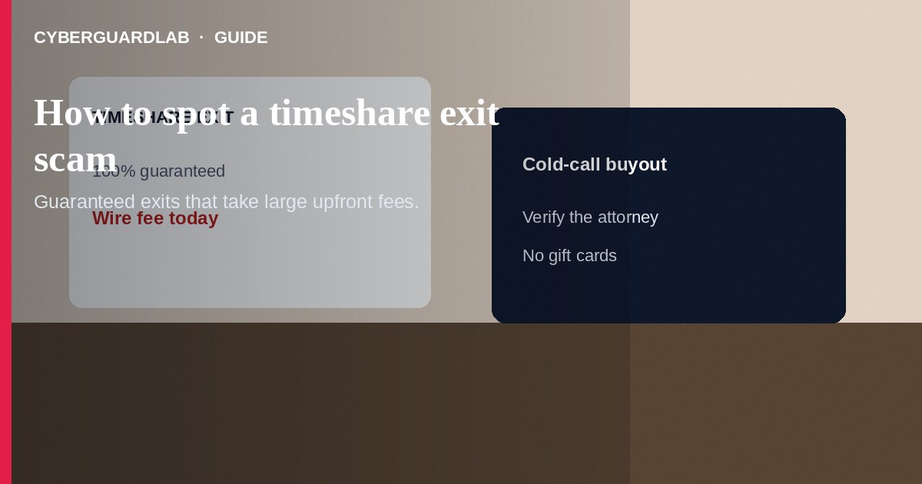
A timeshare exit scam sells a fake or worthless “guaranteed” way out of a timeshare—then takes large upfront fees by wire, check, or card. Some operators also resell your data or vanish after a polished contract. Do not pay advance fees to strangers who guarantee a timeshare cancellation, buyout, or resale. Do not send gift cards.
This guide is about exit and resale fraud—not scholarship fees or romance wires. It can overlap with fake check overpayment and phishing sites. No software purchase required.
Paid link
Norton 360 | See the Norton first-year offer

See the Norton first-year offer
Offer page: https://cyberguardlab.com/norton

1. How timeshare exit and resale scripts work
- Cold-call guarantee — Calls, ads, and mailers claim your timeshare is in default, has a buyer waiting, or can be exited in weeks for a fixed fee (FTC timeshare guidance).
- Fake legal theater — Pitch decks use legal language and “attorney networks” you cannot independently confirm.
- Stop-paying advice — You may be told to stop paying the resort, which can damage credit, while you wire money to a fake escrow.
- Resale fee trap — Your unit is listed at an unrealistic price; advertising or title fees are collected; no buyer appears.
- Overpayment blend — Some pitches mix overpayment tricks similar to a fake check scam.

2. Red flags before you pay an exit fee
Cue | Likely legitimate | Likely scam
First contact | You researched and chose a firm; credentials check out | Unsolicited call about a “buyer ready today”
Fees | Clear services, cautious about big upfront demands | Large advance fee required before any work product
Guarantees | Honest about risk, timelines, and resort rules | “100% exit guaranteed” regardless of contract
Advice on resort payments | Does not casually tell you to default | Instructs you to stop paying maintenance fees immediately
Escrow and lawyers | Verifiable licensed attorneys in the relevant state | Mystery escrow; lawyers you cannot independently confirm
Pressure | Time to review with a trusted advisor | Same-day wire to “hold the buyer”

3. Safer habits (buy-nothing)
- Hang up on unsolicited exit guarantees. Return calls only to numbers you find on official sites.
- Ask your resort in writing what transfer, surrender, or listing options actually exist.
- Verify any attorney or company with state licensing boards and consumer complaint records.
- Refuse gift-card or crypto payments for legal or exit services.
- Do not stop required resort payments solely because a cold caller said so—understand credit and foreclosure risks first.
- Sleep on large exit contracts and get a second opinion from a trusted local consumer attorney if sums are large.

4. If you already paid
- Cancel further scheduled payments with your bank or card issuer when possible.
- Send a written dispute or cancellation request to the company; keep copies.
- Report to the FTC at ReportFraud.ftc.gov and to your state attorney general's consumer office. You can also use the CFPB complaint portal when financial products or services are involved.
- If you shared ID or banking data, monitor accounts and use IdentityTheft.gov as needed.
- Beware “recovery” firms that demand another upfront fee to chase the first scammer.
- If you installed remote-support software during the pitch, remove it and change passwords (FTC guidance if you were scammed).

FAQ

Are all timeshare exit companies scams?
No, but the sector attracts aggressive fraud. Treat guarantees, huge upfront fees, and cold calls as high risk until proven otherwise.

They said a buyer already wired earnest money. Believe it?
Demand independent proof. Fake buyer stories are common. Do not pay marketing fees based on screenshots alone.

Should I stop paying maintenance fees if an exit firm tells me to?
Not without understanding contract and credit consequences. Confirm options with the resort and a trusted advisor first.

How is this different from a general advance-fee loan scam?
The bait is escaping a timeshare or cashing out via resale, not unlocking a personal loan. The upfront-fee mechanic is similar; the story and documents differ. See also wire advance-fee scams.

What documents should I keep?
Contracts, call recordings if lawful in your state, wire receipts, emails, and any buyer or escrow paperwork.

Do I need paid antivirus to avoid a timeshare exit scam?
No. Independent verification and refusing advance-fee guarantees are enough. Buy-nothing is valid.

If you still want a paid suite
Avoiding a timeshare exit scam does not require paid antivirus. Independent checks and patience are a valid buy-nothing stack. If you want multi-device paid protection later, use only these on-site paid links: TotalAV (paid link), Norton (paid link), Bitdefender (paid link), McAfee (paid link), Avast (paid link).

Sources
- Timeshares and Vacation Clubs (FTC)
- ReportFraud.ftc.gov
- CFPB complaint portal
- IdentityTheft.gov

Also read
- How to spot a wire transfer romance or advance-fee scam
- How to spot a fake check scam
- How to spot a vacation rental scam
- How to spot a phishing email
- How to report a scam to the FTC

