
How to spot a TikTok shop or live-stream scam
https://cyberguardlab.com/blog/tiktok-shop-livestream-scam
Independent US household comparison site. Not the vendor. Paid links below may earn a commission. Confirm first-year price, renewal, device limit, and refund terms at checkout.
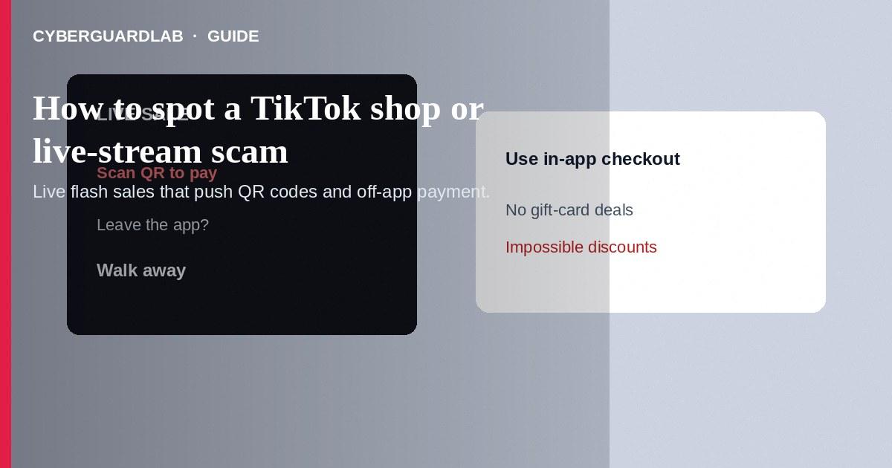
A TikTok shop or live-stream scam uses flash sales, fake stores, or off-platform payment requests during lives to take money for goods that never arrive—or to phish logins. Do not pay creators via random QR codes, gift cards, or wires “to lock the deal.” Prefer official in-app checkout when you shop at all, and treat miracle discounts with caution. If you already paid off-platform, stop contact, save proof, and report through TikTok and the FTC. This guide is about live shopping and fake TikTok Shop storefronts—not Instagram giveaway prize DMs, and not Discord Nitro crypto giveaways.

1. How this scam works
A live host shows luxury bags, phones, or cosmetics at steep discounts. They urge viewers to scan a QR code, move to WhatsApp, or pay a “supplier” directly. Some storefronts look like TikTok Shop but ship empty boxes or nothing. Others run refund tricks: overpay, then ask you to return the “extra” by gift card—similar to fake refund overpayment patterns.
Paid link
Norton 360 | See the Norton first-year offer

See the Norton first-year offer
Offer page: https://cyberguardlab.com/norton
Pressure is the product: countdown timers, “only 2 left,” and hosts who shame hesitation. Unlike Instagram giveaway scams, the pitch is a purchase, not a free prize claim.

2. Red flags before you pay

3. Safer habits (buy-nothing)
- Buy only through official in-app checkout—not QR codes shouted on a live.
- Ignore hosts who demand WhatsApp, wire, or gift-card payment.
- Compare luxury pricing to reality; walk away from impossible deals.
- Do not share bank codes or remote-access apps with “shop support.”
- Screenshot the live username, product claims, and any payment instructions before they vanish.
- For off-platform payment pressure, see Zelle and Cash App payment scams.
If a live ends and a new account continues the sale by QR only, treat it as a reset: verify inside official shop tools or walk away. Household shared phones should lock TikTok logins so kids cannot approve surprise payments.

4. If you already paid
- Stop further payments. Save live recordings if available, usernames, and receipts.
- Report the live, seller, and messages through TikTok’s official reporting tools.
- Contact your bank, card issuer, or payment app fraud team immediately.
- If gift cards were used, contact the card issuer’s fraud line with card details.
- File at ReportFraud.ftc.gov.
- If you typed credentials or opened attachments on a fake page, change passwords, enable two-factor authentication, and scan your device with a trusted tool such as Norton or Bitdefender. Keep one primary real-time antivirus—avoid stacking full suites. TotalAV, McAfee, and Avast are other on-site comparison options.

FAQ

Is TikTok Shop always safe?
No marketplace is risk-free. In-app checkout may offer more recourse than off-platform QR payments—but fake sellers and phishing still exist. Read current TikTok Shop buyer policies for your region.

How is this different from an Instagram giveaway scam?
Giveaway scams bait “free” prizes and claim fees. TikTok shop/livestream scams push merchandise purchases—often during a live—with fake stores or off-platform pay.

The host said paying outside TikTok gets a bigger discount. Should I?
Usually a red flag. Discounts that require leaving buyer protection are not bargains.

I received a tracking number that never moves. What now?
Document it, open any in-app dispute tools promptly, and report. Fake tracking is common.

If you still want a paid suite
Avoiding a a TikTok shop or live-stream scam does not require paid antivirus. Careful habits and official support paths are a valid buy-nothing stack. If you want multi-device paid protection later, use only these on-site paid links: TotalAV (paid link), Norton (paid link), Bitdefender (paid link), McAfee (paid link), Avast (paid link).

Sources
- FTC ReportFraud
- IdentityTheft.gov
- FTC: Online shopping tips
- FTC ReportFraud
- TikTok Support

Also read
- How to spot an Instagram giveaway or influencer scam
- How to spot a fake refund or overpayment scam
- How to spot a Zelle or Cash App payment scam
- How to spot an eBay seller impersonation scam
- How to report a scam to the FTC

