
How to spot synthetic identity theft on a credit file
https://cyberguardlab.com/blog/synthetic-identity-theft-credit-file
Independent US household comparison site. Not the vendor. Paid links below may earn a commission. Confirm first-year price, renewal, device limit, and refund terms at checkout.
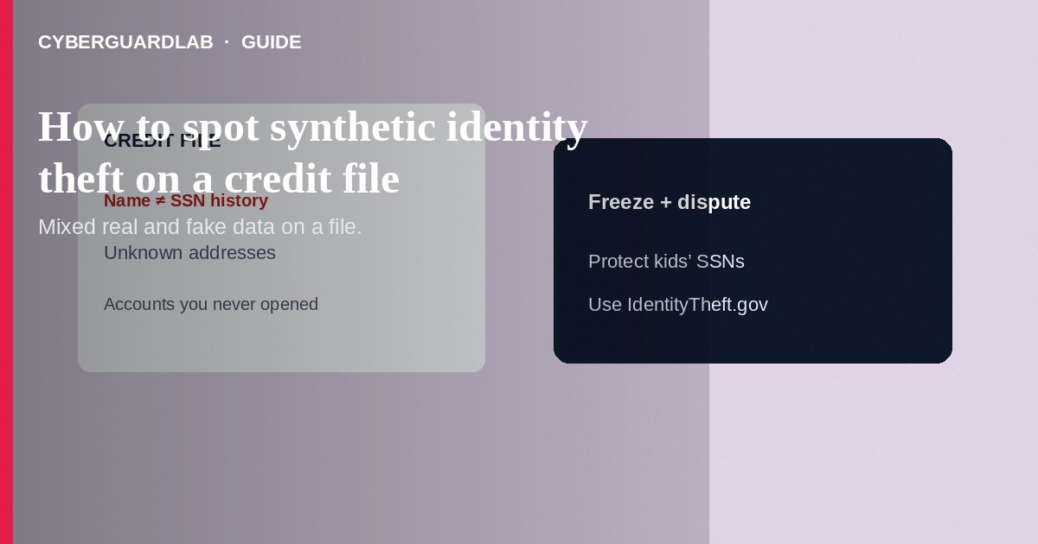
Synthetic identity theft mixes real data (often a child’s or unused SSN) with invented names, dates of birth, or addresses to build a credit file that looks new—then runs up credit the victim may only discover years later. On your reports, warning signs include accounts or personal data that are not yours, thin files that suddenly expand, or inquiries tied to a persona you do not recognize. Pull free reports, freeze credit, and dispute foreign accounts; use IdentityTheft.gov when SSN misuse is clear. This guide is about spotting synthetic patterns on credit files—not the mechanics of ordering free reports alone, not placing freezes alone, and not a routine card charge dispute for a known card you own.

1. What synthetic identity theft looks like
Traditional identity theft often hijacks your exact name and existing accounts. Synthetics invent a hybrid person: your SSN (or a child’s) plus another name, or a fabricated profile that slowly establishes credit with secured cards and store accounts. Parents may first notice when a teen is denied credit or receives preapproval mail for accounts they never started. Adults may see tradelines, addresses, or employers that belong to nobody in the household.
Paid link
Norton 360 | See the Norton first-year offer

See the Norton first-year offer
Offer page: https://cyberguardlab.com/norton
Because the file is “new,” automated matching systems sometimes fail to flag it until lenders lose money—or until you pull a report and do not recognize the biography.
School, medical, and benefits paperwork can expose children’s SSNs. Treat mail for credit offers addressed to a minor as urgent. Freeze early and teach teens to reject “easy starter credit” DMs that ask for SSN photos.

2. Legitimate file vs synthetic red flags
Cue | Likely normal | Investigate as possible synthetic / mixed file
Name / SSN pairing | Matches your legal identity across bureaus | Your SSN with a different name or multiple primary names
Addresses | Places you lived | Unknown cities or long-running addresses you never used
Accounts | Cards and loans you opened | Store cards, utilities, or autos in a persona you do not know
Age of file | History that tracks your adult life | Brand-new file on a child’s SSN, or sudden history that is not yours
Inquiries | Applications you made | Clusters of hard pulls before accounts you never authorized
Collections | Debts you recognize | Medical or telecom collections for a stranger’s date of birth

3. Steps if you suspect a synthetic on your file
- Order free reports from all three bureaus via AnnualCreditReport.com and save PDFs.
- Highlight every personal-info mismatch and unrecognized account or inquiry.
- Place a credit freeze at Equifax, Experian, and TransUnion immediately.
- File an IdentityTheft.gov report and generate an FTC Identity Theft Report for disputes.
- Dispute fraudulent or mixed-file items with each bureau and with furnishers in writing; attach your FTC report where applicable.
- For a child’s SSN, check whether a file exists, freeze the child’s credit where available, and follow FTC child identity theft guidance.
- Ask lenders on fraudulent accounts to flag them as fraud—not merely “not mine” payment disputes—when identity crime is involved.
- Monitor for tax or SSA issues if the SSN was used for wages; use official IRS and SSA channels you open yourself.

4. If collectors contact you on synthetic accounts
- Do not pay to “make it go away” before verifying. Get debt validation in writing.
- Explain suspected identity theft; send your FTC report and dispute letters.
- Keep a log of calls, account numbers, and bureau dispute results.
- Report ongoing fraud at ReportFraud.ftc.gov if new accounts appear.
- Harden email and devices—synthetics often start with stolen SSNs from breaches or phishing. Scan with a trusted tool such as Norton or Bitdefender if you clicked related lures. Keep one primary real-time antivirus—avoid stacking full suites. TotalAV, McAfee, and Avast are other on-site comparison options.

FAQ

How is synthetic identity theft different from ordinary account takeover?
Account takeover abuses cards or logins you already have. Synthetics build or attach credit using mixed or invented identity elements—often invisible until you read bureau files.

Can a child have a credit file?
Children usually should not. A file on a minor’s SSN is a major red flag for synthetic or fraud activity.

Will a freeze stop an existing synthetic file?
A freeze helps block new accounts. You still must dispute and correct existing fraudulent tradelines and personal data.

Why might only one bureau show the fake accounts?
Synthetic and mixed files can appear unevenly. Always check all three nationwide bureaus.

If you still want a paid suite
Avoiding how to spot synthetic identity theft on a credit file does not require paid antivirus. Careful habits and official support paths are a valid buy-nothing stack. If you want multi-device paid protection later, use only these on-site paid links: TotalAV (paid link), Norton (paid link), Bitdefender (paid link), McAfee (paid link), Avast (paid link).

Sources
- FTC / IdentityTheft.gov
- FTC: Free credit reports
- FTC: Credit freezes and fraud alerts
- AnnualCreditReport.com
- FTC: Child identity theft

Also read
- How to place a credit freeze at all three bureaus
- How to get a free annual credit report and read it
- How to dispute a fraudulent credit card charge
- How to replace a stolen Social Security card safely
- Credit card fraud: first hour

