
How to turn on Stolen Device Protection recovery contacts
https://cyberguardlab.com/blog/stolen-device-protection-recovery-contacts
Independent US household comparison site. Not the vendor. Paid links below may earn a commission. Confirm first-year price, renewal, device limit, and refund terms at checkout.
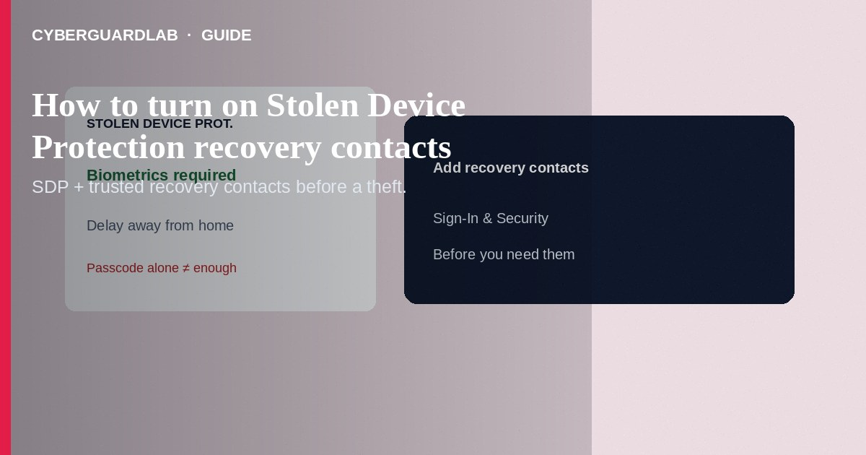
Stolen Device Protection makes Face ID or Touch ID (not just the passcode) required for many sensitive actions—and adds a security delay away from familiar locations—so a thief who watched you type the passcode cannot quickly empty passwords or change Apple Account settings. Pair it with at least one trusted Apple Account recovery contact so you can regain access if you are locked out after a theft. This how-to is about SDP + recovery contacts—not checking configuration profiles, not erasing a lost Apple Watch, and not Safari passkeys.

1. Why both features together
Thieves often learn the passcode in a café or transit setting, then change the Apple Account password and lock you out. SDP blocks passcode-only shortcuts for critical changes. Recovery contacts do not see your account; they can give you a recovery code during Apple’s official recovery flow if you lose access.
Paid link
Norton 360 | See the Norton first-year offer

See the Norton first-year offer
Offer page: https://cyberguardlab.com/norton
Anyone who phones you after a theft and asks you to install remote support apps or read aloud a recovery code is not your recovery contact. Only you start Apple’s recovery UI; only your pre-chosen contact generates a code on their device when you ask in person or by a channel you trust.

2. SDP vs recovery contact vs Find My
Feature | Job | Does not do
Stolen Device Protection | Hardens sensitive changes when passcode may be known | Locate the phone on a map
Recovery contact | Helps you reset Apple Account access with a code they generate | Give them inbox or photo access
Find My / Mark as Lost | Locate, lock, erase; keep Activation Lock | Replace a strong passcode or SDP

3. Steps: Stolen Device Protection and recovery contacts
Steps: turn on Stolen Device Protection
- Update to a current iOS that supports Stolen Device Protection. Set a strong device passcode and ensure Face ID or Touch ID works reliably.
- Open Settings → Face ID & Passcode (or Touch ID & Passcode) → enter the passcode.
- Turn on Stolen Device Protection. Read the on-device explanation of biometric requirements and the security delay away from familiar locations.
- Confirm Find My is on (Settings → [Your Name] → Find My) so you can Mark as Lost later.
- Practice: know that away from home/work, some Apple Account and password changes will require biometrics and a wait—plan recovery contacts before you need them.
Steps: add recovery contacts
- On iPhone: Settings → [Your Name] → Sign-In & Security → Recovery Contacts.
- Tap Add Recovery Contact, authenticate, and choose a trusted person (Family Sharing members may be suggested).
- They must accept on a compatible Apple device with two-factor authentication. You can add more than one (Apple documents up to five).
- Tell them privately how you will contact them in a real lockout—never share recovery codes with strangers who claim to be Apple Support.
- Optionally review a recovery key only if you already understand the lockout risk of losing that key; do not invent parallel “unlock services.”

4. After a theft
- Mark as Lost from another Apple device or icloud.com/find; change the Apple Account password from a trusted device when SDP and account state allow.
- Do not give passcodes or Face ID enrollments to “Apple Support” callers—see fake support patterns in earlier guides.
- Use your recovery contact only inside Apple’s recovery screens you open yourself.

FAQ

Does SDP replace Find My?
No. Turn on both. SDP protects account and password changes; Find My helps locate and lock the device.

Will recovery contacts see my iCloud photos?
No. They only provide a recovery code when you ask during official recovery.

Can I turn SDP off easily if a thief has the phone?
Away from familiar locations, turning SDP off and changing critical settings is designed to be hard without biometrics and delays—that is the point.

Is this the same as a Google Find My Device setup?
No. Google’s lost-device tools are separate—see Google Find My Device setup for Android.

If you still want a paid suite
Avoiding how to turn on Stolen Device Protection recovery contacts does not require paid antivirus. Careful habits and official support paths are a valid buy-nothing stack. If you want multi-device paid protection later, use only these on-site paid links: TotalAV (paid link), Norton (paid link), Bitdefender (paid link), McAfee (paid link), Avast (paid link).

Sources
- Apple Support: About Stolen Device Protection
- Apple Support: If your iPhone or iPad was stolen
- Apple Support: Set up a recovery contact
- FTC: Phone security basics

Also read
- How to check for configuration profiles on iPhone
- How to erase an Apple Watch after it is lost
- How to use Safari passkeys instead of passwords on iPhone
- How to turn on Find My and Activation Lock before travel
- How to recover an Apple ID without SMS access

