
How to spot a solar or clean energy rebate scam
https://cyberguardlab.com/blog/solar-clean-energy-rebate-scam
Independent US household comparison site. Not the vendor. Paid links below may earn a commission. Confirm first-year price, renewal, device limit, and refund terms at checkout.
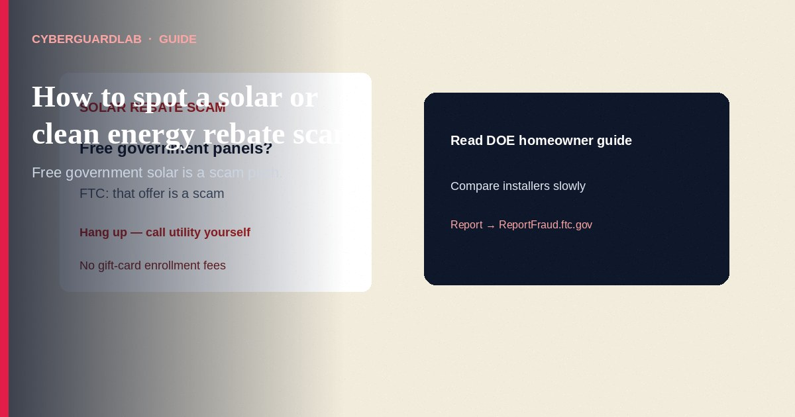
A solar or clean energy rebate scam is when someone claims to be from the government or your utility and promises free or no-cost solar panels, huge rebates, tax credits, or an “energy audit” signup—then pressures you for money or personal data. The FTC states that the federal government does not install solar systems in homes for free, and that “free” or “no cost” panel offers are scams. This guide covers solar / clean energy rebate and utility-impersonation pitches (calls, door knocks, social ads). It is not a utility shutoff threat guide and not a general government grant scam overview.

How solar and clean energy scams usually work
- Unexpected contact — Phone call, social message, or in-person visit offering an “energy audit” or “free” efficiency program.
- Government or utility costume — They claim affiliation with your utility or a government program. They are not.
- Free panels / huge rebates — Promises of free or low-cost solar, oversized rebates, tax credits, or utility incentives that do not match reality.
- “You’re already enrolled—pay now” — Some say the utility already signed you up and you must pay to continue.
- Pressure + risky payment — Demand for immediate contract signature or payment by cash, gift card, wire, payment app, or cryptocurrency—tactics the FTC links to imposters.

Red flags before you sign or pay
Cue | Safer habit | Scam signal
Paid link
Norton 360 | See the Norton first-year offer

See the Norton first-year offer
Offer page: https://cyberguardlab.com/norton
Who started contact | You researched installers; checked DOE homeowner guidance | Cold call, door knock, or “qualify by ZIP” social ad you did not request
“Free” panels | Treat free/no-cost federal installs as false (FTC) | “Government program / free solar if you live in this ZIP”
Time pressure | Take days to compare quotes and read contracts | Sign today, limited spots, pay a fee before any paperwork review
Payment method | Normal contractor invoices you can verify | Gift cards, wires, crypto, payment apps, or cash-only “enrollment”
Personal data ask | Share details only with a company you chose after research | Unexpected form “to see if you qualify” on social media

Steps: what to do when a solar rebate pitch arrives
- Pause — Do not pay, sign, or give SSN/bank details on the spot.
- Reject “free government solar” claims — FTC: the federal government does not install home solar for free; “free” or “no cost” panel offers are scams.
- Verify the utility yourself — Hang up. Call the customer number on your bill or the utility’s official site (typed by you)—not a number from the caller.
- Read real consumer guides before any contract — Start with the Department of Energy Homeowner’s Guide to Solar and FTC solar/clean-energy alerts. DOE also points to Treasury/CFPB/FTC advisory materials on shopping tips and reporting bad actors.
- Compare certified installers — Prefer qualified professionals (DOE notes NABCEP as an industry-standard certification). Get multiple written quotes; understand buy vs lease vs PPA before signing.
- Protect personal information — Do not answer unexpected social or online requests for name/address “to see if you qualify.” FTC: that may be lead-selling or identity theft.
- If you already paid or signed under pressure — Document everything, contact your bank/card issuer, consider CFPB complaints for financing issues (consumerfinance.gov), and report at ReportFraud.ftc.gov.

Safer home-energy shopping habits (buy-nothing)
- Real incentives and tax credits (when they exist) are researched on official sites—not invented by a door-to-door closer.
- Legitimate sellers give you time; imposters push urgent payment methods the FTC flags.
- Family rule: no solar “enrollment fee” by gift card or crypto.
- This is mostly a judgment and paperwork problem. Paid antivirus does not replace reading the contract. Buy-nothing is valid.

FAQ

Are all solar companies scams?
No. Many households go solar successfully. The FTC and DOE focus on imposters and deceptive “free rebate” pitches—not on banning legitimate installs.

Someone said my utility already enrolled me. Is that possible?
FTC describes that line as a scam tactic. Confirm with the utility through a number you look up yourself.

Where can I learn legitimate homeowner solar basics?
Use the Department of Energy Homeowner’s Guide to Solar and related DOE smart-shopping tips linked from that guide.

What if the financing feels confusing?
Pause. DOE and partner guides explain loans, leases, and PPAs. Confusing pressure plus unusual payment methods is a reason to walk away and report.

Do I need paid antivirus to avoid solar rebate scams?
No. Verifying callers, rejecting free-panel claims, and reporting to the FTC are enough for most households.

If you still want a paid suite
Spotting a solar rebate scam does not require paid antivirus. If you still want multi-device paid protection, use only these on-site links: Norton (paid link), Bitdefender (paid link), TotalAV (paid link), McAfee (paid link), Avast (paid link).

Extra caution
A branded vest or a PDF “utility letter” does not prove a government solar program. Check DOE/FTC guidance, call your utility yourself, and never pay enrollment fees with gift cards.

Sources
- FTC: How to avoid getting burned by solar or clean energy scams
- FTC: Don’t waste your energy on a solar scam
- DOE: Homeowner’s Guide to Solar
- FTC: How to avoid a scam
- FTC: eBay seller impersonation scam
- ReportFraud.ftc.gov
- CFPB consumer finance

Also read
- Utility shutoff scam
- Government grant scam
- eBay seller impersonation scam
- Is Microsoft Defender enough?
- Clicked a phishing link: first hour
- Report identity theft at IdentityTheft.gov

