
How to segment smart TVs and cameras on a separate VLAN
https://cyberguardlab.com/blog/smart-tv-camera-vlan-segment
Independent US household comparison site. Not the vendor. Paid links below may earn a commission. Confirm first-year price, renewal, device limit, and refund terms at checkout.
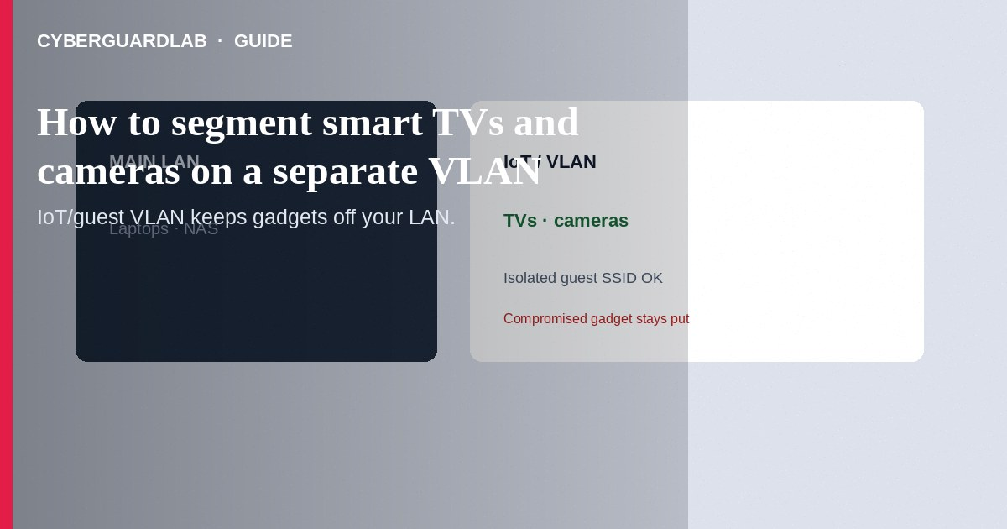
Put smart TVs and cameras on a separate VLAN or isolated IoT/guest SSID so a compromised gadget cannot freely scan laptops and NAS on your main LAN. You need a router or firewall that supports VLANs/guest isolation (or a mesh vendor’s “IoT network” feature). This how-to is LAN segmentation—not Android Private DNS, not WPA3 alone, and not ISP phishing.

1. What you need
- Router/firewall/AP firmware with VLAN, “guest network,” or “IoT network” controls (prosumer and many mesh systems).
- Ability to set a second SSID or wired VLAN membership for TVs/cameras.
- Optional: firewall rules blocking IoT → LAN while allowing IoT → internet (and limited LAN → IoT if you use a viewing app).
Exact menus differ by vendor—use the vendor manual for click-by-click paths; the pattern below is portable.
Paid link
Norton 360 | See the Norton first-year offer

See the Norton first-year offer
Offer page: https://cyberguardlab.com/norton
Convenience casting is why many homes skip isolation. If a cheap camera is wormed, flat LANs hand attackers a path to file shares—segment first, then open only the ports you prove you need.

2. VLAN vs Private DNS vs WPA3
Control | Primary job | Not a substitute for
IoT VLAN / guest SSID | Isolate device groups on LAN | DNS-over-TLS on phones
Private DNS | Encrypt DNS on one Android device | Stopping camera↔laptop LAN worms
WPA3 | Strong Wi-Fi handshake | Separating trusted vs untrusted devices once joined

3. Steps: segment TVs and cameras
- Update the router/AP firmware from the official vendor source.
- Create a new IoT / Guest network or VLAN ID (example pattern: VLAN 20 named `iot`).
- Assign a dedicated SSID (e.g., `Home-IoT`) to that VLAN; use strong WPA2/WPA3 settings appropriate for those clients.
- Enable client/AP isolation on that SSID if you do not need camera-to-camera chatter.
- Firewall defaults to prefer: IoT may reach the internet; IoT may not initiate connections to your main LAN; your phone on main LAN may reach cameras only on required ports if the app needs it—or use the vendor cloud (understand the privacy tradeoff).
- Move smart TVs and cameras onto `Home-IoT` (forget the old SSID on each device).
- Keep PCs, phones, and NAS on the main LAN/SSID.
- Test: phone on main LAN still streams the camera app if that is required; a TV on IoT should not see your NAS shares.
- Document the VLAN ID and SSID in your household notes.
- Recheck IoT update support so segmented devices still get patches.

4. If your ISP gateway cannot VLAN
- Add your own router behind the ISP modem in true router mode (avoid double-NAT surprises—follow vendor guidance).
- Or use the gateway’s Guest Wi-Fi as a lighter isolation layer when full VLANs are unavailable.
- Still change router admin credentials and keep endpoints patched with Norton or Bitdefender (TotalAV, McAfee, Avast on-site).

FAQ

Will casting from phone to TV break?
Sometimes. You may need mDNS/reflection rules or keep the phone on a network that can reach the TV. Prefer vendor-documented cast ports over “allow all.”

Is guest Wi-Fi good enough?
Guest isolation is a practical middle ground when VLANs are unavailable. True VLANs give cleaner wired + wireless policy.

Does this stop ISP bill phishing?
No. Phishing is an account problem—see the ISP phishing guide.

Do cameras still need passwords?
Yes. Segmentation limits blast radius; unique camera passwords and updates remain mandatory.

If you still want a paid suite
Avoiding how to segment smart TVs and cameras on a separate VLAN does not require paid antivirus. Careful habits and official support paths are a valid buy-nothing stack. If you want multi-device paid protection later, use only these on-site paid links: TotalAV (paid link), Norton (paid link), Bitdefender (paid link), McAfee (paid link), Avast (paid link).

Sources
- CISA: Secure your home network
- FTC: Internet of Things security basics
- CISA: Internet of Things security tips
- Example vendor VLAN help (TP-Link Omada concept docs)

Also read
- How to turn on Private DNS on Android
- How to check if an IoT device still gets security updates
- How to set up a guest Wi-Fi network at home
- How to turn on WPA3 or the strongest Wi-Fi encryption you have
- How to change your router admin password safely

