
How to set a unique password on a smart doorbell
https://cyberguardlab.com/blog/smart-doorbell-unique-password
Independent US household comparison site. Not the vendor. Paid links below may earn a commission. Confirm first-year price, renewal, device limit, and refund terms at checkout.
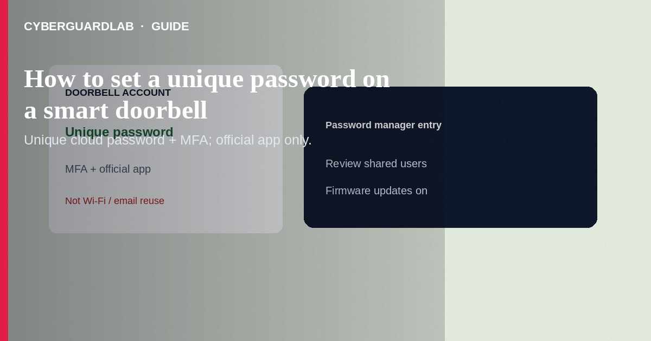
Give your smart doorbell (and its cloud account) a unique long password stored in a password manager—never reuse your email, Amazon, or Wi-Fi passphrase. Finish with MFA, app authenticity checks, and firmware updates. This how-to is doorbell / camera account credentials—not fake smart-home apps deep-dives alone, not NAS hardening, and not household password-manager rollout.

1. Steps: unique doorbell credentials
- Install only the official app (box QR or brand site)—spot clones first via fake smart-home app cues.
- Create or sign in to the doorbell vendor account (Ring, Google Nest, Arlo, etc.).
- Generate a unique password in your password manager (12+ random characters or a long passphrase). Do not reuse Gmail/iCloud/Microsoft passwords.
- Enable the vendor’s two-factor / verification codes (app or hardware key when offered).
- Change any device PIN/passcode used for local settings if separate from the cloud password.
- Use a strong, unique Wi-Fi passphrase on the home network; guest/IoT SSID when available—see VLAN segment for cameras.
- Turn on automatic firmware updates in the official app; confirm the device still receives patches—IoT updates check.
- Review shared-user invites; remove ex-roommates and unknown emails.
- Store the password only in the manager (or a sealed offline backup)—not on a sticky note by the door chime.
One shared doorbell password in a group text becomes tomorrow’s breach when a phone is lost. Prefer vendor multi-user invites with individual sign-ins.
Paid link
Norton 360 | See the Norton first-year offer

See the Norton first-year offer
Offer page: https://cyberguardlab.com/norton

2. Safer vs weaker doorbell habits
Habit | Safer | Weaker
Cloud password | Unique + manager + MFA | Same as email / “password123”
App source | Official publisher | Look-alike store listing
Sharing | Named family accounts | One login texted to everyone
Network | Updated router; IoT segment | Default Wi-Fi + UPnP wide open

3. Steps: unique doorbell credentials
- Install only the official app (box QR or brand site)—spot clones first via fake smart-home app cues.
- Create or sign in to the doorbell vendor account (Ring, Google Nest, Arlo, etc.).
- Generate a unique password in your password manager (12+ random characters or a long passphrase). Do not reuse Gmail/iCloud/Microsoft passwords.
- Enable the vendor’s two-factor / verification codes (app or hardware key when offered).
- Change any device PIN/passcode used for local settings if separate from the cloud password.
- Use a strong, unique Wi-Fi passphrase on the home network; guest/IoT SSID when available—see VLAN segment for cameras.
- Turn on automatic firmware updates in the official app; confirm the device still receives patches—IoT updates check.
- Review shared-user invites; remove ex-roommates and unknown emails.
- Store the password only in the manager (or a sealed offline backup)—not on a sticky note by the door chime.

4. If the account was reused or phished
- Change the doorbell cloud password immediately; sign out other sessions in the vendor app/web.
- Change the email password if it was the same; enable MFA there too.
- Review event history for unfamiliar viewers.
- Scan phones/PCs with Norton or Bitdefender; keep one primary product (TotalAV, McAfee, Avast).

FAQ

Is the Wi-Fi password enough?
No. Attackers who phish the cloud account can view live video without your Wi-Fi key.

How is this different from a household password-manager setup?
This article sets one IoT account correctly. A household manager rollout covers all family logins systematically.

Do passkeys work on doorbell brands?
Support varies. Use whatever MFA the vendor offers today; add passkeys on Google/Apple/Microsoft accounts that recover the doorbell email.

Should I disable the doorbell mic/camera when home?
Optional privacy preference—still keep the account password unique either way.

If you still want a paid suite
Avoiding how to set a unique password on a smart doorbell does not require paid antivirus. Careful habits and official support paths are a valid buy-nothing stack. If you want multi-device paid protection later, use only these on-site paid links: TotalAV (paid link), Norton (paid link), Bitdefender (paid link), McAfee (paid link), Avast (paid link).

Sources
- CISA: Secure our world — Use strong passwords
- FTC: How to secure your home Wi-Fi network
- Example vendor help (Ring account security)
- Example vendor help (Google Nest account)

Also read
- How to spot a fake smart-home app on the app store
- How to set up a password manager for a US household
- How to segment smart TVs and cameras on a separate VLAN
- How to check if an IoT device still gets security updates
- How to turn on passkeys for Google, Apple, and Microsoft

