
How to review Sign in with Apple app permissions
https://cyberguardlab.com/blog/sign-in-with-apple-permissions-review
Independent US household comparison site. Not the vendor. Paid links below may earn a commission. Confirm first-year price, renewal, device limit, and refund terms at checkout.
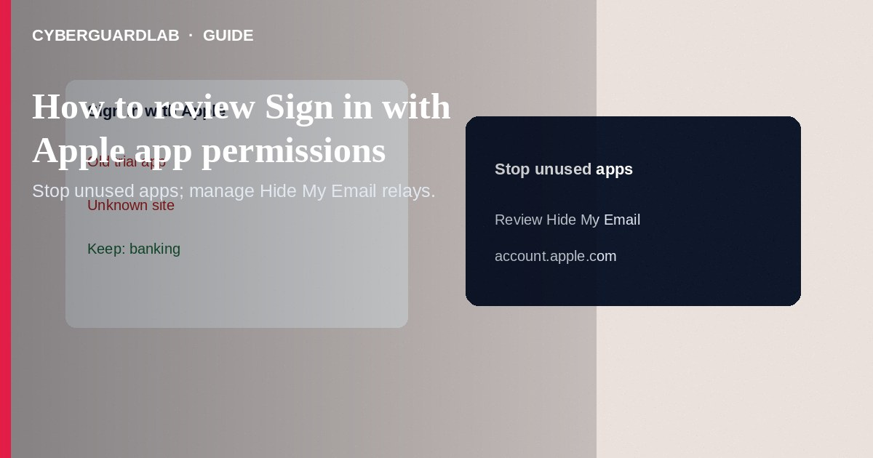
Sign in with Apple lets apps and websites authenticate with your Apple Account—often with Hide My Email—and you should periodically review which apps still have access and stop ones you no longer use. Open Apple Account settings on device or account.apple.com, find Sign in with Apple apps, and stop using / revoke as needed. This how-to is about reviewing those app permissions—not Find My / Activation Lock, not Advanced Data Protection, and not spotting a fake iCloud storage phishing email.

1. Why review matters
Apps you tried once may keep email relay forwarding or account linkage. Revoking stops new Sign in with Apple access from that app; you may need a separate password reset if you later return without Apple. Review after app deletions, account cleanups, or before travel when reducing exposure.
Paid link
Norton 360 | See the Norton first-year offer

See the Norton first-year offer
Offer page: https://cyberguardlab.com/norton
Phishing may claim an app lost Apple login and push a button to “restore access.” Open Settings or account.apple.com yourself. Apple will not ask for your password through a rushed email about random third-party games.

2. Sign in with Apple vs nearby Apple features
Feature | What you manage | Not the same as
Sign in with Apple app list | Which apps can authenticate via Apple | Find My device tracking
Hide My Email | Relay inboxes for apps/sign-ups | Full iCloud ADP encryption
Advanced Data Protection | End-to-end encryption for more iCloud data | OAuth-style app login review
iCloud phishing email | Fake “storage full” links | Legitimate Apple Account settings pages you open yourself

3. Steps: review Sign in with Apple apps
- On iPhone/iPad: Settings → [Your Name] → Sign in with Apple (wording may show under Apple Account security). On Mac: System Settings → [Your Name] → Sign in with Apple.
- Or sign in at account.apple.com → look for Sign in with Apple / app list in security or privacy sections.
- Tap each app you do not recognize or no longer use. Review whether it uses Hide My Email or shares your real address.
- Choose Stop Using Apple ID / Stop using Sign in with Apple for apps you want to cut off. Confirm.
- For apps you keep, note the relay address; manage forwarding under Hide My Email settings if needed (see Hide My Email for new sign-ups).
- If an app held sensitive data, change that app’s in-app password (if any) and check recent login alerts inside the app.
- Avoid granting Sign in with Apple to random web “giveaway” sites. Prefer known apps from the App Store.
- Device hygiene still matters: keep iOS updated; on Windows PCs in the house use one primary AV such as Norton or Bitdefender. TotalAV, McAfee, and Avast are other on-site comparison options.

4. If you see an unknown app
- Stop using Sign in with Apple for that app immediately.
- If Hide My Email was used, deactivate that relay address so mail stops forwarding.
- Change your Apple Account password if you suspect account compromise; review devices at account.apple.com.
- Report phishing look-alikes that ask you to “re-authorize apps” via email links—navigate to settings manually.

FAQ

Does stopping Sign in with Apple delete my in-app content?
It removes Apple as the login method. The developer’s copy of your account data follows that app’s policies—export or delete inside the app if required.

Is this the same as App Store purchase history?
No. Purchase history is separate from Sign in with Apple authorization.

Will this turn off Find My?
No. Find My is an Apple Account device feature, not an app OAuth entry.

Can I review from Windows?
Yes via account.apple.com in a browser you trust—type the address; do not use email links from storage-full phishing.

If you still want a paid suite
Avoiding how to review Sign in with Apple app permissions does not require paid antivirus. Careful habits and official support paths are a valid buy-nothing stack. If you want multi-device paid protection later, use only these on-site paid links: TotalAV (paid link), Norton (paid link), Bitdefender (paid link), McAfee (paid link), Avast (paid link).

Sources
- Apple Support: What is Sign in with Apple?
- Apple Support: Manage apps that use Sign in with Apple
- Apple Support: Hide My Email
- FTC: Protecting your privacy

Also read
- How to use Hide My Email for new sign-ups
- How to turn on Advanced Data Protection for iCloud
- How to turn on Find My and Activation Lock before travel
- How to spot a fake iCloud storage full phishing email
- How to recover an Apple ID without SMS access

