
How to secure a home NAS or personal cloud drive
https://cyberguardlab.com/blog/secure-home-nas-personal-cloud
Independent US household comparison site. Not the vendor. Paid links below may earn a commission. Confirm first-year price, renewal, device limit, and refund terms at checkout.
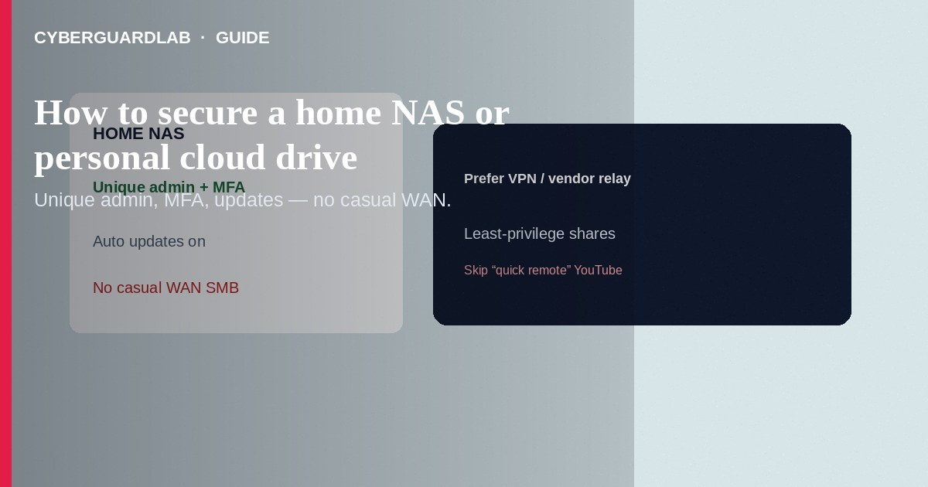
Secure a home NAS or personal cloud drive by unique admin credentials, automatic updates, MFA where offered, least-privilege shares, and no casual WAN exposure. Prefer VPN or the vendor’s signed cloud relay over opening SMB/RDP to the internet. This how-to is NAS/personal cloud hardening—not turning off UPnP alone, not smart-doorbell passwords, and not password-manager vault recovery.

1. Baseline hardening steps
- Create a strong unique admin password in a password manager; disable default `admin` if the vendor allows renaming.
- Create separate user accounts for each person/app; never share the admin login for daily file access.
- Enable 2FA/MFA on the NAS cloud account and on any remote-access portal the vendor provides.
- Install firmware and package updates from the vendor’s official channel only—check IoT / device update status habits apply here too.
- Turn off unused services (Telnet, older SMB1, public guest shares, anonymous FTP).
- Keep UPnP off on the router; avoid automatic port opens—see turn off UPnP.
- If you need remote files: use the vendor’s official app/cloud, or a VPN you control—not raw SMB on port 445 to the world.
- Put the NAS on a trusted LAN or IoT segment; limit which VLANs can reach admin ports when your router supports it.
- Enable volume encryption options the vendor documents; keep recovery keys offline.
- Test restores from backups; ransomware that encrypts a NAS is a common household incident path.
Tutorials that tell you to DMZ the NAS or expose the admin UI on port 5000/5001 to the internet skip basic threat modeling. Prefer vendor-documented secure remote access.
Paid link
Norton 360 | See the Norton first-year offer

See the Norton first-year offer
Offer page: https://cyberguardlab.com/norton

2. Safer vs riskier NAS habits
Area | Safer | Riskier
Remote access | Vendor cloud / VPN + MFA | WAN port forward to SMB/RDP/admin UI
Accounts | Per-user + least share rights | Everyone uses admin
Updates | Official firmware on a schedule | Years-old OS packages “because it works”
Shares | Private folders; guest off | World-readable “media” share on the WAN

3. Baseline hardening steps
- Create a strong unique admin password in a password manager; disable default `admin` if the vendor allows renaming.
- Create separate user accounts for each person/app; never share the admin login for daily file access.
- Enable 2FA/MFA on the NAS cloud account and on any remote-access portal the vendor provides.
- Install firmware and package updates from the vendor’s official channel only—check IoT / device update status habits apply here too.
- Turn off unused services (Telnet, older SMB1, public guest shares, anonymous FTP).
- Keep UPnP off on the router; avoid automatic port opens—see turn off UPnP.
- If you need remote files: use the vendor’s official app/cloud, or a VPN you control—not raw SMB on port 445 to the world.
- Put the NAS on a trusted LAN or IoT segment; limit which VLANs can reach admin ports when your router supports it.
- Enable volume encryption options the vendor documents; keep recovery keys offline.
- Test restores from backups; ransomware that encrypts a NAS is a common household incident path.

4. If you suspect compromise
- Disconnect WAN temporarily; keep local console access if needed.
- Change admin and user passwords from a known-clean PC.
- Review logged-in sessions, shared links, and unexpected admin accounts.
- Reinstall/reset per vendor guidance if persistence is suspected; restore from a clean backup.
- Scan household PCs with Norton or Bitdefender; keep one primary product (TotalAV, McAfee, Avast).

FAQ

Is a Synology / QNAP / TrueNAS “personal cloud” the same as Google Drive?** Functionally similar for file sync, but **you** own the patching and exposure decisions. Treat admin access like a mini-server. **Can I leave UPnP on “just for the NAS”?
Better to disable UPnP and use documented remote methods. Auto port mapping is easy to forget.

Do I need antivirus on the NAS?
Follow vendor guidance. Always keep the PCs that mount shares protected and patched.

How is this different from securing a smart doorbell?
Doorbells are single-purpose IoT with vendor apps. A NAS holds bulk personal files and often runs many services—higher impact if breached.

If you still want a paid suite
Avoiding how to secure a home NAS or personal cloud drive does not require paid antivirus. Careful habits and official support paths are a valid buy-nothing stack. If you want multi-device paid protection later, use only these on-site paid links: TotalAV (paid link), Norton (paid link), Bitdefender (paid link), McAfee (paid link), Avast (paid link).

Sources
- CISA: Secure your home network
- FTC: Protecting your computer from ransomware
- CISA: Stopransomware (general guidance)
- Example vendor security tips (Synology)

Also read
- How to turn off UPnP on a home router
- How to segment smart TVs and cameras on a separate VLAN
- How to change your router admin password safely
- How to set up a password manager for a US household
- How to check if an IoT device still gets security updates

