
How to spot a school parent portal phishing email
Read online: https://cyberguardlab.com/blog/school-parent-portal-phishing
Published September 25, 2026 · Updated September 25, 2026
Short answer
Ignore links in unexpected parent-portal emails or texts; sign in only through your district’s known website or official app bookmark; never pay school fees from a cold message.
Advertising disclosure: CyberGuardLab is an independent comparison site. We are not TotalAV, Norton, Bitdefender, McAfee, or Avast. If you buy through our links, we may earn a commission, which can affect ranking and placement.
Independent US household comparison site. Not the vendor. Paid links below may earn a commission. Confirm first-year price, renewal, device limit, and refund terms at checkout.
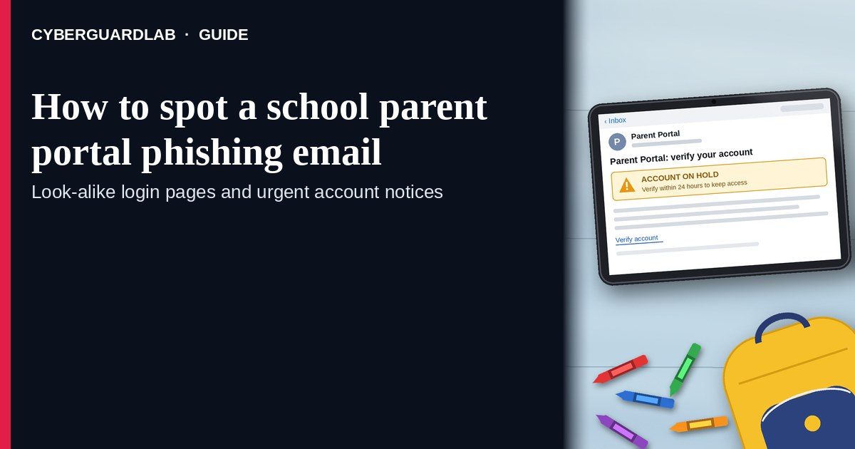
A school parent portal phishing email (or text) is designed to look like PowerSchool, Infinite Campus, Canvas, ClassDojo, or your district’s Google / Microsoft school login — then steal the password, harvest a one-time code, or push a fake fee payment. Real districts do send portal notices. The safe habit is the same as other phishing: do not trust the link inside an unexpected message; open the parent portal only from a bookmark or school website URL you typed yourself, or from the official app you already installed. Never pay tuition, Chromebook fees, lunch balances, or “urgent holds” from a cold email link. This pattern is distinct from a scholarship application fee scam and an unpaid internship fee scam (different lure, same “pay now or lose access” pressure). CyberGuardLab is independent. Referral fees may affect product placement on other pages. Buying nothing and sticking to free verification habits is a valid outcome.

The short answer
Ignore links in unexpected parent-portal emails or texts; sign in only through your district’s known website or official app bookmark; never pay school fees from a cold message.
Paid link
Norton 360 | See the Norton first-year offer

See the Norton first-year offer
Offer page: https://cyberguardlab.com/norton
Ad link: https://trysecurities.com/offer/norton?dtm=gg&cid=

What parent-portal phishing usually looks like
Scammers copy school branding because parents are busy and the stakes feel high: grades, attendance, bus routes, lunch money, enrollment holds.
Common shapes US households report:
- “Urgent login required” email naming PowerSchool, Infinite Campus, Canvas, or “District Parent Portal” with a button that goes to a look-alike domain.
- Fake fee / lunch / Chromebook / activity hold that must be paid in the next few hours or the student “cannot attend.”
- Password-reset or “verify your parent account” message you did not request.
- Text with a short link to “view a new report card” or “confirm emergency contacts.”
- Follow-up after a click — a page that asks for the school password plus a one-time code from SMS or authenticator, then empties related email or payment accounts.
FTC phishing guidance: unexpected messages that claim account problems or ask you to confirm payment are classic bait; do not click; contact the organization using a phone number or website you already know is real; forward phishing email to reportphishing@apwg.org and report at ReportFraud.ftc.gov. CISA’s social-engineering guidance matches: verify through a channel you initiate.
A real portal notice from your district is a different product. If the school app already shows the same alert after you open it yourself, act inside that signed-in session — not inside the email.

Portal phishing vs scholarship fee vs unpaid internship fee
Signal | Parent portal phishing | Scholarship application fee scam | Unpaid internship fee scam
Opening hook | “Portal locked / fee due / grades ready — log in now.” | “Pay a processing fee to release scholarship money.” | “Pay for training / background / equipment to start the unpaid role.”
Ask | Password, OTP, card on a look-alike portal. | Application or “release” fee to a stranger. | Upfront fee to a stranger employer.
Pressure | Student cannot attend class tomorrow. | Deadline to claim aid. | Offer expires today.
Safe next step | Bookmark / school site only; call the school office number you already have. | Real aid does not require surprise fees to strangers — see scholarship guide. | Legitimate unpaid roles do not charge you to start — see internship guide.
Related guide | This page · How to spot a phishing email | Scholarship application fee scam | Unpaid internship fee scam
If the message is only about a password you did not reset, treat it like general phishing — still verify on the real portal, not the email button.

How to verify a parent portal message (US household steps)
Do this when any unexpected school login or fee claim appears. You do not need a paid product to finish these steps.
- Do not click the button, open the attachment, or reply with codes. Close the email or text. Hover or long-press only if you are documenting the URL for a report — do not visit it.
- Open the portal the way you already trust. Use a bookmark, the district website URL you type yourself, or the official PowerSchool / Infinite Campus / Canvas / Google app already on your phone — not a link from the message.
- Confirm fees only inside the signed-in portal or by calling the school. Lunch balances, Chromebook fees, and activity charges should appear in the real system or on a bill the school office confirms. Never pay from a cold email “Pay now” page.
- Protect the credentials that unlock everything else. School portals often share email addresses with family Gmail / Outlook accounts. Use a unique password and turn on two-factor authentication where the district offers it; our household walk-through is Turn on 2FA for Gmail, Apple, and bank accounts.
- If you already typed a password or paid on a fake page, treat the first hour as incident response. Change the portal password from a clean bookmark session (or call the school IT / office), change the matching email password, revoke unfamiliar sessions, watch bank/card statements, and follow Clicked a phishing link — first hour. Report the message to the school, forward phishing email to reportphishing@apwg.org when appropriate, and report at ReportFraud.ftc.gov. Checklist: How to report a scam to the FTC.
- Tell other caregivers on the account. Shared parent portals mean one person’s click can expose student data and linked payments. Agree that nobody pays school fees from unexpected email links.

Signs the message is fake or unsafe (scan table)
Use this as a quick pass before you spend money or time.
Sign | Why it matters | What to do
Sender domain is not your district’s known domain (or is a free Gmail/Outlook address claiming to be the school) | Display names are easy to fake | Ignore; open the real bookmark
Link goes to a look-alike spelling, URL shortener, or random cloud form | Credential and card theft | Never click; type the district site
Demands immediate card payment for tuition, holds, or “portal reactivation” | Fee phishing | Verify only in signed-in portal or school office
Asks for a one-time code “to unlock grades” | OTP theft for account takeover | Do not share; sign in yourself on the real app
Threatens suspension, police, or ICE-style consequences for a lunch balance | Fear used to skip verification | End contact; call the school office number you know
You did not expect a reset / new device login | Credential phishing | See general phishing guide; check real portal only

Free habits that reduce the blast radius
You do not need a new subscription to lower damage if a portal lure gets through.
- Save the real parent-portal URL as a bookmark on every caregiver’s phone.
- Unique password for the portal; 2FA when the district supports it.
- Household rule: school payments only inside the signed-in portal or the school’s published payment vendor — never from email.
- Mark obvious phishing as junk and report it to school IT when your district publishes a report path.
- Optional antivirus / web filtering is a separate layer after a bad click; it does not replace the bookmark habit.

What this page is not
This page is not a review of PowerSchool, Infinite Campus, or Canvas, not a district IT policy, and not legal advice about student records.
It does not claim CyberGuardLab lab scores or “#1 anti-phishing” ranks. It does not tell you to ignore a real fee you can see inside your signed-in district portal — it tells you to verify there, not in the email. Official recovery and reporting stay with your school/district IT contacts, ReportFraud.ftc.gov, and IdentityTheft.gov if personal data was stolen.

If you decide a paid extra is a real job
Most households can handle parent-portal phishing with the free steps above. Open a paid page only if you already named a job — for example broader web filtering, cross-device AV, or identity alerts after you gave a scammer personal data — and you will actually use it.
- PC / Mac suite with phishing and web protections many households already compare: Norton plans (paid link; confirm renewal price).
- Independent-test–oriented suite option: Bitdefender plans (paid link).
- Household suite shopping starting point: TotalAV plans (paid link; confirm renewal).
- Multi-device bill under one vendor: McAfee plans (paid link; confirm device limit).
- Another suite path some homes already use: Avast plans (paid link).
Buying nothing beyond free bookmark-and-verify habits is still valid. Paid links above are on-site only.

FAQ

Did my school really email that the parent portal is locked?
Maybe — but you cannot trust the email alone. Open the portal from your bookmark or the district website you type yourself. If nothing is wrong there, treat the message as phishing.

The email has a PowerSchool / Infinite Campus / Canvas logo. Is that enough?
No. Logos are trivial to copy. FTC phishing guidance focuses on urgency, unexpected payment asks, and suspicious links — not on whether a logo looks polished.

They want a lunch or Chromebook fee paid through the email link. What now?
Do not pay. Sign into the real portal or call the school office number from the school website / handbook. Cold-email payment pages are a common phishing endgame.

How is this different from scholarship or unpaid-internship fee scams?
Portal phishing steals school-login credentials or fakes K-12 district fees. Scholarship and internship fee scams target aid or job offers with upfront payments to strangers. Related: Scholarship application fee scam and Unpaid internship fee scam.

I already entered my portal password on a fake page. What should I do first?
Change the portal password from a clean bookmark session (or contact school IT), change the related email password, turn on 2FA where available, and follow Clicked a phishing link — first hour. Report at ReportFraud.ftc.gov and tell the school.

Do I need paid antivirus to spot these emails?
No. Spotting is a verification habit: ignore the link, use the bookmark, never pay from cold email. Antivirus can be a separate optional layer for malware after a bad click; it does not replace that habit.

Sources
- How To Recognize and Avoid Phishing Scams (FTC)
- Protect yourself from phishing scams (FTC)
- ReportFraud.ftc.gov
- IdentityTheft.gov
- Avoiding Social Engineering and Phishing Attacks (CISA)
- Phishing Guidance: Stopping the Attack Cycle at Phase One (CISA)
- Online Toolkit: Partnering to Safeguard K-12 Organizations (CISA)
- Anti-Phishing Working Group report address (reportphishing@apwg.org)

Also read
- How to spot a phishing email
- Clicked a phishing link: first hour
- Scholarship application fee scam
- How to report a scam to the FTC

