
How to spot a student scholarship application fee scam
https://cyberguardlab.com/blog/scholarship-application-fee-scam
Independent US household comparison site. Not the vendor. Paid links below may earn a commission. Confirm first-year price, renewal, device limit, and refund terms at checkout.
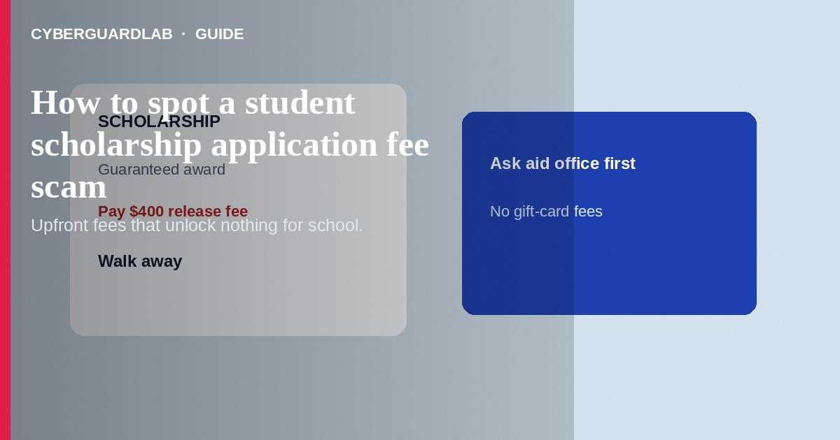
A student scholarship application fee scam charges you upfront to “apply,” “guarantee,” or “release” scholarship money that is fake or wildly misrepresented. Real scholarship searches should not require wiring fees, gift cards, or crypto to unlock an award. Do not pay strangers who guarantee free money for school.
Families and students are the audience here—not timeshare exits or IRS calls. Pressure often includes gift cards and overlaps with phishing emails. No software purchase required.
Paid link
Norton 360 | See the Norton first-year offer

See the Norton first-year offer
Offer page: https://cyberguardlab.com/norton

1. How scholarship application fee scripts work
- “You were selected” — Messages claim a limited grant is waiting or a portal needs a processing fee, insurance fee, or tax before funds can deposit (FTC scholarship scam guidance).
- Look-alike branding — Sites mimic .edu or federal aid language, or sell overpriced “exclusive” application lists after a hard sell.
- Seasonal pressure — Blasts spike around FAFSA season, graduation, and community-college transfers.
- Data harvest — Requests for Social Security numbers, student IDs, or parent bank details arrive by text or DM.
- Gift-card or wire unlock — Payment demands often include gift cards or wires similar to advance-fee patterns (StudentAid.gov scam resources).

2. Red flags before you pay
Cue | Likely legitimate | Likely scam
How you found it | School aid office, known foundation, or reputable search you initiated | Unsolicited DM, text, or “you are guaranteed” pop-up
Fees | Usually no fee to be considered; be skeptical of any upfront pay-to-win | Application fee, release fee, or tax required before any award posts
Guarantees | Competitive process with clear criteria | “Guaranteed $10,000 if you pay today”
Payment methods | Transparent school billing when a real institutional fee exists | Gift cards, wires, crypto, Cash App to a person
Data requests | Through official school or FAFSA channels you open yourself | SSN over text; photos of IDs to a stranger
Contact quality | Verifiable phone and web domains | Poor grammar plus urgency and secrecy from parents

3. Safer habits (buy-nothing)
- Start at your school's financial aid office or official website—not a cold link.
- Treat “guaranteed scholarship for a fee” as a red flag.
- Never pay with gift cards or crypto for financial aid access.
- Do not share SSN or banking data by text or DM.
- Search the organization name with the word “scam” and verify the domain carefully.
- For federal student aid questions, use official StudentAid.gov resources you type yourself.

4. If you already paid
- Stop further fees. Save receipts, chats, and site URLs.
- Contact your bank or card issuer about unauthorized or scam payments.
- Change passwords if you created an account on a suspicious portal.
- Report at ReportFraud.ftc.gov. If identity data was shared, use IdentityTheft.gov.
- Tell a school counselor or aid advisor so they can watch for follow-on fraud.
- Watch for follow-up identity theft such as fraudulent loans or tax returns using the student's data.

FAQ

Do real scholarships ever charge application fees?
Some contests or platforms may charge, but upfront fees paired with guarantees, gift-card payments, or cold contact are classic scam signals. Verify through your school before paying anyone.

Someone said my grant is ready after I pay a $400 tax. Legitimate?
No. You do not pay strangers a tax or release fee by gift card or wire to receive scholarship funds.

Is this the same as a FAFSA phishing email?
Related but not identical. FAFSA phishing steals login or identity data. Scholarship fee scams primarily extract money for fake awards—though both can steal data.

Can parents spot this for a teen?
Yes. Ask who contacted them, what fee is required, and whether the school aid office confirms the program.

Where should students search for real aid?
Start with the school financial aid office and official federal student aid sites you navigate to yourself—not ads promising guaranteed money.

Do I need paid antivirus to avoid a scholarship fee scam?
No. School verification and refusing gift-card fees are enough. Buy-nothing is valid.

If you still want a paid suite
Avoiding a scholarship application fee scam does not require paid antivirus. School checks and cautious payment habits are a valid buy-nothing stack. If you want multi-device paid protection later, use only these on-site paid links: TotalAV (paid link), Norton (paid link), Bitdefender (paid link), McAfee (paid link), Avast (paid link).

Sources
- Scholarship and Financial Aid Scams (FTC)
- Avoiding scams (StudentAid.gov)
- ReportFraud.ftc.gov
- IdentityTheft.gov

Also read
- How to spot a gift card scam
- How to spot a student loan forgiveness scam
- How to spot a government grant scam
- How to spot a phishing email
- How to report a scam to the FTC

