
How to use Safari passkeys instead of passwords on iPhone
https://cyberguardlab.com/blog/safari-passkeys-iphone
Independent US household comparison site. Not the vendor. Paid links below may earn a commission. Confirm first-year price, renewal, device limit, and refund terms at checkout.
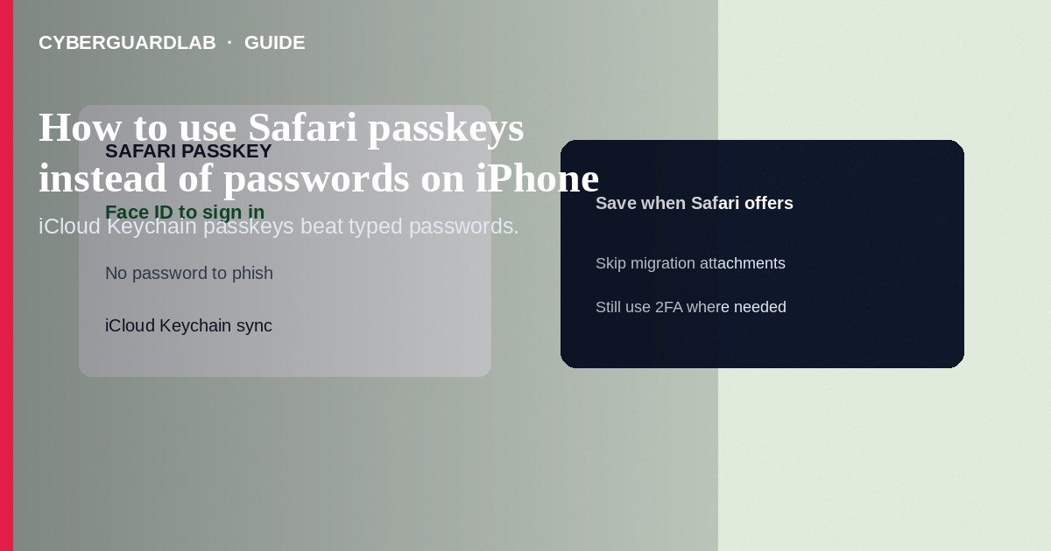
A passkey is a site-bound cryptographic credential stored in iCloud Keychain (and unlocked with Face ID / Touch ID / device passcode) so Safari on iPhone can sign you in without typing a reusable password that phishers can steal. Create passkeys on supporting sites in Safari, keep iCloud Keychain on, and keep a recovery plan for your Apple Account. This how-to is about Safari passkeys on iPhone—not Stolen Device Protection, not configuration profiles, and not Chrome Enhanced Safe Browsing on Google’s browser.

1. Why passkeys help
Phishing pages can capture passwords you type. Passkeys are designed to work only with the real site origin and require your device unlock—so a look-alike domain should not successfully replay the same credential the way a stolen password does. They do not replace device security or account recovery planning.
Paid link
Norton 360 | See the Norton first-year offer

See the Norton first-year offer
Offer page: https://cyberguardlab.com/norton
Emails with configuration profiles or apps that claim to “export all passkeys securely” after a breach scare are usually theft. Manage Passwords only in Settings / Passwords / Safari UI you open yourself.

2. Passkeys vs passwords vs profiles
Method | Phishing resistance | Notes
Safari passkey | Strong against classic password replay | Needs Keychain + device unlock
Password + SMS code | Weaker (SIM swap, relay calls) | Upgrade accounts that offer passkeys
Configuration profile “login helper” | Often hostile | See profile check—not a passkey

3. Steps: prepare iPhone and use a passkey in Safari
Steps: prepare iPhone
- Update iOS. Turn on iCloud Keychain: Settings → [Your Name] → iCloud → Passwords and Keychain (labels vary slightly by iOS)—enable sync.
- Set a strong device passcode and working Face ID / Touch ID.
- Confirm you know your Apple Account password and have recovery contacts or another Apple-documented recovery method.
- Optional but wise: turn on Stolen Device Protection so passcode-only thieves cannot easily raid Passwords settings away from familiar places.
Steps: create and use a passkey in Safari
- Open Safari (not a random in-app browser) and go to a site that offers passkeys (look for “Sign in with passkey,” “Create a passkey,” or password-manager prompts during account settings).
- Choose to save or create a passkey when Safari / Passwords offers it. Authenticate with Face ID, Touch ID, or passcode.
- Next visit: choose passkey sign-in; unlock the phone when prompted instead of typing the old password when the site allows.
- Review saved credentials in Settings → Passwords (or the Passwords app). Delete obsolete passwords only after passkey sign-in works on that account.
- On other Apple devices signed into the same iCloud Keychain, the passkey can sync—verify before you abandon the password everywhere.
- For shared/family computers, do not leave the iPhone unlocked; passkeys still need your biometric or passcode on device.

4. If a site does not offer passkeys yet
Keep a unique password in iCloud Keychain or another reputable manager; prefer app-based or hardware second factors over SMS when available. Do not install third-party “passkey enabler” configuration profiles from ads.

FAQ

Are passkeys the same as iCloud Keychain passwords?
Related storage, different credential type. Passkeys are public-key credentials for specific sites; passwords are shared secrets you type.

What if I lose my iPhone?
Use Find My, Mark as Lost, and Apple Account recovery. Passkeys syncing via iCloud Keychain can appear on your other signed-in Apple devices—plan a second device or recovery contact before you need it.

Can I use the same passkey on Android Chrome?
Cross-platform passkey use depends on the site and ecosystem features (e.g., Google Password Manager vs iCloud). This guide focuses on Safari on iPhone; do not assume automatic parity.

Do passkeys stop fake App Store emails?
They reduce damage if you never type a password into a fake page, but you must still ignore phishing links—see fake App Store receipt phishing.

If you still want a paid suite
Avoiding how to use Safari passkeys instead of passwords on iPhone does not require paid antivirus. Careful habits and official support paths are a valid buy-nothing stack. If you want multi-device paid protection later, use only these on-site paid links: TotalAV (paid link), Norton (paid link), Bitdefender (paid link), McAfee (paid link), Avast (paid link).

Sources
- Apple Support: Passkeys
- Apple Support: iCloud Keychain
- Apple Support: Stolen Device Protection
- FTC: Protect your accounts

Also read
- How to check for configuration profiles on iPhone
- How to turn on Stolen Device Protection recovery contacts
- Password manager vs browser passwords
- How to turn on 2FA for Gmail, Apple, and bank
- How to review Sign in with Apple app permissions

