
How to turn off UPnP on a home router
https://cyberguardlab.com/blog/router-turn-off-upnp
Independent US household comparison site. Not the vendor. Paid links below may earn a commission. Confirm first-year price, renewal, device limit, and refund terms at checkout.
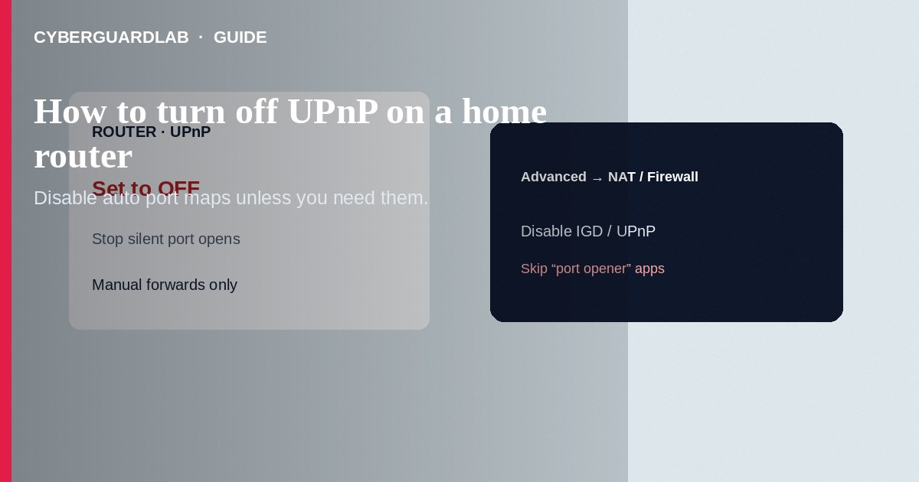
Turn off Universal Plug and Play (UPnP) on your home router unless a specific device truly needs it. UPnP can open inbound ports without a clear prompt, which widens the attack surface for malware and exposed services. Prefer manual port forwards you understand, keep the router admin password unique, and update firmware. This how-to is about the UPnP setting—not changing the router admin password, not WPA3 Wi-Fi encryption, and not securing a NAS.

1. Why UPnP matters on a home network
UPnP lets apps and gadgets ask the router to open ports automatically (games, cameras, some media servers). Convenience is the pitch; the risk is silent exposure of services you did not intend to publish to the internet. Many consumer guides recommend disabling UPnP when you do not rely on it.
Paid link
Norton 360 | See the Norton first-year offer

See the Norton first-year offer
Offer page: https://cyberguardlab.com/norton
Sideloaded “NAT type fix” APKs and shady Windows “optimizer” tools that promise open ports are a malware path. Change settings only in the official router UI or vendor app.

2. UPnP on vs safer habits
Choice | Safer default | Higher risk
UPnP | Off unless you verified a need | Left on forever with unknown gadgets
Port access | Manual forward you documented | Silent auto-opens you never reviewed
Cameras / NAS | Vendor cloud / VPN you control | Direct WAN exposure via UPnP
Admin login | Unique password; LAN-only admin | Default admin + UPnP still on

3. Steps: disable UPnP
- Prefer a wired PC on the LAN. Type your router’s admin address yourself (sticker/manual)—do not use a cold “ISP support” link.
- Sign in with the admin credentials (not the Wi-Fi passphrase). If unknown, follow the vendor reset docs, then set a new admin password—see router admin password change.
- Open Advanced / WAN / Firewall / NAT sections (labels vary by brand).
- Find UPnP, Universal Plug and Play, or IGD. Set it to Off / Disable. Save/Apply.
- Reboot the router if the firmware asks you to.
- Retest devices that previously needed auto-ports. If a game or camera breaks, add a manual port forward for that one service only—or use the vendor’s documented cloud relay instead of opening WAN ports.
- While you are in the UI: turn off remote WAN administration if unused; check firmware updates.
- Note the change in your household password manager so the next admin knows UPnP is off.

4. After you turn it off
- Confirm critical apps still work (gaming consoles may need a static LAN IP + manual forward).
- Review any “DMZ host” or “exposed host” settings—disable those unless you intentionally use them.
- For IoT cameras and TVs, prefer a guest/IoT segment when your router supports it—see smart TV / camera VLAN segment.
- Keep PCs patched and scanned with one primary product such as Norton or Bitdefender; TotalAV, McAfee, and Avast are other on-site options.

FAQ

Will turning off UPnP break my Wi-Fi?
No. Wi-Fi and UPnP are different. You may need manual forwards for a few apps.

Is this the same as changing the admin password?
No. Admin password protects the settings panel. UPnP controls automatic port mapping.

My ISP gateway has no UPnP toggle.
Some ISP units hide advanced NAT. Ask the ISP, or put your own router behind it in a supported mode and manage UPnP there.

Do I need UPnP for “work from home” VPN?
Usually not. Use your employer’s documented client; ask IT before opening ports.

Do game consoles need UPnP?
Often they work without it. If multiplayer fails after disabling UPnP, assign a static LAN IP and create a documented manual forward—or use the console maker’s guidance—rather than re-enabling blanket UPnP.

If you still want a paid suite
Avoiding how to turn off UPnP on a home router does not require paid antivirus. Careful habits and official support paths are a valid buy-nothing stack. If you want multi-device paid protection later, use only these on-site paid links: TotalAV (paid link), Norton (paid link), Bitdefender (paid link), McAfee (paid link), Avast (paid link).

Sources
- CISA: Secure your home network
- FTC: How to secure your home Wi-Fi network
- Example vendor help (Netgear UPnP)
- Example vendor help (TP-Link UPnP)

Also read
- How to change your router admin password safely
- How to turn on WPA3 or the strongest Wi-Fi encryption you have
- How to segment smart TVs and cameras on a separate VLAN
- How to secure a home NAS or personal cloud drive
- How to update home router firmware

