
How to change your router admin password safely
https://cyberguardlab.com/blog/router-admin-password-change
Independent US household comparison site. Not the vendor. Paid links below may earn a commission. Confirm first-year price, renewal, device limit, and refund terms at checkout.
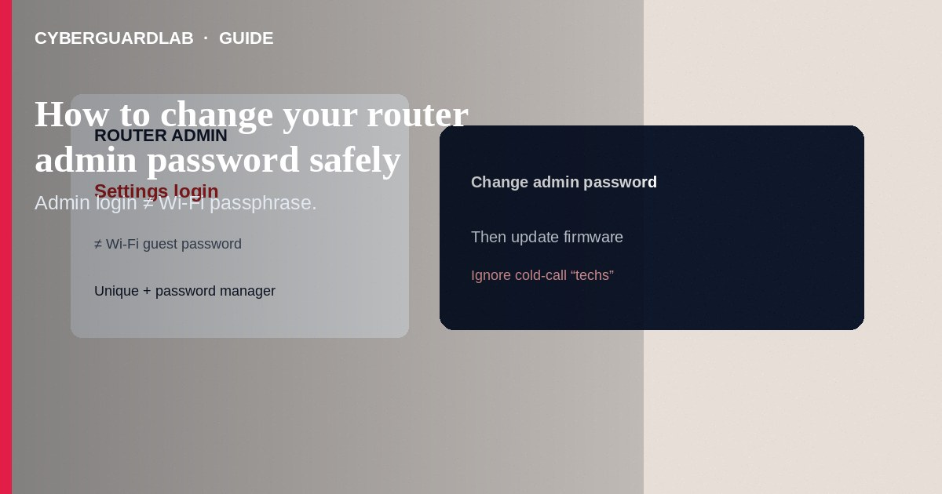
Change your router admin password (the login that opens the router’s settings web UI or app)—not only the Wi-Fi passphrase guests type. Use a unique, long password stored in a password manager, and finish by updating firmware. This how-to is router administration credentials—not turning on WPA3 / Wi-Fi encryption, not Private DNS on Android, and not ISP bill phishing.

1. Why the admin password is different from Wi-Fi
Wi-Fi passwords let devices join the network. The admin password lets someone change DNS, open ports, install malicious firmware settings, or create a hidden guest network. Default stickers like `admin/admin` are still common on older gear.
Paid link
Norton 360 | See the Norton first-year offer

See the Norton first-year offer
Offer page: https://cyberguardlab.com/norton
Callers who demand the admin password to “fix your slow Wi-Fi” are a common social-engineering path. Hang up; use the number on your bill or ISP app.

2. Safe vs unsafe admin habits
Habit | Safer | Risky
Where you log in | LAN IP you typed / official app | “Router support” link from cold email
Password | Unique long admin secret | Same as Wi-Fi or printed default forever
Remote WAN admin | Off unless required + vendor MFA | Open to the internet with default creds
Firmware | Vendor-signed updates | Third-party “optimizer” firmware files from forums

3. Steps: change the admin password safely
- Prefer Ethernet from a PC to the router for this session when possible.
- Find the LAN admin URL from the sticker or manual (often `192.168.0.1`, `192.168.1.1`, or a vendor `.local` name)—type it; do not use a random SMS link.
- Sign in with the current admin credentials. If unknown, use the vendor’s documented reset procedure (this wipes settings).
- Immediately set a new admin password (and admin username if the firmware allows). Use a password manager.
- Turn off remote administration / WAN-side management if you do not need it.
- Change the Wi-Fi passphrase separately if it was ever shared widely—see also WPA3.
- Check for firmware updates in the same admin UI or the vendor’s official app/site.
- Save a configuration backup only to encrypted storage you control; note the new password offline.
- Reboot and confirm you can still log in; reconnect devices.

4. After a suspected compromise
- Factory-reset the router, reinstall settings from scratch, and set a new admin password.
- Change Wi-Fi passphrases; revisit IoT update status.
- Review DNS settings for unfamiliar resolvers.
- Scan PCs with Norton or Bitdefender; keep one primary product (TotalAV, McAfee, Avast).

FAQ

I changed Wi-Fi—does that change admin too?
Usually no. Change admin separately inside the router UI.

Is this the same as WPA3?
No. WPA3 is wireless encryption between clients and the access point. Admin password guards the settings panel.

ISP gateway vs my own router?
If the ISP device is your only gateway, use their app/portal or documented admin page. Some ISP units lock admin; ask the ISP for the procedure.

Can I email the password to myself?
Prefer a password manager. Email is a weak vault.

If you still want a paid suite
Avoiding how to change your router admin password safely does not require paid antivirus. Careful habits and official support paths are a valid buy-nothing stack. If you want multi-device paid protection later, use only these on-site paid links: TotalAV (paid link), Norton (paid link), Bitdefender (paid link), McAfee (paid link), Avast (paid link).

Sources
- CISA: Securing home networks / routers (guidance hub)
- FTC: Secure your router
- Example vendor help (Netgear admin password)
- Example vendor help (TP-Link login)

Also read
- How to turn on WPA3 or the strongest Wi-Fi encryption you have
- How to update home router firmware
- How to set up a guest Wi-Fi network at home
- How to segment smart TVs and cameras on a separate VLAN
- How to spot a fake ISP outage or bill phishing email

