
How to report a scam to the FTC
https://cyberguardlab.com/blog/report-scam-ftc
Independent US household comparison site. Not the vendor. Paid links below may earn a commission. Confirm first-year price, renewal, device limit, and refund terms at checkout.
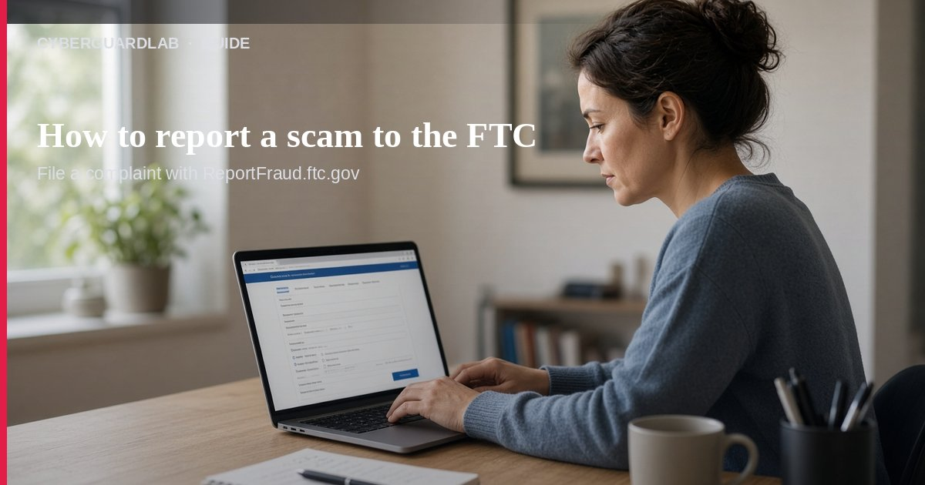
Reporting a scam to the FTC means telling the Federal Trade Commission what happened so patterns can be tracked and other households warned. The FTC’s own How To Avoid a Scam page says: if you were scammed or think you saw a scam, tell the FTC at ReportFraud.ftc.gov. This guide is about how and where to report, not full identity-theft recovery (see IdentityTheft.gov steps) and not every scam type’s playbook. You do not need to buy antivirus to file a report.

1. Start here: ReportFraud.ftc.gov
- Open ReportFraud.ftc.gov from a browser you trust.
- Describe what happened in plain language — phone, text, email, website, app, or in person.
- Include dates, names or titles the scammer used, phone numbers, emails, websites, payment methods, and amounts if you paid.
- Attach or note screenshots when you have them.
- Submit even if you did not lose money — FTC guidance treats “I saw a scam” reports as useful.

2. Use USAGov when you’re not sure which agency
USAGov’s Learn where to report a scam tool asks roughly:
Paid link
Norton 360 | See the Norton first-year offer

See the Norton first-year offer
Offer page: https://cyberguardlab.com/norton
Ad link: https://trysecurities.com/offer/norton?dtm=gg&cid=
- Where the scam took place
- Which scam category fits
- Extra details
- Which steps to take next
USAGov notes scams happen online, by mail, phone, text, social media, in person, and through new technologies. If the issue is a legitimate business dispute rather than a scam, use USAGov’s complaints path instead of forcing a fraud report.

3. What to do in the same hour you report
From FTC avoid-scam guidance and common recovery practice:
- Stop contact — Hang up; don’t reply; don’t click more links.
- Contact your bank, card issuer, or payment provider if money moved.
- Change passwords on email and financial accounts, and turn on MFA (CISA Turn On MFA).
- Tell someone you trust what happened — FTC: talking it through helps you realize it’s a scam and stop further payments.
- If identity theft is involved, continue at IdentityTheft.gov (covered in our identity-theft guide).

4. Four scam signs worth reporting every time
FTC “four signs” summary:
- Pretend to be an organization you know (government, utility, tech firm, even a charity).
- Say there’s a problem or a prize.
- Pressure you to act immediately.
- Tell you to pay only with crypto, wire services, payment apps, or gift-card numbers.
Also remember: the FTC will never threaten you, tell you to move money to “protect it,” or tell you to withdraw cash or buy gold and hand it to someone.

FAQ

How do I report a scam to the FTC?
Go to ReportFraud.ftc.gov and submit what happened, with as many contact and payment details as you have.

Should I report if I didn’t lose money?
Yes. FTC asks people to report scams they saw, not only losses.

Is ReportFraud the same as IdentityTheft.gov?
No. ReportFraud is the general scam intake. Use IdentityTheft.gov when your identity was misused — see our IdentityTheft.gov guide.

Is Microsoft Defender required to report?
No. Reporting is a browser form and follow-up with your bank. Defender is optional if a PC was also compromised — see Is Microsoft Defender enough?.

Where else can I get routing help?
USAGov where to report a scam.

If you still want a paid suite
Filing an FTC report does not require paid antivirus. Microsoft Defender is a valid buy-nothing choice for many Windows households. What actually helps is reporting promptly and securing accounts with MFA. If the household later wants multi-device paid protection, use only these on-site paid links: TotalAV (paid link), Norton (paid link), Bitdefender (paid link), McAfee (paid link), Avast (paid link).

Sources
- ReportFraud.ftc.gov (FTC)
- How To Avoid a Scam (FTC)
- Learn where to report a scam (USAGov)
- IdentityTheft.gov
- Turn On MFA (CISA)
- Avoiding Social Engineering and Phishing Attacks (CISA)

Also read
- How to report identity theft at IdentityTheft.gov
- How to spot a phishing email
- How to spot a tech support scam phone call
- How to spot a gift card scam
- How to stop spam text messages

