
How to replace a stolen Social Security card safely
https://cyberguardlab.com/blog/replace-stolen-social-security-card
Independent US household comparison site. Not the vendor. Paid links below may earn a commission. Confirm first-year price, renewal, device limit, and refund terms at checkout.
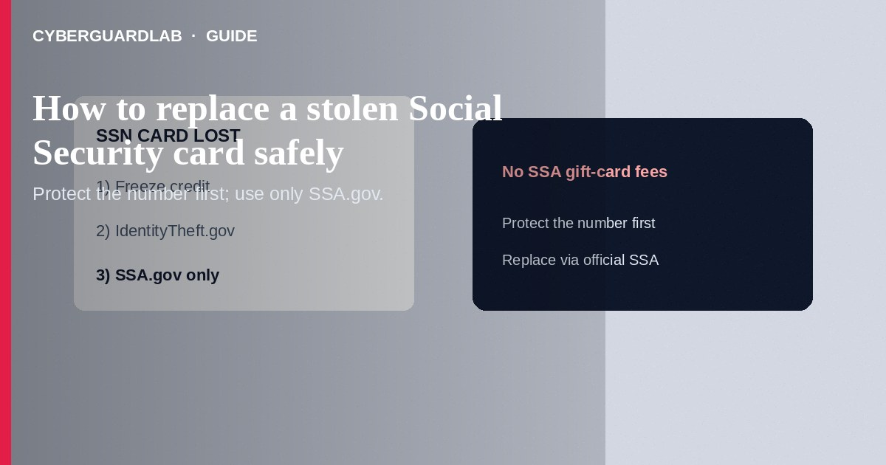
If your Social Security card was stolen—or you lost it with a wallet—focus first on fraud prevention (freezes, alerts, IdentityTheft.gov), then replace the card only through Social Security Administration (SSA) channels you open yourself. SSA does not charge random “expedite” fees by gift card, crypto, or wire, and it will not call to demand immediate payment to reissue a card. This how-to is about safely replacing a stolen Social Security card—not credit freeze steps alone, not synthetic identity on a credit file diagnosis alone, and not disputing a credit card charge.

1. Prioritize protection before the paper card
- Place a credit freeze at Equifax, Experian, and TransUnion.
- Consider an initial fraud alert at one bureau (it notifies the other two).
- Start a plan at IdentityTheft.gov if the card theft involves likely SSN misuse.
- Monitor bank, tax, and unemployment accounts for new claims you did not file.
- File a police report if your wallet or documents were stolen—keep a copy for disputes.
- Remember: memorizing your SSN matters more day-to-day than carrying the card; avoid keeping the card in a daily wallet after replacement when possible.
Impostors threaten arrests over “SSN suspension” and demand payment. SSA will not call to demand gift cards or crypto to replace a stolen card. Teach household members to hang up and start only at SSA.gov.
Paid link
Norton 360 | See the Norton first-year offer

See the Norton first-year offer
Offer page: https://cyberguardlab.com/norton

2. Legitimate SSA vs scam cues
Cue | Likely legitimate | Likely scam
Website | SSA.gov you typed | Look-alike “ssA-card-renewal” domains from ads
Fees | SSA replacement card processes do not use gift cards or crypto | “Pay $99 to unlock your replacement” via wire or cards
Contact | You initiate via SSA.gov or published SSA phone lines | Cold call: “Your card is suspended—pay now”
Remote access | Not required | Technician needs screen control to “file SS-5”
Documents | SSA’s published proof list | Stranger asks you to text photos of your full SSN card and passport together

3. Steps: replace the card through SSA
- Open SSA’s official site yourself: ssa.gov. Use the replacement Social Security card guidance pages (including my Social Security online options when eligible).
- Check whether you can request a replacement online via a my Social Security account you create through SSA.gov—or whether you must apply by mail or in person based on your situation.
- Gather acceptable proof of identity and, if required, citizenship or immigration documents listed on SSA’s current instructions—do not mail originals unless SSA’s process specifically requires and you follow their mailing guidance.
- Complete Form SS-5 only from SSA’s official source—not from a third-party “form kit” seller.
- Submit through the channel SSA describes (online, mail, or field office appointment). Book field office visits through official SSA scheduling tools when required.
- Never pay a “broker,” WhatsApp agent, or cold caller who claims they can rush a card for a fee paid by gift cards or crypto.
- After the new card arrives, store it securely; update only employers or agencies that truly need to see it.
- Continue freezes and report monitoring for at least several months—card replacement does not erase SSN exposure.

4. If scammers already contacted you
- Hang up; do not pay. Report at ReportFraud.ftc.gov.
- If you gave card numbers or SSN details to an impostor, use IdentityTheft.gov and freeze credit.
- If you typed credentials on a fake SSA page, change passwords and enable two-factor authentication on email.
- Scan your device with a trusted tool such as Norton or Bitdefender. Keep one primary real-time antivirus—avoid stacking full suites. TotalAV, McAfee, and Avast are other on-site comparison options.

FAQ

Does replacing the card change my Social Security number?
No. A replacement card keeps the same SSN. Changing an SSN is rare and separate; follow only SSA’s official rules if you ever pursue that.

Should I carry the new card every day?
Usually no. Memorize the number for forms; store the card in a safe place to reduce re-theft risk.

How is this different from a credit freeze?
A freeze blocks many new credit applications. Replacing the card restores a document you may need for work authorization paperwork—it does not by itself stop credit fraud.

Can I pay someone on social media to submit SS-5 for me?
No. Use SSA.gov processes. Third-party “expediters” demanding unconventional payment are a scam pattern.

If you still want a paid suite
Avoiding how to replace a stolen Social Security card safely does not require paid antivirus. Careful habits and official support paths are a valid buy-nothing stack. If you want multi-device paid protection later, use only these on-site paid links: TotalAV (paid link), Norton (paid link), Bitdefender (paid link), McAfee (paid link), Avast (paid link).

Sources
- SSA: Replace Social Security card
- SSA: my Social Security
- IdentityTheft.gov
- FTC: Credit freezes and fraud alerts
- FTC ReportFraud
- AnnualCreditReport.com

Also read
- How to place a credit freeze at all three bureaus
- How to get a free annual credit report and read it
- How to spot synthetic identity theft on a credit file
- How to spot an IRS wage garnishment scam
- How to report a scam to the FTC

