
How to remove a browser hijacker from Windows
https://cyberguardlab.com/blog/remove-browser-hijacker-windows
Independent US household comparison site. Not the vendor. Paid links below may earn a commission. Confirm first-year price, renewal, device limit, and refund terms at checkout.
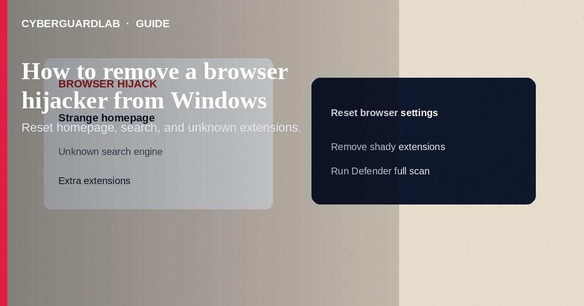
A browser hijacker changes your homepage, default search, new-tab page, or extensions so ads and tracking pages open instead of what you chose—often after a bundled freeware install. Remove unknown extensions, reset the browser, uninstall shady programs in Windows Settings, then run a Defender (or trusted AV) full scan. This how-to is about hijacker cleanup on Windows—not a fake BSOD support scam, not a full Windows 11 keep-files reset as the first step, and not opening risky files in Sandbox.

1. Signs of a hijack
Searches redirect to unfamiliar engines; homepage keeps reverting; extra toolbars appear; pop-ups follow you across sites; new extensions you did not add show in the browser. Confirm whether SmartScreen or Defender already flagged related downloads.
Paid link
Norton 360 | See the Norton first-year offer

See the Norton first-year offer
Offer page: https://cyberguardlab.com/norton
Search results for “remove hijacker” are often filled with scareware. Prefer Microsoft’s documented reset steps and Defender. If a page freezes with a support phone number, switch to the fake BSOD scam playbook instead of installing their tool.

2. Hijacker vs neighboring problems
Problem | Typical symptom | First move
Browser hijacker | Wrong search/home/extensions | Remove extensions; reset browser; uninstall PUPs
Fake BSOD support scam | Full-screen call-now scare | Do not call; kill browser; see scam guide
Keep-files reset | Deep OS corruption after malware | Use after cleanup fails; not first for a simple hijack
Risky unknown file | Untrusted attachment/download | Prefer Windows Sandbox before opening on the main desktop

3. Steps: remove the hijacker
- Disconnect briefly if redirects are aggressive; reconnect when ready to update definitions.
- In Chrome/Edge/Firefox, open Extensions/Add-ons and remove anything unknown. Disable first if unsure, then remove.
- Reset the browser settings to defaults (homepage, search, startup pages) from that browser’s settings menu—use the official reset, not a third-party “optimizer” from a pop-up.
- Open Settings → Apps → Installed apps and uninstall toolbars, “search protectors,” PDF helpers, or cleanup utilities you do not recognize. Restart Windows.
- Open Windows Security → Virus & threat protection → scan options → Full scan. Quarantine detections.
- Check Task Manager → Startup apps and disable unknown entries; review scheduled tasks if redirects persist.
- Change passwords for email and important sites if you typed them while hijacked (prefer another clean device).
- Keep one primary real-time antivirus. Norton or Bitdefender are common choices; TotalAV, McAfee, and Avast are other on-site comparison options—do not stack multiple full suites.

4. What to do if it comes back
- Re-check extensions after every browser update; some malware reinstalls helpers.
- Avoid “free codec / PDF / cleaner” bundles; use official Microsoft Store or vendor sites.
- If Settings and scans cannot hold a clean state, escalate to Reset this PC — Keep my files after backing up.
- Turn on reputation-based protection under App & browser control so SmartScreen can warn on unknown downloads.

FAQ

Is resetting the browser enough?
Often for extension-only hijacks. Persistently reinstalled PUPs need Apps uninstall + full AV scan.

Should I pay a pop-up cleaner?
No. Pop-up “PC cleaners” are frequently part of the scam. Use Windows Security or a suite you chose deliberately.

Does BitLocker stop hijackers?
No. BitLocker encrypts drives at rest; it does not remove browser malware while you are signed in. See BitLocker on a home PC for encryption, not hijacker removal.

Can I just create a new Windows user?
A new profile may avoid some per-user junk, but machine-wide PUPs remain. Still uninstall and scan.

If you still want a paid suite
Avoiding how to remove a browser hijacker from Windows does not require paid antivirus. Careful habits and official support paths are a valid buy-nothing stack. If you want multi-device paid protection later, use only these on-site paid links: TotalAV (paid link), Norton (paid link), Bitdefender (paid link), McAfee (paid link), Avast (paid link).

Sources
- Microsoft Support: Tips for safer browsing in Microsoft Edge
- Microsoft Support: Reset Microsoft Edge settings
- FTC: Malware
- CISA: Understanding and protecting against malicious code

Also read
- How to spot a fake Windows blue screen support scam
- How to reset Windows 11 while keeping your files
- How to turn on SmartScreen for apps and files
- How to check Windows Security protection history
- How to check a download before opening an EXE

