
How to recover an Apple ID without SMS access
https://cyberguardlab.com/blog/recover-apple-id-without-sms
Independent US household comparison site. Not the vendor. Paid links below may earn a commission. Confirm first-year price, renewal, device limit, and refund terms at checkout.
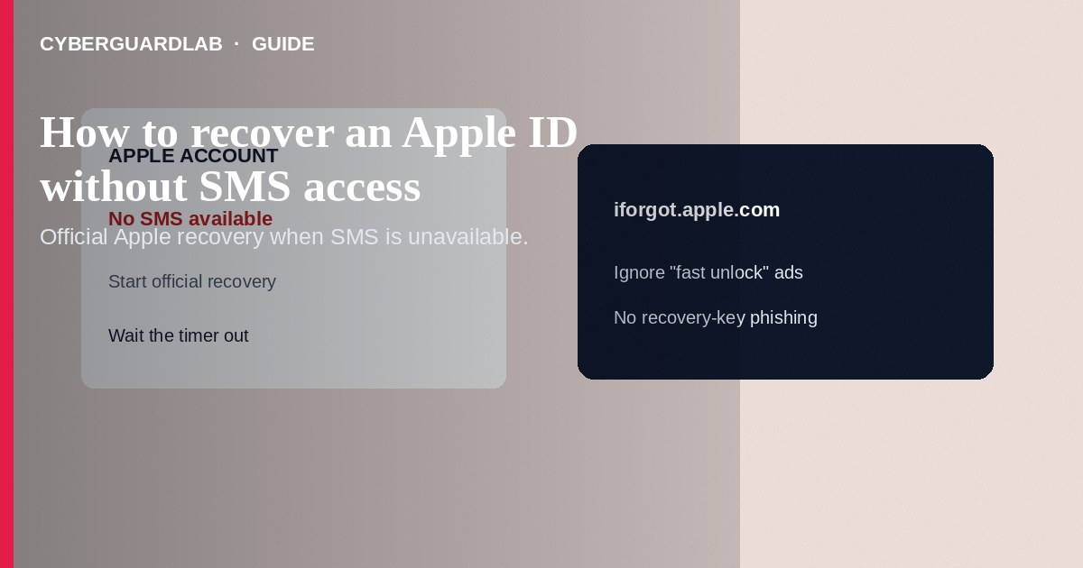
If you cannot receive SMS on your Apple Account trusted number—and you lack another trusted device that shows a verification code—start Apple’s official account recovery at iforgot.apple.com (or the sign-in “Didn’t get a code?” path) rather than paying a third-party “unlock” service. Recovery can take days; Apple Support generally cannot skip the wait. This how-to is about regaining the Apple Account/Apple ID when SMS is unavailable—not turning off iMessage on a lost iPhone, and not spotting a fake Apple Support screen-sharing scam.

1. When this applies
Use these steps when the phone that gets SMS is lost, the number was ported, or you permanently lost trusted devices and trusted numbers. If another iPhone, iPad, or Mac is still signed in, generate a code or reset the password there first—that is faster than full account recovery. If you previously enabled a recovery key, you must have that key; standard recovery may not apply the same way.
Paid link
Norton 360 | See the Norton first-year offer

See the Norton first-year offer
Offer page: https://cyberguardlab.com/norton
During the wait, scammers email “complete recovery now” links that harvest passwords and codes. Type iforgot.apple.com yourself. Never share recovery keys, backup codes, or screen control with inbound callers.

2. Recovery vs related Apple tasks
Situation | Right path | Not the same as
No SMS, no trusted device | Account recovery via iforgot.apple.com | Paying a “Apple unlocker” on social media
Lost iPhone still getting iMessage | Deregister iMessage / Find My workflows | Full Apple ID password recovery (different goal)
Cold call offering screen share to “speed recovery” | Hang up; use Apple’s documented wait | Real Apple Support needing AnyDesk
Still have a signed-in Mac/iPad | Reset password or get code on that device | Starting recovery prematurely

3. Steps: recover without SMS access
- On a browser you control, open iforgot.apple.com or appleid.apple.com yourself—never a link from a cold text or caller.
- Enter your Apple Account email or phone and follow password reset / sign-in prompts.
- When asked for a verification code, choose Didn’t get a code? or Can’t get to your devices?
- Choose Can’t use [phone number] (wording may vary) when you cannot receive SMS or calls on any trusted number.
- Follow on-screen account recovery. Provide the identity details Apple requests. Expect a confirmation (often within about 72 hours) with an estimated wait—recovery may take several days or longer.
- Do not pay anyone who claims they can “expedite Apple recovery” with gift cards, crypto, or remote access.
- When Apple notifies you that recovery is ready, complete the steps only through iforgot.apple.com or official Apple channels.
- After you regain access: add a second trusted phone number, review devices, consider a hardware security key where supported, and scan devices you used during the lockout with a trusted tool such as Norton or Bitdefender. Keep one primary real-time antivirus—avoid stacking full suites. TotalAV, McAfee, and Avast are other on-site comparison options.

4. What to do while you wait
- Note the estimated ready time from Apple’s confirmation; check status again at iforgot.apple.com with the same account identifier.
- Secure the email inbox tied to the Apple Account; enable strong 2FA there.
- If the number was stolen (SIM swap), contact the carrier, set a new account PIN, and enable number lock when available.
- Mark all “Apple Support” calls/texts during the wait as suspect—Apple will not ask for gift cards to finish recovery.

FAQ

Can Apple Support shorten account recovery?
Apple’s documentation states contacting Support cannot speed up the recovery waiting period. Be wary of anyone who claims otherwise.

Is this the same as turning off iMessage for a lost phone?
No. iMessage deregistration stops messages routing to a lost device. Account recovery restores sign-in when you lack trusted factors.

What if I have a recovery key?
You typically need the recovery key plus remaining verification steps Apple documents. Store the key offline going forward.

Should I create a new Apple ID instead?
Only as a last resort after understanding you may lose purchases and iCloud data tied to the old account. Prefer official recovery first.

If you still want a paid suite
Avoiding how to recover an Apple ID without SMS access does not require paid antivirus. Careful habits and official support paths are a valid buy-nothing stack. If you want multi-device paid protection later, use only these on-site paid links: TotalAV (paid link), Norton (paid link), Bitdefender (paid link), McAfee (paid link), Avast (paid link).

Sources
- Apple Support: Account recovery
- Apple Support: Trusted phone numbers and devices
- Apple Support: Two-factor verification codes
- iforgot.apple.com
- FTC ReportFraud

Also read
- How to turn off iMessage on a lost iPhone from another device
- How to spot a fake Apple Support screen-sharing scam
- How to use a hardware security key for your main accounts
- How to spot a one-time passcode relay scam call
- How to move authenticator apps to a new phone safely

