
How to spot a QR code scam
https://cyberguardlab.com/blog/qr-code-scam
Independent US household comparison site. Not the vendor. Paid links below may earn a commission. Confirm first-year price, renewal, device limit, and refund terms at checkout.
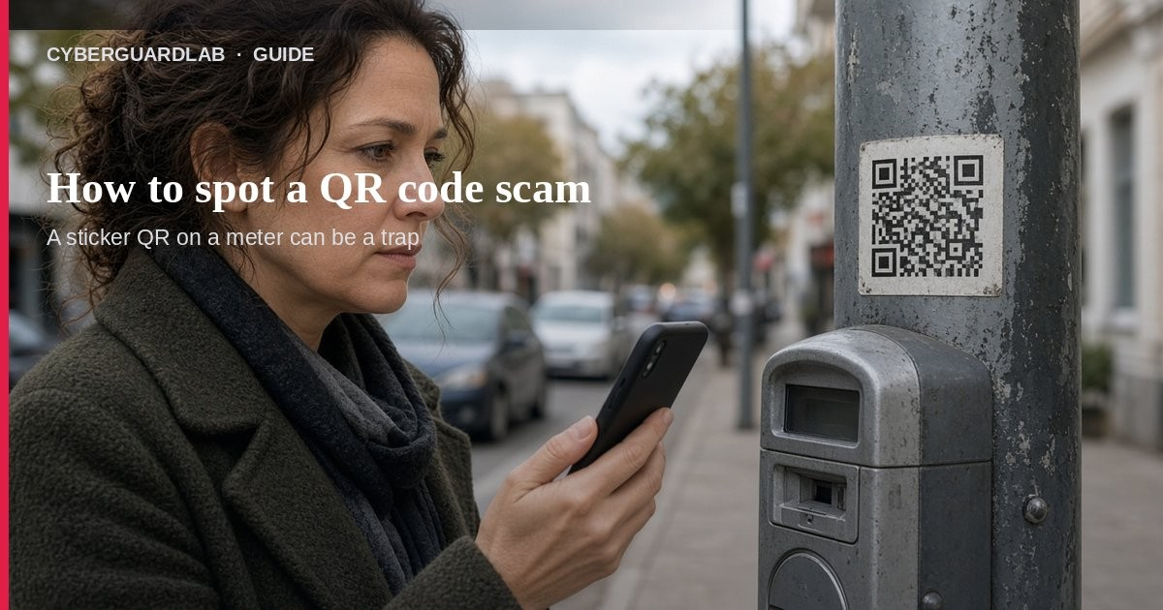
A QR code scam (sometimes called “quishing”) is when a code sends your phone to a fake site or harmful link so someone can steal money or personal information. Per FTC consumer alerts, scammers stick their own codes over real parking-meter codes, and they also send unexpected QR codes by text or email with urgent stories. This guide is about QR codes you scan in the real world or in a message, not general email phishing, fake delivery texts, or spam texts (those scripts sometimes end with a QR, but the primary keyword here is the code itself). You do not need to buy antivirus to refuse a sketchy scan.

1. How QR scams usually work
From FTC QR-code alerts:
Paid link
Norton 360 | See the Norton first-year offer

See the Norton first-year offer
Offer page: https://cyberguardlab.com/norton
Ad link: https://trysecurities.com/offer/norton?dtm=gg&cid=
- Sticker-over parking meters — People report scammers covering a legit pay-to-park QR with their own sticker. The fake code opens a lookalike payment site.
- Unexpected text or email QR — The story creates urgency: package problem, account issue, “suspicious activity,” password change.
- Spoofed login or payment page — After you scan, the page looks real. If you type a password or card number, the scammer gets it.
- Malware risk — FTC notes a bad QR can also try to install malware that steals information.
- Rush is the tell — They want you to open the URL without reading the preview.

2. Check before you scan (or before you open the link)
- Look at the physical code — Raised edges, crooked placement, different paper, or a sticker taped over another code are red flags. Prefer the official app or a card reader when something looks off.
- Read the URL preview — Many phone cameras show the link before opening. Look for misspellings, switched letters, odd domains, or shortened links you cannot verify.
- Skip unexpected message QRs — FTC: don’t scan a QR in an email or text you weren’t expecting, especially if it urges you to act immediately. Contact the company with a number or site you already trust.
- Type the site yourself when unsure — For banks, carriers, or retailers, open the real app or type the known URL instead of trusting the code.
- Keep the phone updated — Update the OS and apps so malicious links are harder to exploit.

3. What to do in the first 15 minutes if you already scanned
- Stop interacting — Do not message “support” on the page you reached.
- Change passwords — If you entered a username or password, change it everywhere you reused that password.
- Turn on MFA — Add multifactor authentication on email, banking, and the account involved (see CISA MFA guidance). See also turn on 2FA.
- Review transactions — Check bank and card statements for charges you did not make; follow credit card fraud first-hour if needed.
- Report — File at ReportFraud.ftc.gov.
- Optional device check — Only if you installed an app or saw strange behavior: run Windows Security / Microsoft Defender on a PC, or review phone apps. Buying a suite is not required first — see Is Microsoft Defender enough?.

4. Safer QR habits (without buying software)
- Treat parking and public stickers with extra care; inspect before you scan.
- Prefer official apps for parking, restaurants, and tickets when available.
- Never enter a password or card on a page you reached only through an unverified code.
- Use strong unique passwords and MFA on money and email accounts.
- Teach kids and grandparents the same “preview the URL” pause.

FAQ

How do I spot a QR code scam?
A code that looks stickied over another, arrives in an unexpected message, or opens a misspelled / rushed login or payment page is a classic QR scam pattern per FTC alerts.

Is every QR code dangerous?
No. Menus, tickets, and boarding passes are common and often fine. The risk is unexpected or tampered codes and the sites they open.

What if I already entered my card?
Call the card issuer, watch for unauthorized charges, and report at ReportFraud.ftc.gov.

Do I need antivirus to handle a QR scam?
No. Refuse the login/payment, change passwords, enable MFA, and report. Defender or good habits are enough unless you also installed malware.

How is this different from phishing email?
Same goal (steal credentials or money), different delivery: the harmful link is inside a scannable code instead of a clickable email URL.

If you still want a paid suite
Avoiding a bad QR scan does not require paid antivirus. Microsoft Defender is a valid buy-nothing choice for many Windows households. What actually helps is previewing URLs, refusing unexpected codes, and MFA. If the household later wants multi-device paid protection, use only these on-site paid links: TotalAV (paid link), Norton (paid link), Bitdefender (paid link), McAfee (paid link), Avast (paid link).

Sources
- See a QR code parked somewhere? Don’t scan it…yet! (FTC, Sep 2026)
- Scammers hide harmful links in QR codes to steal your information (FTC)
- How To Avoid a Scam (FTC)
- ReportFraud.ftc.gov (FTC)
- Turn On MFA (CISA)
- Recognize and Report Phishing (CISA)
- Windows security overview (Microsoft)

Also read
- How to spot a phishing email
- How to spot a fake delivery text scam
- How to recognize and report spam text messages
- Credit card fraud: first hour
- Turn on 2FA for Gmail, Apple, and bank

