
How to review app permissions on your phone
https://cyberguardlab.com/blog/phone-app-permissions-review
Independent US household comparison site. Not the vendor. Paid links below may earn a commission. Confirm first-year price, renewal, device limit, and refund terms at checkout.
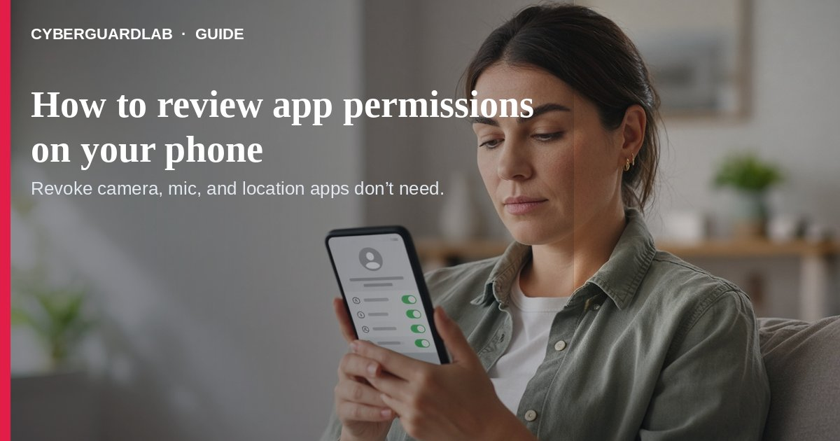
Reviewing app permissions means checking which apps can use your camera, microphone, location, photos, contacts, and other data — then turning off access that is not needed. Google’s Android Help and Apple’s iPhone User Guide both let you change permissions per app or by permission type in Settings.
This guide is about privacy permissions on the phone you already own, not a full Play Protect malware scan and not parental Screen Time / Family Link setup. No purchase required.
Paid link
Avast Premium | See the Avast first-year offer
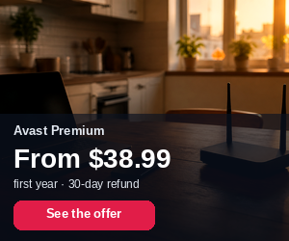
See the Avast first-year offer
Offer page: https://cyberguardlab.com/avast
Ad link: https://trysecurities.com/offer/avast?dtm=gg&cid=

1. Why a quarterly permissions check helps
- Apps sometimes ask for camera, mic, or location “for features” you never use.
- Unused apps can keep sensitive access until you revoke it (Android can pause unused apps).
- Over-permissioned flashlight, wallpaper, or “cleaner” apps are a common household risk pattern.
- After installing kids’ games or shopping apps, permissions drift — a 10-minute review resets the baseline.

2. Android — change permissions (Google Help)
- Open Settings → Apps, pick the app (or See all apps).
- Tap Permissions, then tap a permission and choose Allow or Don’t allow.
- For location, camera, and microphone, prefer Allow only while using the app or Ask every time when available; avoid All the time location unless you truly need it.
- Or open Settings → Security & privacy → Privacy → Permission manager, pick a permission type (Camera, Location, Microphone, Photos…), and audit every app on the list.
- Under an app’s unused settings, turn on Pause app activity if unused so idle apps lose permissions automatically.
- Optional hard stop: Privacy controls to disable Camera access or Microphone access device-wide.
- Still run Play Protect if an app behaves oddly.

3. iPhone — control access (Apple Support)
- Go to Settings → Privacy & Security.
- Tap a category (Location Services, Camera, Microphone, Photos, Contacts, Calendars, etc.).
- Turn access off for any app that does not need it.
- Open App Privacy Report (same Privacy & Security screen) to see how apps used the permissions you granted and their network activity.
- Revisit after installing new apps; the first prompt is not the last chance to change your mind.

4. Household rules (buy-nothing)
- Flashlight, QR, and wallpaper apps almost never need Contacts or full Files access — deny.
- Banking apps may need camera for deposits; they do not need your full photo library forever — tighten Photos to limited access when the OS allows.
- Shared family phones: pair this review with Family Link or Screen Time.
- Before selling a phone, revoke cloud sessions and wipe the device.
- Smart-home companion apps: change default passwords too — smart home default passwords.

FAQ

How do I review app permissions on Android?
Settings → Apps → [app] → Permissions, or Permission manager by type (Google Help).

How do I review app permissions on iPhone?
Settings → Privacy & Security → category → toggle per app; use App Privacy Report for usage (Apple).

Is this the same as scanning for malware?
No. Permissions are privacy access controls; malware scanning is separate (Play Protect).

Do I need a paid security app to manage permissions?
No. Built-in Settings are enough for this task. Buy-nothing is valid.

What should I revoke first?
Camera, Microphone, Location “all the time,” and Contacts on apps that are not chat/maps/camera tools. Also see the home privacy checklist.

If you still want a paid suite
Permission reviews do not require paid antivirus. Microsoft Defender (on Windows PCs in the household) and built-in phone tools are a valid buy-nothing stack. If you want multi-device paid protection, use only these on-site paid links: TotalAV (paid link), Norton (paid link), Bitdefender (paid link), McAfee (paid link), Avast (paid link).

Sources
- Change app permissions on your Android phone (Google)
- Control access to information in apps on iPhone (Apple)

Also read
- How to run an Android Play Protect malware scan
- How to change smart home default passwords
- Home privacy checklist for US families 2026
- How to set up Google Family Link parental controls
- How to set up iPhone Screen Time parental controls
- How to lock a lost phone with Apple or Google
- How to wipe a device before selling it

