
How to spot a pet adoption or puppy deposit scam
https://cyberguardlab.com/blog/pet-adoption-puppy-deposit-scam
Independent US household comparison site. Not the vendor. Paid links below may earn a commission. Confirm first-year price, renewal, device limit, and refund terms at checkout.
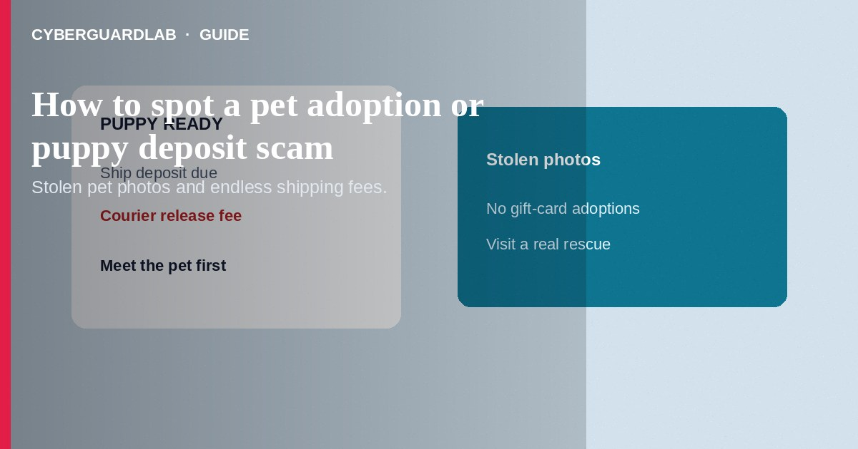
A pet adoption or puppy deposit scam advertises an adorable dog, cat, or “rescue” animal, then demands shipping fees, vaccination deposits, crate costs, or adoption payments before you meet the pet—often with photos stolen from real breeders or shelters. Do not wire money or buy gift cards for an animal you have not met. Do not accept “I’ll ship first, you pay the courier” stories. If you already paid, stop contact, save evidence, and report to the FTC.
This guide is about fake rehoming and puppy deposit schemes—not Craigslist apartment rental deposits. Fake-check twists overlap with fake check scams. No software purchase required.
Paid link
Norton 360 | See the Norton first-year offer

See the Norton first-year offer
Offer page: https://cyberguardlab.com/norton

1. How pet adoption and puppy deposit scripts work
Listings show puppies “ready now” at a bargain. The “owner” is moving, deployed, or can’t keep the litter. After you inquire, they demand a holding deposit, then more for transport, insurance, or customs. Some send a fake check to cover shipping and ask you to return part of it.
- Stolen cute photos — Images lifted from real rescues or breeders.
- Stacked shipping fees — Endless courier, crate, and “release” charges.
- No live video — Excuses forever for why you cannot see the animal in real time.
- Fake-check wrap — Overpay and refund patterns (fake check scam).

2. Red flags before you pay
Cue | Likely legitimate | Likely scam
Meeting the animal | In-person visit or verified shelter/rescue process | Pay first; meet never happens
Payment | Transparent fees to a known rescue/breeder with a physical footprint | Gift cards, wires, crypto, or endless add-on shipping fees
Photos and video | Live video, consistent background, real-time answers | Only stock photos; excuses why video is impossible
Papers | Health records you can verify with a vet clinic | Blurry PDFs and pressure to decide immediately
Location story | Local pickup or reputable transport you arrange | Courier holding the puppy—pay release fee now
Communication | Consistent name and reachable phone | Scripted emails; new fee every reply

3. Safer habits (buy-nothing)
- Prefer local shelters, rescues, and breeders you can visit.
- Reverse-image search pet photos when the deal feels unreal.
- Refuse gift cards and surprise courier release fees.
- Ask for a live video call; hang up on endless excuses.
- Verify microchip or clinic claims independently when provided.
- Flag and report suspicious ads on the platform where you found them.

4. If you already paid
- Stop paying any further “final” fees. Scammers stack them on purpose.
- Save listings, chats, payment receipts, and websites used.
- Contact your bank, wire service, or card issuer to report fraud immediately (FTC if you were scammed).
- If gift cards were involved, contact each issuer’s fraud department with details.
- Report at ReportFraud.ftc.gov; notify the platform.
- If you opened attachments or used a fake payment portal, change passwords and ignore recovery callers.

FAQ

Can a real rescue ask for an adoption fee online?
Yes, many do—but after an application process with a verifiable organization. Blind deposits to a stranger for a puppy in another state are high risk.

They sent papers with a vet’s name. Is that enough?
Call the clinic using a number you look up yourself. Scammers forge letterhead.

How is this different from a rental deposit scam?
Both demand money before delivery, but pet scams weaponize animal urgency and shipping fees. Rental scams weaponize housing need and keys.

Is a rehoming fee always a scam?
Not always, but combine it with remote-only contact and gift-card payment and you should walk away.

What if they threaten the animal if I stop paying?
Do not send more money. Report with your evidence; continued payment rarely results in a real pet arriving.

Do I need paid antivirus to avoid a puppy deposit scam?
No. Meeting the animal and refusing gift-card shipping fees is enough. Buy-nothing is valid.

If you still want a paid suite
Avoiding a pet adoption or puppy deposit scam does not require paid antivirus. Careful habits and official support paths are a valid buy-nothing stack. If you want multi-device paid protection later, use only these on-site paid links: TotalAV (paid link), Norton (paid link), Bitdefender (paid link), McAfee (paid link), Avast (paid link).

Sources
- Online Shopping Tips (FTC)
- ReportFraud.ftc.gov
- IdentityTheft.gov
- Fake Check Scams (FTC)

Also read
- How to spot a Craigslist rental deposit scam
- How to spot a fake check scam
- How to spot a Zelle or Cash App payment scam
- How to spot a phishing email
- How to report a scam to the FTC

