
How to spot a PayPal goods and services scam
https://cyberguardlab.com/blog/paypal-goods-services-scam
Independent US household comparison site. Not the vendor. Paid links below may earn a commission. Confirm first-year price, renewal, device limit, and refund terms at checkout.
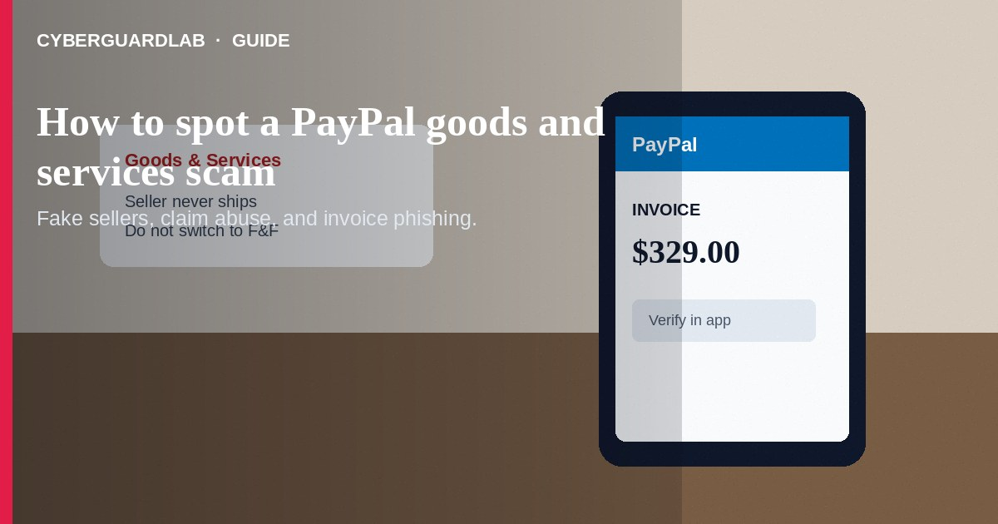
A PayPal Goods and Services scam uses PayPal's buyer–seller flow to steal money or goods. Scammers pose as sellers who never ship, buyers who abuse claims, or “support” who push you off platform. Do not send money outside PayPal to “upgrade,” “verify,” or “unlock” a purchase. Do not pay with gift cards or wires for an online order.
This guide covers Goods and Services purchase and claim abuse. It is distinct from Zelle or Cash App send-money scams and from Cash App refund or deposit scams. It overlaps with fake check overpayment and phishing emails. No software purchase required.
Paid link
Norton 360 | See the Norton first-year offer

See the Norton first-year offer
Offer page: https://cyberguardlab.com/norton

1. How PayPal goods and services scripts work
The wording changes, but the goal is usually the same: get you to pay under weak protection, ship goods you cannot recover, or hand over account access.
- Fake seller bargain — Phones, tickets, pets, or rentals appear at a too-good price. The seller steers you to PayPal Goods and Services (or flips you to Friends and Family), then disappears, ships an empty box, or sends tracking that never moves.
- Fake invoice email — A look-alike PayPal invoice asks you to pay through a short link. The page collects passwords or card details (FTC phishing guidance).
- Buyer overpayment — A buyer “overpays” and demands a partial refund—similar to a fake check scam. If the original payment reverses, your separate refund is the real loss.
- False item-not-received claims — After receiving goods, a buyer opens a dispute. Sellers need proof of shipment and clear communication inside PayPal.
- “PayPal Support” impostors — An unsolicited call or message after a purchase asks for codes, remote access, or a fee. Real help starts when you open PayPal Help yourself (PayPal Help Center).

2. Red flags before you pay or ship
Cue | Likely legitimate | Likely scam
Seller history | Established shop or known person you can verify | Brand-new account, pressure to decide in minutes
Payment path | Official PayPal Goods and Services for the item | Friends and Family only, gift cards, crypto, wire, or off-app cash apps
Invoice source | Created after you start checkout in PayPal or a known merchant site | Cold email or SMS “invoice” with a short link
Price and story | Matches market reality | Too-good pricing plus urgency or “shipping agent” fees
After payment | Clear tracking and a responsive seller | Silence, fake tracking, or sudden customs-fee asks
Support contact | You open PayPal Help yourself | Unsolicited call asking for codes or remote desktop

3. Safer habits (buy-nothing)
- Start on sites you trust. Open PayPal yourself—do not use invoice links from strangers (FTC online shopping tips).
- Prefer Goods and Services for marketplace buys when buyer protection may apply. Be wary if a seller demands Friends and Family.
- Confirm amount, item, and seller username inside PayPal before you pay.
- Never pay a second shipping, insurance, or verification fee outside PayPal.
- Ignore unsolicited PayPal support calls. Use in-app or official site help only.
- If you sell, require proof of shipment, keep unedited tracking, and be careful with unusual partial-refund requests after “accidental” overpayment.

4. If you already paid
- Stop further payments. Document the listing, chat, invoice, and PayPal transaction ID.
- Open a dispute or claim in PayPal within the stated time windows when eligible.
- Contact your bank or card issuer if a linked card or balance was involved and PayPal options are exhausted (FTC guidance if you were scammed).
- Report the seller or phishing page through PayPal security channels in Help, then file at ReportFraud.ftc.gov.
- If you entered a password on a fake PayPal page, change PayPal and email passwords, enable two-factor authentication, and review devices and recovery options.
- Be wary of “recovery” callers who promise to retrieve the money for another upfront fee.

FAQ

Is PayPal Goods and Services always safe?
No payment method is risk-free. Goods and Services can offer more purchase protection than Friends and Family, but fake sellers and phishing still exist. Read PayPal's current buyer protection rules for your case.

A seller asked me to switch to Friends and Family for a discount. Should I?
Usually no. That switch often removes useful purchase protection. Walk away if the only reason is a small discount.

I received a PayPal invoice I did not expect. What should I do?
Do not pay or click links in the message. Sign in by opening PayPal yourself and check whether a real invoice exists.

How is this different from a Cash App refund scam?
Cash App refund scams bait you with fake incoming money. This scam centers on PayPal checkout, invoices, shipping, and claims for goods or services. See also Cash App refund and deposit scams.

Can scammers open a claim against me as a seller?
Yes. Keep proof of shipment and communication. Respond in PayPal with tracking and documentation. Be cautious with overpayment refund requests.

Do I need paid antivirus to avoid a PayPal goods scam?
No. Careful checkout habits, official app sign-in, and refusing off-platform fees are enough. Buy-nothing is valid.

If you still want a paid suite
Avoiding a PayPal goods and services scam does not require paid antivirus. Careful payment habits and official support paths are a valid buy-nothing stack. If you want multi-device paid protection later, use only these on-site paid links: TotalAV (paid link), Norton (paid link), Bitdefender (paid link), McAfee (paid link), Avast (paid link).

Sources
- Online Shopping Tips: Spotting Scams and Keeping Your Money Safe (FTC)
- ReportFraud.ftc.gov
- IdentityTheft.gov
- PayPal Help Center

Also read
- How to spot a Cash App refund or deposit scam
- How to spot a Zelle or Cash App payment scam
- How to spot a fake check scam
- How to spot a phishing email
- How to report a scam to the FTC

