
How to spot a payday loan application phishing site
https://cyberguardlab.com/blog/payday-loan-phishing-site
Independent US household comparison site. Not the vendor. Paid links below may earn a commission. Confirm first-year price, renewal, device limit, and refund terms at checkout.
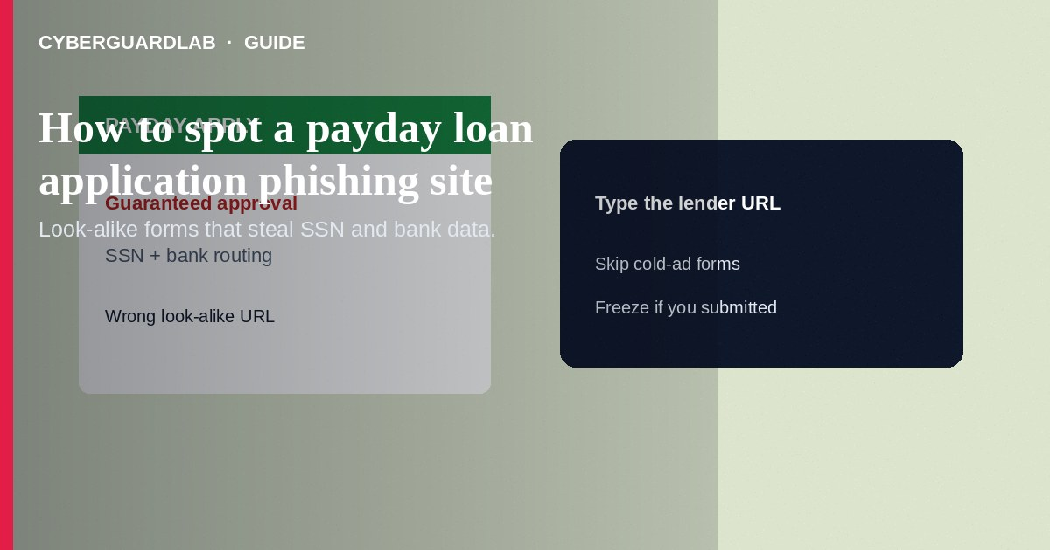
A payday loan application phishing site copies a lender’s branding and tricks you into submitting SSN, bank routing numbers, employer details, and photos of ID on a look-alike form—then sells or abuses that data. Stop if the URL is wrong, the offer is “guaranteed approval in minutes” from a cold ad, or the site asks for remote-access software. If you already submitted data, change banking passwords, monitor accounts, consider a credit freeze, and report to the FTC. This guide is about fake payday-loan application pages—not fake IRS W-2 phishing, not credit repair pitches, and not legitimate loan comparison on sites you typed yourself.

1. How payday loan phishing sites work
Search ads and social posts promise “$1,000 cash today—no credit check.” The landing page looks like a national payday or installment lender: logos, chat widgets, and progress bars. After you enter personal and banking data, the page errors, demands an “insurance fee,” or installs a helper app. Sometimes a caller continues the script and asks for a one-time bank code or TeamViewer access “to finish funding.”
Paid link
Norton 360 | See the Norton first-year offer

See the Norton first-year offer
Offer page: https://cyberguardlab.com/norton
Unlike W-2 phishing—which targets employees with fake HR tax forms—payday phishing targets people seeking short-term credit and harvests banking credentials plus employer and income fields.
Texts that say your payday funds are ready and include a link are high-risk. Open lender apps from your phone’s app store or type the brand’s domain. Household shared PCs used for bill pay are frequent targets—clear sessions after any suspicious form.

2. Red flags before you submit
Cue | Likely legitimate | Likely scam
How you arrived | You typed the lender’s known domain or used a licensed storefront | Cold ad → shortened link → odd domain or homoglyph URL
Licensing | State lender license you can verify on a state regulator site | No license, fake seal images, or “FDIC insured loan form” misuse
Fees before funding | Clear APR and fees disclosed before you obligate | Pay a gift-card or wire “processing fee” to release funds
Software | Normal web or official app from an app store you opened yourself | Must install remote-access or APK outside official stores
Contact | Support numbers match the real lender’s published help pages | Only chat/Telegram; pressure to finish “before the offer expires”
Data ask | Needed underwriting fields on a verified site | Full SSN + bank login + selfie ID for a banner ad you just clicked

3. Safer habits (buy-nothing)
- Check the browser address bar character by character. Leave if it is not the lender you intended.
- Do not enter SSN, routing numbers, or online banking passwords on cold-ad forms.
- Never pay gift cards or crypto to “unlock” a payday deposit.
- Do not install remote-access tools for a loan agent.
- Prefer licensed lenders you research through your state regulator—not the first ad result.
- For tax-document phishing at work, see fake W-2 phishing—different lure, same data-theft goal.

4. If you already submitted data
- Contact your bank or credit union immediately; watch for ACH pulls and new payees. Ask about account alerts or a new account if credentials were taken.
- Change email and banking passwords on a clean device; turn on stronger two-factor methods than SMS when offered.
- Place free credit freezes at Equifax, Experian, and TransUnion—see credit freeze how-to.
- File at ReportFraud.ftc.gov and use IdentityTheft.gov if SSN or ID images were uploaded.
- If a fee was charged, dispute it with your card issuer or bank.
- Scan the device you used with a trusted tool such as Norton or Bitdefender. Keep one primary real-time antivirus—avoid stacking full suites. TotalAV, McAfee, and Avast are other on-site comparison options.

FAQ

How is payday-loan phishing different from W-2 phishing?
W-2 phishing impersonates employers or payroll to steal tax IDs and wage data. Payday phishing impersonates lenders to steal banking and identity data from loan seekers.

The site used a real lender’s logo. Is it safe?
Logos are easy to copy. Trust the domain and licensing checks you perform yourself.

Are all online payday loans scams?
No—but short-term credit is heavily marketed by fraudsters. Licensing, disclosures, and never paying advance “release” fees are key filters.

What if I only entered my email and phone?
Expect follow-up phishing calls and texts. Do not read codes aloud; report and block.

If you still want a paid suite
Avoiding how to spot a payday loan application phishing site does not require paid antivirus. Careful habits and official support paths are a valid buy-nothing stack. If you want multi-device paid protection later, use only these on-site paid links: TotalAV (paid link), Norton (paid link), Bitdefender (paid link), McAfee (paid link), Avast (paid link).

Sources
- FTC: Online lending and loan scams (consumer guidance hub)
- FTC: How to spot phishing
- FTC ReportFraud
- IdentityTheft.gov
- CFPB: Payday loans consumer topic

Also read
- How to spot a fake IRS Form W-2 phishing email
- How to spot a fake credit repair company scam
- How to place a credit freeze at all three bureaus
- How to spot a phishing email
- How to report a scam to the FTC

