
How to recover from a password manager vault breach alert
https://cyberguardlab.com/blog/password-manager-vault-breach-alert
Independent US household comparison site. Not the vendor. Paid links below may earn a commission. Confirm first-year price, renewal, device limit, and refund terms at checkout.
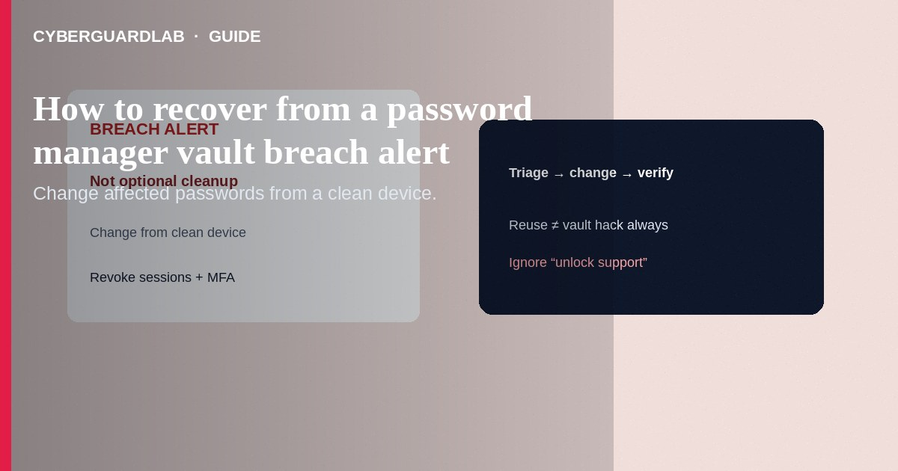
When your password manager shows a breach / dark-web / reused / compromised alert, treat it as an incident: change the affected passwords from a clean device, revoke sessions, and confirm MFA—not as optional cleanup. Alerts usually mean a site you use appeared in a known leak, or your vault found password reuse—not always that the manager itself was hacked. This playbook is breach-alert response—not day-one household password manager setup, not fake reset emails, and not clearing browser saves.

1. Triage steps
- Read the alert carefully: which sites/usernames are flagged? Note whether it says vault breach vs. watched password found in a public leak.
- Use a device you trust. If the PC acts odd, switch to a phone hotspot + known-clean machine.
- Unlock the official manager app/extension only—ignore parallel “vault support” emails/calls.
- For each flagged item (start with email and banking): open the real site by bookmark/typing, change to a new unique password generated by the manager, save it.
- Turn on or refresh MFA; prefer app codes or passkeys over SMS when available.
- Sign out other sessions / revoke app passwords on those accounts.
- If the same password was reused elsewhere, change those sites too—the manager’s “reused” report helps.
- If the alert claims the vault vendor itself was breached, follow that vendor’s official status/security bulletin (open from a bookmark), rotate the master password if they instruct, and enable any new MFA requirements.
- Scan the device with Norton or Bitdefender; keep one primary product (TotalAV, McAfee, Avast).
- Document what you changed for household members who share items.
Cold callers who claim they are 1Password/Bitwarden/LastPass staff and need your master password or a screen share are impersonators. Real vendors will not ask for your master password.
Paid link
Norton 360 | See the Norton first-year offer

See the Norton first-year offer
Offer page: https://cyberguardlab.com/norton

2. Alert type vs action
Alert flavor | Typical meaning | First action
Watched password in leak | Site or reuse appeared in known breach data | Rotate that login + siblings with same password
Weak / reused report | Health check inside your vault | Generate unique replacements on a schedule
Vendor security bulletin | Issue at the manager company | Follow official vendor steps only
Phish posing as the manager | Fake “unlock vault” email | Do not click—open the app yourself

3. Triage steps
- Read the alert carefully: which sites/usernames are flagged? Note whether it says vault breach vs. watched password found in a public leak.
- Use a device you trust. If the PC acts odd, switch to a phone hotspot + known-clean machine.
- Unlock the official manager app/extension only—ignore parallel “vault support” emails/calls.
- For each flagged item (start with email and banking): open the real site by bookmark/typing, change to a new unique password generated by the manager, save it.
- Turn on or refresh MFA; prefer app codes or passkeys over SMS when available.
- Sign out other sessions / revoke app passwords on those accounts.
- If the same password was reused elsewhere, change those sites too—the manager’s “reused” report helps.
- If the alert claims the vault vendor itself was breached, follow that vendor’s official status/security bulletin (open from a bookmark), rotate the master password if they instruct, and enable any new MFA requirements.
- Scan the device with Norton or Bitdefender; keep one primary product (TotalAV, McAfee, Avast).
- Document what you changed for household members who share items.

4. Alert type vs action
Alert flavor | Typical meaning | First action
Watched password in leak | Site or reuse appeared in known breach data | Rotate that login + siblings with same password
Weak / reused report | Health check inside your vault | Generate unique replacements on a schedule
Vendor security bulletin | Issue at the manager company | Follow official vendor steps only
Phish posing as the manager | Fake “unlock vault” email | Do not click—open the app yourself

FAQ

Does a breach alert mean hackers have my master password?
Not necessarily. Many alerts are about individual site passwords found in third-party leaks. Still rotate flagged items promptly.

Should I delete the password manager?
Usually no—the manager is how you fix reuse at scale. Fix hygiene; only switch products if you have a concrete trust reason.

How is this different from a fake password-reset email?
Reset phishing tries to steal a single account via email links. Vault alerts are warnings inside (or about) your manager’s monitoring—respond via official apps, not email links.

What if I ignored alerts for months?
Start today with email → banking → stores. Prioritize by impact, not chronological order.

If you still want a paid suite
Avoiding how to recover from a password manager vault breach alert does not require paid antivirus. Careful habits and official support paths are a valid buy-nothing stack. If you want multi-device paid protection later, use only these on-site paid links: TotalAV (paid link), Norton (paid link), Bitdefender (paid link), McAfee (paid link), Avast (paid link).

Sources
- CISA: Use strong passwords
- FTC: Protecting personal information
- IdentityTheft.gov
- Have I Been Pwned (breach notification service)

Also read
- How to set up a password manager for a US household
- How to spot a fake password-reset email
- How to check if your email was in a data breach
- How to clear saved passwords from a shared family PC
- How to turn on passkeys for Google, Apple, and Microsoft

