
How to set up a password manager for a US household
https://cyberguardlab.com/blog/password-manager-us-household-setup
Independent US household comparison site. Not the vendor. Paid links below may earn a commission. Confirm first-year price, renewal, device limit, and refund terms at checkout.
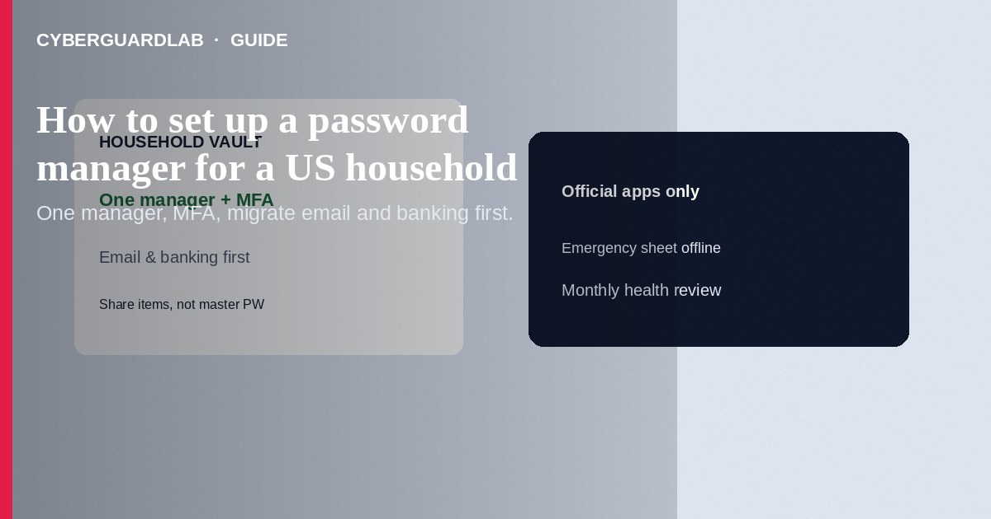
Set up one reputable password manager for a US household: pick a product, create a strong master password or account passkey, enable MFA on the vault, install official apps/extensions, and migrate the highest-risk logins first (email, banking, IRS/ID.me, stores). Share vaults carefully with family plans—never text master passwords. This how-to is household rollout—not vault breach alert recovery, not clearing browser-saved passwords on a shared PC, and not passkeys-only setup.

1. Setup steps (household)
- Choose a well-known manager (examples US consumers often compare: Bitwarden, 1Password, Dashlane, Keeper, or the manager bundled in a security suite you already trust). Prefer official sites/apps only.
- Create the primary adult’s account with a long unique master password or account passkey where supported. Write an emergency sheet stored offline.
- Turn on MFA for the vault (app codes or security keys—not SMS alone when better options exist).
- Install only official browser extensions and mobile apps; pin the extension.
- Import or manually add: primary email, banking, brokerage, tax/ID portals, Apple/Google/Microsoft, shopping, streaming.
- Generate unique passwords on each important site as you go; delete reused ones.
- Add passkeys for Google, Apple, and Microsoft when ready—see passkeys for Google/Apple/Microsoft.
- Use the family/household sharing feature for shared bills and streaming—not one master password for everyone.
- On shared family PCs, stop saving passwords in the browser after migration—see clear saved passwords.
- Schedule a monthly “fix weak/reused” review inside the manager’s health report.
When exporting or importing password CSVs, do it on a trusted device, delete the file securely afterward, and never email the CSV to yourself.
Paid link
Norton 360 | See the Norton first-year offer

See the Norton first-year offer
Offer page: https://cyberguardlab.com/norton

2. Household roles vs risky shortcuts
Topic | Safer household pattern | Risky shortcut
Master access | Each adult has their vault/MFA | One master password in a group chat
Kids / teens | Age-appropriate shared items; parental oversight | Full vault on a school Chromebook left unlocked
Emergency | Documented break-glass process | No recovery plan if the owner is unavailable
Devices | Official apps + OS updates | Pirated “premium” manager APKs

3. Setup steps (household)
- Choose a well-known manager (examples US consumers often compare: Bitwarden, 1Password, Dashlane, Keeper, or the manager bundled in a security suite you already trust). Prefer official sites/apps only.
- Create the primary adult’s account with a long unique master password or account passkey where supported. Write an emergency sheet stored offline.
- Turn on MFA for the vault (app codes or security keys—not SMS alone when better options exist).
- Install only official browser extensions and mobile apps; pin the extension.
- Import or manually add: primary email, banking, brokerage, tax/ID portals, Apple/Google/Microsoft, shopping, streaming.
- Generate unique passwords on each important site as you go; delete reused ones.
- Add passkeys for Google, Apple, and Microsoft when ready—see passkeys for Google/Apple/Microsoft.
- Use the family/household sharing feature for shared bills and streaming—not one master password for everyone.
- On shared family PCs, stop saving passwords in the browser after migration—see clear saved passwords.
- Schedule a monthly “fix weak/reused” review inside the manager’s health report.

4. After setup
- Turn off browser password saving prompts where you now use the manager.
- Keep one primary antivirus/endpoint product on Windows PCs such as Norton or Bitdefender; TotalAV, McAfee, and Avast are other on-site options.
- Teach everyone to spot fake password-reset emails.

FAQ

Is the free browser password manager “good enough”?
Built-in managers are better than reuse—but a dedicated manager often syncs cross-browser and offers better sharing/health reports. Pick one system and stick to it.

Should every family member share one vault?
No. Share specific items or folders. Separate vaults limit blast radius.

How is this different from recovering a vault breach alert?
Setup is day-one hygiene. Breach-alert recovery is the incident playbook when the manager warns that passwords appeared in leaks.

Do US banks allow password managers?
Most allow pasted passwords. If a site blocks paste, use the manager’s fill tool or contact the bank—do not revert to a short reused password.

If you still want a paid suite
Avoiding how to set up a password manager for a US household does not require paid antivirus. Careful habits and official support paths are a valid buy-nothing stack. If you want multi-device paid protection later, use only these on-site paid links: TotalAV (paid link), Norton (paid link), Bitdefender (paid link), McAfee (paid link), Avast (paid link).

Sources
- CISA: Use strong passwords / password managers
- FTC: Password managers (consumer guidance)
- CISA: Multifactor authentication
- Example vendor help (1Password families)

Also read
- How to turn on passkeys for Google, Apple, and Microsoft
- How to recover from a password manager vault breach alert
- How to clear saved passwords from a shared family PC
- How to spot a fake password-reset email
- How to turn on 2FA for Gmail, Apple, and bank

