
How to turn on passkeys for Google, Apple, and Microsoft
https://cyberguardlab.com/blog/passkeys-google-apple-microsoft
Independent US household comparison site. Not the vendor. Paid links below may earn a commission. Confirm first-year price, renewal, device limit, and refund terms at checkout.
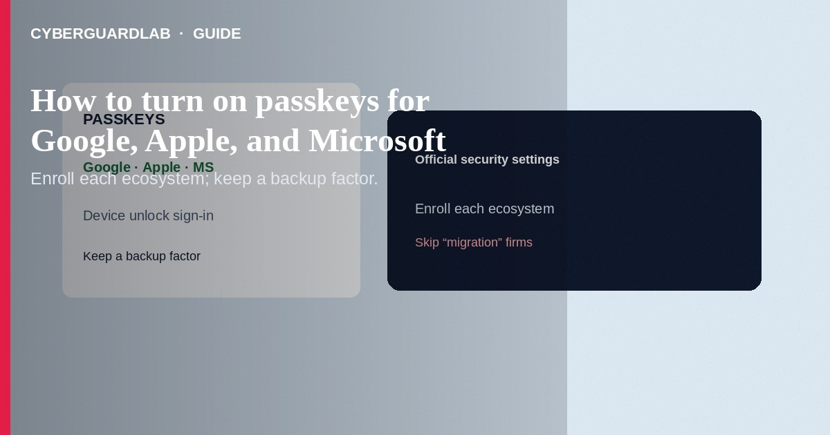
Turn on passkeys for your Google, Apple, and Microsoft accounts so sign-in can use device unlock (biometrics/PIN) instead of phishable passwords on supporting sites. Create passkeys from each account’s official security settings, keep a backup factor, and enroll household devices intentionally. This how-to is passkey enrollment on the big three ecosystems—not full household password-manager setup, not vault breach recovery, and not clearing browser-saved passwords.

1. Why passkeys help
Passkeys are designed so a fake website cannot replay the same secret the way stolen passwords can. Pair them with a password manager for sites that still need passwords. Still ignore fake password-reset emails.
Paid link
Norton 360 | See the Norton first-year offer

See the Norton first-year offer
Offer page: https://cyberguardlab.com/norton
Unsolicited services that ask you to export all passkeys into their portal for “family setup” are unnecessary. Use each platform’s built-in enrollment and your known password manager.

2. Cross-ecosystem checklist
Task | Do | Avoid
Where you enroll | Official account portals/apps | Links from cold “enable passkey” email
Backup | Second device + recovery codes where offered | Single phone with no spare factor
Sharing | Each adult enrolls their own | One shared Apple ID for all banking
Old passwords | Still unique in a manager for legacy sites | Deleting the manager the same day

3. Steps: Google, Apple, and Microsoft
Steps: Google account
- On a trusted device, open Google Account → Security (myaccount.google.com) by typing/bookmark—not an email link.
- Find Passkeys and security keys (wording may vary) and follow Create a passkey.
- Confirm with your phone/computer lock (fingerprint, face, PIN).
- Review devices with passkeys; remove old phones you no longer own.
- Keep 2-Step Verification options current as backup.
Steps: Apple ID (iPhone/Mac)
- Open Settings → [Your Name] → Sign-In & Security (or System Settings → Apple ID on Mac).
- Use Apple’s passkey / security options for the Apple Account and for Safari/iCloud Keychain passkeys on websites.
- Ensure iCloud Keychain is on if you want Apple-ecosystem sync of passkeys.
- Add a second trusted device so you are not locked to one phone.
Steps: Microsoft account
- Open account.microsoft.com → Security from a bookmark.
- Choose advanced security options and Add a new way to sign in or verify → passkey / face/fingerprint/PIN options as offered.
- Enroll Windows Hello on your PC when prompted for a device-bound passkey.
- Review “Sign-in activity” after enrollment for strangers.

4. After enrollment
- Practice signing out and back in once on each major device.
- Continue migrating other passwords via your household manager.
- Keep devices patched; use one primary security product on Windows such as Norton or Bitdefender (TotalAV, McAfee, Avast also listed on-site).

FAQ

Do passkeys replace my password manager?
Not fully. Many sites still need passwords. Passkeys cover supporting accounts; the manager covers the rest and stores backups.

How is this different from Google Advanced Protection?
Advanced Protection is a stricter program for high-risk users. Passkeys are a broadly available sign-in method you can enable without joining that program.

What if I lose my phone?
Use a second enrolled device, account recovery flows, or hardware keys you set up earlier. Enroll a spare before you need it.

Can a scammer “phish a passkey” with a fake login page?
Passkeys are origin-bound by design, which blocks classic look-alike password forms. Still do not approve unexpected device prompts.

If you still want a paid suite
Avoiding how to turn on passkeys for Google, Apple, and Microsoft does not require paid antivirus. Careful habits and official support paths are a valid buy-nothing stack. If you want multi-device paid protection later, use only these on-site paid links: TotalAV (paid link), Norton (paid link), Bitdefender (paid link), McAfee (paid link), Avast (paid link).

Sources
- CISA: Multifactor authentication
- Google Account Help: Passkeys
- Apple Support: Passkeys
- Microsoft Support: Passkeys (passwordless)

Also read
- How to set up a password manager for a US household
- How to use Safari passkeys instead of passwords on iPhone
- How to turn on 2FA for Gmail, Apple, and bank
- How to clear saved passwords from a shared family PC
- How to spot a fake password-reset email

