
How to spot a mystery shopper check scam
https://cyberguardlab.com/blog/mystery-shopper-check-scam
Independent US household comparison site. Not the vendor. Paid links below may earn a commission. Confirm first-year price, renewal, device limit, and refund terms at checkout.
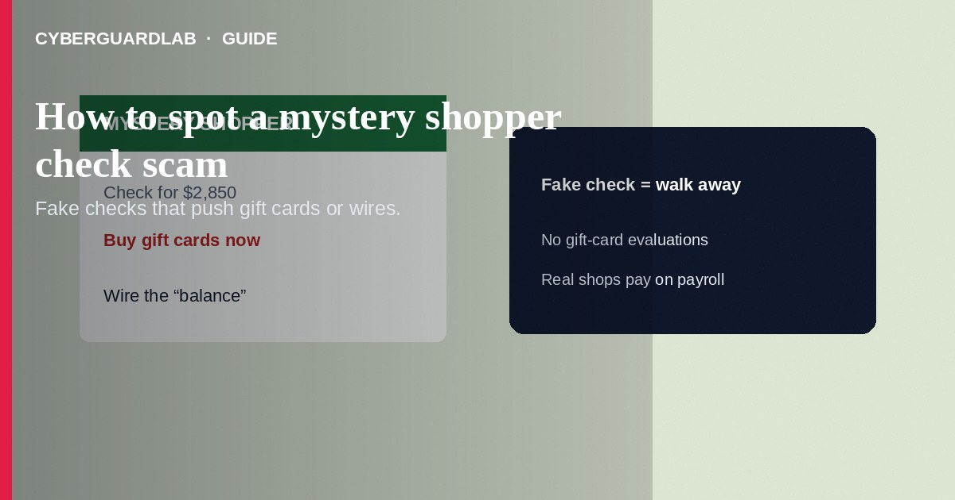
A mystery shopper check scam “hires” you to evaluate stores or money-transfer services, then mails a fake check and tells you to deposit it, buy gift cards or wire funds, and keep a “fee.” The check later bounces; the money you sent is gone and your bank may demand repayment. Do not deposit unexpected mystery-shopper checks or buy gift cards as a job task. If you already deposited a check and sent money, contact your bank the same day and report to the FTC. This guide is about fake-check mystery shopping—not work-from-home reshipping, not unpaid internship fee upfront charges, and not general gift card payment pressure outside a “shopper” job story.

1. How mystery shopper check scams work
You answer a job ad or get an email offering mystery-shopper work with flexible hours. A package arrives with a check for more than your “assignment”—often several thousand dollars—and instructions: deposit it, wait a day, then buy gift cards or use Western Union/MoneyGram to “test” a store’s cash services, and text the codes to your coordinator. They say you keep a few hundred as pay.
Paid link
Norton 360 | See the Norton first-year offer

See the Norton first-year offer
Offer page: https://cyberguardlab.com/norton
Banks may show provisional credit before the fake check clears. When it fails, you owe the full amount. Real mystery shopping companies do not pay by overpayment check and never require gift-card or wire “tests” funded from your deposit.
Scripts that ask you to evaluate Western Union or MoneyGram by sending cash to a name they provide are designed so the funds leave your control instantly. Real shopper assignments do not require you to fund strangers. Warn family members who answer flexible-income ads about overpayment checks.

2. Red flags before you cash a check
Cue | Likely legitimate | Likely scam
How you are paid | Pay after the shop through a known firm’s normal payroll | Large check arrives first; you must spend most of it
Task | Observe service, fill a survey, keep modest receipts | Buy gift cards or wire cash and send numbers to a stranger
Contact | Company you researched; no secrecy about “compliance” | Personal email, chat apps only, urgency to finish same day
Check amount | Matches agreed pay or expense range | Far above the job; “send the rest back” or “test funds”
Tools required | Phone notes or a company app | Must purchase Google Play, Apple, or Vanilla cards for “evaluation”
Recruiting | Clear application and background steps | Hired after one email; check mailed immediately

3. Safer habits (buy-nothing)
- Refuse any mystery-shopper job that starts with a check you must deposit and partly return.
- Never buy gift cards or send wires as a “shopping test.”
- Verify firms through industry directories you open yourself—not links in the offer.
- Talk the offer through with a trusted person before depositing anything.
- If a check arrives unsolicited for a job you barely applied to, do not deposit it—contact your bank’s fraud team for guidance.
- For gift-card-only pressure without a check story, see gift card scams.

4. If you already paid
- Call your bank or credit union immediately. Report the fake check and any wires or card purchases; ask about next steps and account monitoring.
- If you bought gift cards, contact each card issuer’s fraud line with card numbers, photos, and receipts—ask for a freeze and possible refund.
- Save the check images, envelope, emails, and chat logs.
- File at ReportFraud.ftc.gov.
- If you shared SSN or bank login for “onboarding,” use IdentityTheft.gov and change credentials.
- If you opened attachments from the “employer,” change passwords, enable two-factor authentication, and scan your device with a trusted tool such as Norton or Bitdefender. Keep one primary real-time antivirus—avoid stacking full suites. TotalAV, McAfee, and Avast are other on-site comparison options.

FAQ

The bank said the check “cleared.” Am I safe?
Provisional credit is not final clearance. Fake checks often reverse days later. Do not spend funds from an unexpected job check.

How is this different from a reshipping scam?
Reshipping moves physical stolen goods through your address. Mystery shopper check scams extract money via fake checks plus gift cards or wires.

Are all mystery shopping jobs fake?
Legitimate market-research shops exist, but they do not overpay by check and demand gift-card codes. That payment pattern is the scam.

What if I already spent the “fee” portion?
You may still owe the bank when the check bounces. Report quickly and keep documentation for disputes.

If you still want a paid suite
Avoiding how to spot a mystery shopper check scam does not require paid antivirus. Careful habits and official support paths are a valid buy-nothing stack. If you want multi-device paid protection later, use only these on-site paid links: TotalAV (paid link), Norton (paid link), Bitdefender (paid link), McAfee (paid link), Avast (paid link).

Sources
- FTC: Job scams
- FTC: Fake check scams
- FTC: Gift card scams
- FTC ReportFraud
- IdentityTheft.gov

Also read
- How to spot a fake check scam
- How to spot a work-from-home package reshipping scam
- How to spot a gift card scam
- How to spot a wire transfer romance or advance-fee scam
- How to report a scam to the FTC

