
How to spot a multi-level marketing pressure pitch
https://cyberguardlab.com/blog/mlm-pressure-scam
Independent US household comparison site. Not the vendor. Paid links below may earn a commission. Confirm first-year price, renewal, device limit, and refund terms at checkout.
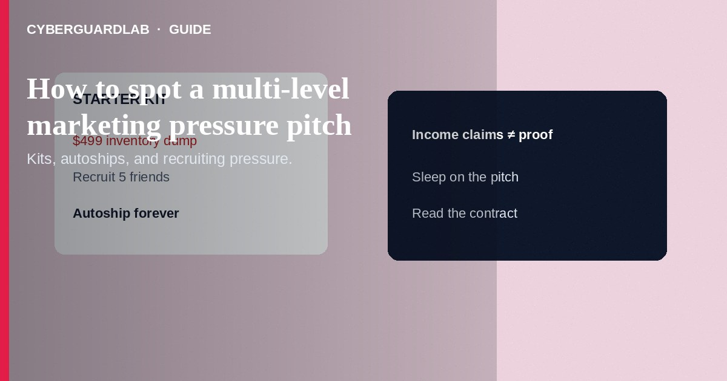
A multi-level marketing (MLM) pressure pitch pushes you to buy starter kits, monthly autoships, or event tickets—and to recruit friends—while downplaying whether anyone profits from actual product sales to real customers. High-pressure MLM pitches blur into fraud when earnings claims are deceptive, inventory loading is forced, or you must pay to “unlock” ranks. Do not borrow money, drain savings, or guilt-trip your contacts because a recruiter promises lifestyle cars and freedom. If you already bought inventory you cannot sell, stop autoships, document claims, and report deceptive practices to the FTC. This guide is about high-pressure MLM recruiting and inventory loading—not a fake unpaid internship fee, not a mystery shopper check, and not a pure investment romance pig butchering trading app.

1. How MLM pressure pitches work
A friend, classmate, or social DM invites you to “business ownership,” a Zoom “opportunity,” or a luxury lifestyle meetup. The pitch focuses on ranks, bonuses, and recruiting—not on whether end customers buy the product without being distributors. You are urged to buy a large starter pack “today,” sign autoship, and message everyone you know. Dissent is framed as negativity; quitting is framed as personal failure.
Paid link
Norton 360 | See the Norton first-year offer

See the Norton first-year offer
Offer page: https://cyberguardlab.com/norton
Some MLMs operate legally when they emphasize retail sales and avoid deceptive income claims. Pressure becomes a consumer-protection problem when recruiters invent income, require heavy inventory purchases, or hide that most participants lose money. Pyramid-like structures reward recruiting more than selling to people outside the network.
Pressure often starts as wellness tips or “who wants residual income?” in class, church, or campus chats. Ask for income disclosure documents before any purchase. Protect friends by refusing to forward recruitment scripts that omit loss rates.

2. Red flags before you buy a kit
Cue | Likely lower risk / more legitimate retail | Likely high-pressure / deceptive
Focus | Product value to customers who are not distributors | Recruiting tree, ranks, and “build your team” first
Earnings talk | Documented, typical results; clear that many earn little | Guaranteed cars, mansions, or “replace your salary in 90 days”
Buying in | Optional small samples; no loan pressure | Must buy large inventory or monthly packs to stay qualified
Social tactics | Time to research; written disclosures | Love-bombing, secrecy scripts, and “decide before you leave”
Refunds / exits | Clear buyback or cancellation policies you can use | Guilt, threats to reputation, or endless upsells to “fix” losses
Payment | Normal card checkout you control | Crypto, wires, or borrowing to hit a launch deadline

3. Safer habits (buy-nothing)
- Ask what share of revenue comes from retail customers who are not distributors—and demand written income disclosures.
- Refuse same-day inventory purchases, loans, or credit-card maxing “to go diamond.”
- Search the company name plus “FTC,” “settlement,” “complaint,” and “pyramid” before buying.
- Do not recruit friends under scripts that hide costs and failure rates.
- Sleep on it and talk to a trusted person who is not in the upline.
- For fake job fees dressed as career prestige rather than selling kits, see unpaid internship fee scams.

4. If you already paid
- Cancel autoships and recurring payments with your bank or card issuer if the company will not stop them.
- Request refunds or buybacks in writing using any policy in your agreement; keep order numbers.
- Save pitch decks, chat promises, and earnings claims for complaints.
- Report deceptive MLM practices at ReportFraud.ftc.gov.
- If you shared ID for “distributor onboarding” with a dubious overseas entity, monitor accounts via IdentityTheft.gov steps.
- If a pitch led you to a fake earnings dashboard or malware link, change passwords, enable two-factor authentication, and scan your device with a trusted tool such as Norton or Bitdefender. Keep one primary real-time antivirus—avoid stacking full suites. TotalAV, McAfee, and Avast are other on-site comparison options.

FAQ

Are all MLMs illegal?
No. Some are lawful direct-selling businesses. Deceptive earnings claims, inventory loading, and pyramid-like pay that depends mainly on recruiting can violate consumer-protection law—focus on conduct, not the label alone.

How is this different from an internship fee scam?
Internship fee scams sell fake placement access. MLM pressure sells inventory and recruiting as “business ownership.”

My upline says unsuccessful people just did not hustle enough.
Blaming victims is a common pressure tactic. Look at typical participant outcomes and your real retail customer base—not motivational quotes.

Can I get my starter kit money back?
Sometimes via company policy or card disputes for misrepresentation. Act quickly and document the pitch claims.

If you still want a paid suite
Avoiding how to spot a multi-level marketing pressure pitch does not require paid antivirus. Careful habits and official support paths are a valid buy-nothing stack. If you want multi-device paid protection later, use only these on-site paid links: TotalAV (paid link), Norton (paid link), Bitdefender (paid link), McAfee (paid link), Avast (paid link).

Sources
- FTC: Multi-level marketing
- FTC ReportFraud
- FTC: Business opportunity scams
- IdentityTheft.gov

Also read
- How to spot a fake unpaid internship fee scam
- How to spot a LinkedIn recruiter phishing scam
- How to spot a work-from-home package reshipping scam
- How to spot a mystery shopper check scam
- How to report a scam to the FTC

