
How to spot a military romance overseas money scam
https://cyberguardlab.com/blog/military-romance-overseas-money-scam
Independent US household comparison site. Not the vendor. Paid links below may earn a commission. Confirm first-year price, renewal, device limit, and refund terms at checkout.
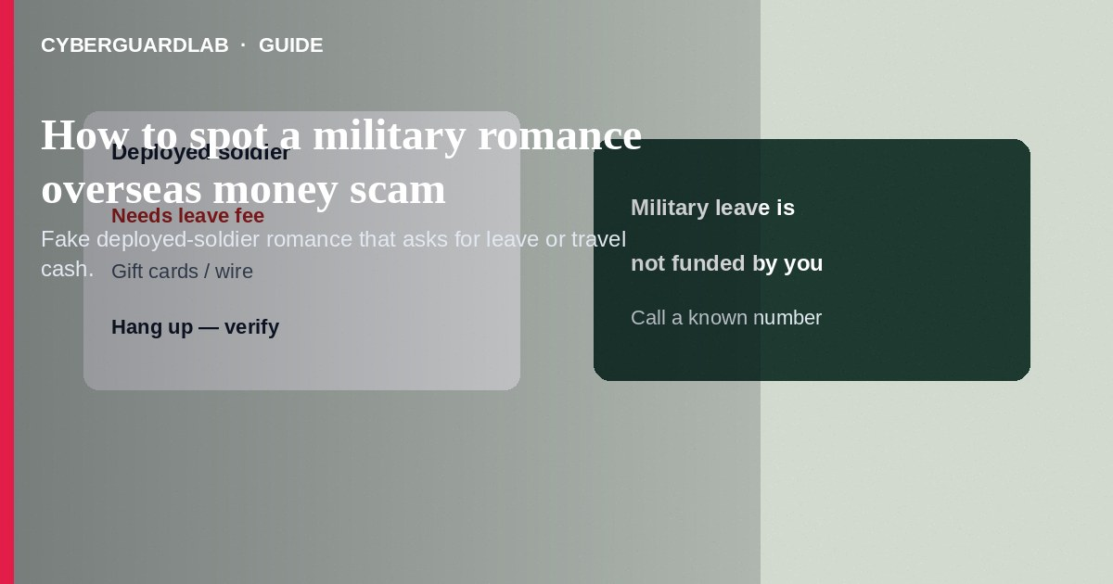
A military romance overseas money scam uses a fake U.S. or allied service-member identity—often “deployed,” “on a peacekeeping mission,” or “about to rotate home”—to build a long-distance relationship and then request money for leave, travel, medical bills, equipment, or customs. Do not send cash, gift cards, crypto, or wires to someone you have only met online as a soldier. Real service members do not need civilians to pay for leave or to release a shipment. If you already paid, stop contact, save messages, and report through the FTC and the platform. This guide is about fake-military romance requests for money—not pig butchering investment romance trading apps, and not a general catfish profile with no cash ask.

1. How this scam works
Profiles show a person in uniform, often with stock or stolen photos. Chat moves quickly to love and marriage plans. Then a crisis appears: unpaid leave documents, a broken laptop needed for orders, hospital fees for a child, or a package of gold/valuables stuck in customs that needs a fee. They may claim email is restricted and insist on WhatsApp or Google Chat only.
Paid link
Norton 360 | See the Norton first-year offer

See the Norton first-year offer
Offer page: https://cyberguardlab.com/norton
Unlike pig butchering, there is usually no fake trading dashboard—just repeated emergencies. Unlike sextortion, the pressure is guilt and love, not leaked intimate images. Impostors may drop official-sounding unit names; those details are easy to invent.

2. Red flags before you pay

3. Safer habits (buy-nothing)
- Never pay for leave, travel orders, medical care, or customs for someone claiming to be deployed.
- Demand a live video call with specific gestures; treat refusal as a deal-breaker.
- Reverse-search photos; stolen military images are common.
- Do not move the conversation off the dating app solely because they “cannot use email.”
- Verify claims through official public resources—not through phone numbers or emails the chat partner provides.
- For gift-card payment pressure, see gift card scams.
Some scripts claim valuables are waiting in a foreign port and only a fee will release them. That is advance-fee fraud dressed as romance. Do not pay. Share the pattern with family members who chat with new overseas “soldiers.”

4. If you already paid
- Stop sending money. Screenshot profiles, chats, payment receipts, and any “officer” emails.
- Contact your bank, wire service, or card issuer immediately to report fraud.
- If you bought gift cards, contact the card issuer’s fraud line with numbers and photos of the cards.
- Report the profile on the dating or social platform and file at ReportFraud.ftc.gov.
- Use IdentityTheft.gov if you shared ID images, bank details, or passwords.
- If you typed credentials or opened attachments on a fake page, change passwords, enable two-factor authentication, and scan your device with a trusted tool such as Norton or Bitdefender. Keep one primary real-time antivirus—avoid stacking full suites. TotalAV, McAfee, and Avast are other on-site comparison options.

FAQ

Do real deployed service members ever need money from dating partners?
Legitimate leave and travel are handled through official channels. Requests for civilians to fund leave, customs, or “finance office” fees are classic scam scripts.

How is this different from pig butchering?
Pig butchering pushes fake investment deposits. Military romance scams push crisis fees tied to a fake deployment story—usually without a trading app.

They sent me a photo of a badge and orders. Is that enough?
No. Documents are easy to forge. Independent verification and refusal of money requests matter more than images.

What if they say they already love me after a week?
Fast emotional intensity plus money asks is a warning pattern—not proof of a real relationship.

If you still want a paid suite
Avoiding a a military romance overseas money scam does not require paid antivirus. Careful habits and official support paths are a valid buy-nothing stack. If you want multi-device paid protection later, use only these on-site paid links: TotalAV (paid link), Norton (paid link), Bitdefender (paid link), McAfee (paid link), Avast (paid link).

Sources
- FTC ReportFraud
- IdentityTheft.gov
- FTC: Romance scams
- U.S. Army: Impersonation / romance scam awareness (search current Army.mil consumer alerts)
- FBI IC3

Also read
- How to spot a pig butchering investment romance scam
- How to spot a wire transfer romance or advance-fee scam
- How to spot a gift card scam
- How to spot a catfish profile on a dating app
- How to report a scam to the FTC

