
How to protect a Mac from malware with built-in tools
https://cyberguardlab.com/blog/mac-protect-from-malware
Independent US household comparison site. Not the vendor. Paid links below may earn a commission. Confirm first-year price, renewal, device limit, and refund terms at checkout.
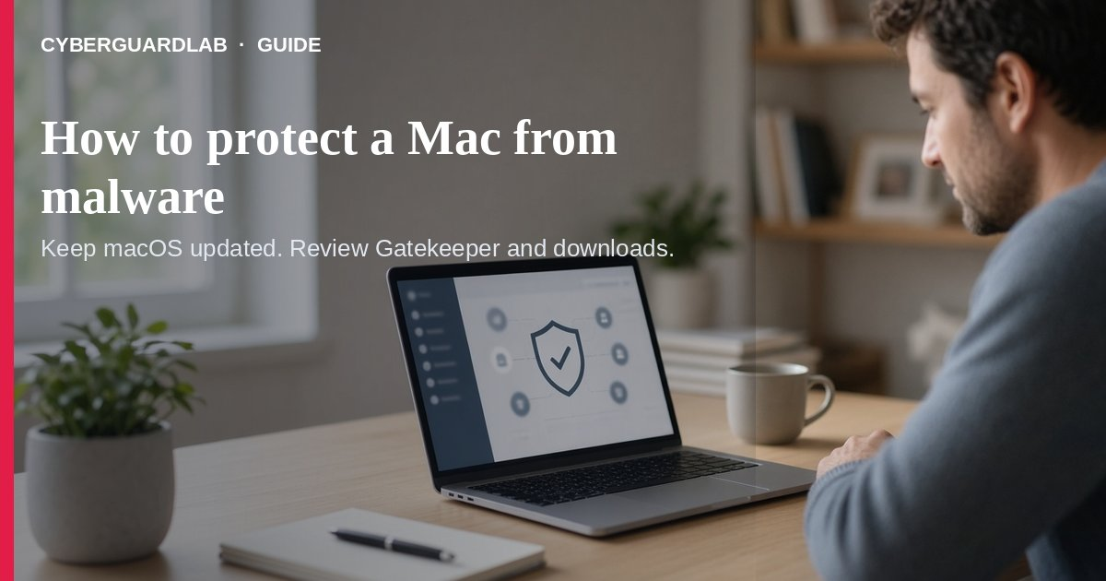
Protecting a Mac from malware starts with Apple’s built-in Gatekeeper, notarization checks, and Privacy & Security “Allow applications from” settings — not a scary pop-up that demands you call a number. Apple’s Mac User Guide explains how to limit app sources and what to do if macOS says a download is malware: put it in the Trash and empty the Trash. This guide is Mac-only built-in hygiene, not Windows Microsoft Defender, not Android Play Protect, and not fake virus warning pop-ups. Buy-nothing is a valid outcome.

1. What Apple’s built-in layers do
- App Store / known developers: macOS can require apps from the Mac App Store only, or App Store plus identified developers (Gatekeeper + notarization on modern macOS).
- First-open approval: macOS asks before opening newly downloaded software so you are not tricked into running unexpected apps.
- Known malware block: If Apple detects known malware, macOS can refuse to open the app and move it to the Trash (see Apple’s safely-open-apps article).
- User choice matters: Overriding warnings or running unsigned / unnotarized software raises risk — Apple documents this clearly.

2. Set “Allow applications from” (household default)
- Choose Apple menu → System Settings → Privacy & Security (scroll if needed).
- Under Security, open Allow applications from.
- Prefer App Store for the strictest household setting, or App Store and Known Developers if you install trusted developer apps.
- Keep automatic updates on so security data and macOS patches arrive.
- Treat odd “your Mac is infected — call this number” full-screen pages as scams — same pattern as fake Windows pop-ups.

3. If macOS says a download is malware
- Do not open the file again.
- Move it to the Trash and empty the Trash (Apple’s malware overview).
- Prefer re-downloading later only from a site or developer you verified yourself — same caution as checking downloads before opening on Windows.
- Change important passwords from a different trusted device if you already ran something suspicious.
- For a machine you no longer trust before sale or hand-me-down, follow wipe before selling.

4. Household habits (still buy-nothing)
- Do not install “Mac cleaner” or “virus remover” from pop-up ads.
- Be careful with scripts, web archives, and random disk images from email.
- Shared family Macs: keep the stricter Allow-applications setting and a standard user account for kids when practical.
- Phones in the same home still need their own tools (Play Protect / iOS updates) — Mac settings do not cover them.

FAQ

How do I protect a Mac from malware without buying antivirus?
Use Privacy & Security → Allow applications from (App Store or App Store + known developers), keep macOS updated, and trash items macOS flags as malware (Apple Support).
Paid link
Norton 360 | See the Norton first-year offer

See the Norton first-year offer
Offer page: https://cyberguardlab.com/norton
Ad link: https://trysecurities.com/offer/norton?dtm=gg&cid=

What should I do if macOS says a file is malware?
Put it in the Trash and empty the Trash; do not override the warning unless you fully trust the source.

Is Gatekeeper the same as Windows Defender?
Different platforms. Gatekeeper/notarization control what runs on Mac; Defender is Microsoft’s Windows protection. Both can be “buy nothing” baselines on their OS — see Is Microsoft Defender enough?.

Are full-screen “call Apple support” warnings real?
Usually not — treat them like fake virus pop-ups. Use real Apple Support URLs you type yourself.

Do I need a paid Mac antivirus?
Not required for this baseline. Buy-nothing with Apple’s built-ins is valid. Paid suites are optional for multi-device households.

If you still want a paid suite
Mac malware hygiene can stay on Apple’s built-in tools. If you want multi-device paid protection across PCs and phones, use only these on-site paid links: TotalAV (paid link), Norton (paid link), Bitdefender (paid link), McAfee (paid link), Avast (paid link).

Sources
- Protect your Mac from malware (Apple Mac User Guide)
- What is malware on Mac? (Apple Mac User Guide)
- Safely open apps on your Mac (Apple Support)

Also read
- Is Microsoft Defender enough?
- Android Play Protect malware scan
- Check a download before opening an EXE
- 8 ways to tell a virus warning popup is fake
- How to wipe a device before selling
- Automatic updates on Windows, Mac, and phone

