
How to spot a jury duty warrant scam
https://cyberguardlab.com/blog/jury-duty-warrant-scam
Independent US household comparison site. Not the vendor. Paid links below may earn a commission. Confirm first-year price, renewal, device limit, and refund terms at checkout.
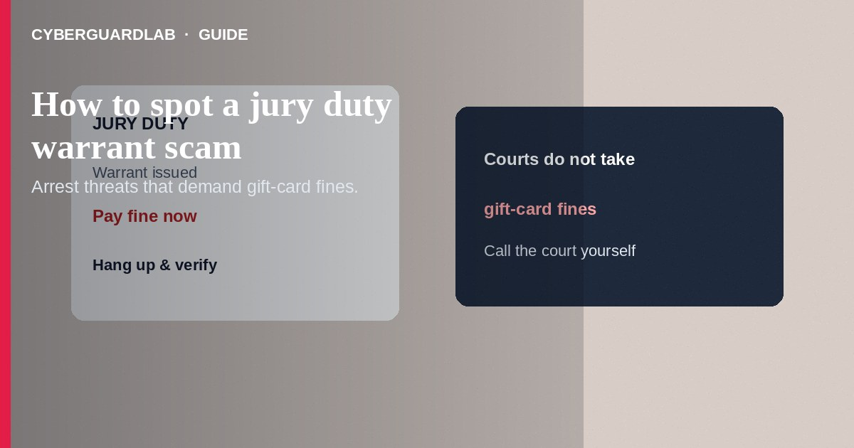
A jury duty warrant scam claims you missed jury service and that police will arrest you unless you pay a fine immediately—usually by gift card, wire, or cash transfer. Courts do not collect jury fines with gift cards over the phone. Do not pay. Hang up. Verify any jury issue through official court contact information you look up yourself.
This differs from IRS wage-garnishment threats and from DMV renewal texts. Payment demands often match gift card scams and other government impersonation patterns. No software purchase required.
Paid link
Norton 360 | See the Norton first-year offer

See the Norton first-year offer
Offer page: https://cyberguardlab.com/norton

1. How jury duty warrant scripts work
- Impersonation call — Callers pose as sheriffs, court clerks, or “jury coordinators,” recite a badge number, claim a warrant number, and demand secrecy.
- Gift-card fine — Payment moves to gift cards, wires, or crypto (FTC gift card scam guidance).
- Fake docket follow-up — Texts or emails arrive with fake docket PDFs. Spoofed caller ID may show a local courthouse.
- Arrest theater — Fear of arrest at work or in front of family drives rushed compliance. Scammers may keep you on the line while you drive to a store.
- Borrowed personal data — They may already know your name and city from data brokers.

2. Red flags before you pay
Cue | Likely legitimate | Likely scam
First notice | Official summons by mail or approved official channels in your jurisdiction | Surprise call threatening same-day arrest for missed jury duty
Payment | Court payments through official instructions you verify independently | Gift cards, crypto, retail cash reload, wire to a person
Communication style | You can hang up and call the court switchboard from a public listing | Forbids hanging up; coaches secrecy from family
Caller ID | Unreliable either way | Treated as proof by the caller
Personal data | Courts do not need your credit-card numbers via an urgent cold call in this gift-card pattern | Demands card numbers, codes, or remote access
Tone | Procedural | Threats, insults, countdown timers

3. Safer habits (buy-nothing)
- Hang up. Do not argue about the warrant story.
- Look up your local court or jury office on the official government website and call back separately.
- Ask family not to pay if someone else in the household got the call.
- Never buy gift cards to pay a “court fine.”
- If you truly missed a summons, handle it through official court procedures—not a threatening caller.
- Employers' HR teams are not collection agents for gift-card fines—do not pay while a stranger remains on an open call.

4. If you already paid
- Contact the gift-card company and your bank immediately with card numbers and amounts.
- Save the phone number, names used, and any warrant or case numbers given.
- Report at ReportFraud.ftc.gov. Local police non-emergency lines sometimes take reports for these scams as well.
- If you shared SSN or banking data, use IdentityTheft.gov guidance.
- Refuse “recovery agents” who want another fee.
- Remove any remote-support apps you installed and change passwords (FTC guidance if you were scammed).

FAQ

Can I really be arrested for missing jury duty?
Jurisdictions vary, but a cold call demanding gift cards is not how lawful process works. Verify only through official court channels.

They said my warrant is in the system and quoted my address. Real?
Address data is widely available. It does not prove a warrant. Check with the court directly.

Is this the same as an IRS arrest scam?
Same family of government-impersonation tactics, different agency story. Payment demands via gift cards are a shared tell. See IRS wage garnishment scams.

What should I tell older relatives?
Courts will not ask them to pay jury fines with steam cards or grocery gift cards. Hang up and call the court from a known number.

Do I need a lawyer after a scam call?
If you only hung up, usually no. If you paid or shared identity data, consider reporting steps and, for large losses, a consumer attorney or legal aid referral.

Do I need paid antivirus to avoid a jury duty warrant scam?
No. Hanging up and calling the court yourself are enough. Buy-nothing is valid.

If you still want a paid suite
Avoiding a jury duty warrant scam does not require paid antivirus. Hang-up habits and official court numbers are a valid buy-nothing stack. If you want multi-device paid protection later, use only these on-site paid links: TotalAV (paid link), Norton (paid link), Bitdefender (paid link), McAfee (paid link), Avast (paid link).

Sources
- Government Impersonation Scams (FTC)
- Gift Card Scams (FTC)
- ReportFraud.ftc.gov
- IdentityTheft.gov

Also read
- How to spot a gift card scam
- How to spot a fake IRS wage garnishment call
- How to spot a Social Security scam
- How to spot a DMV or license renewal text scam
- How to report a scam to the FTC

