
How to set up an IRS Identity Protection PIN
https://cyberguardlab.com/blog/irs-identity-protection-pin
Independent US household comparison site. Not the vendor. Paid links below may earn a commission. Confirm first-year price, renewal, device limit, and refund terms at checkout.
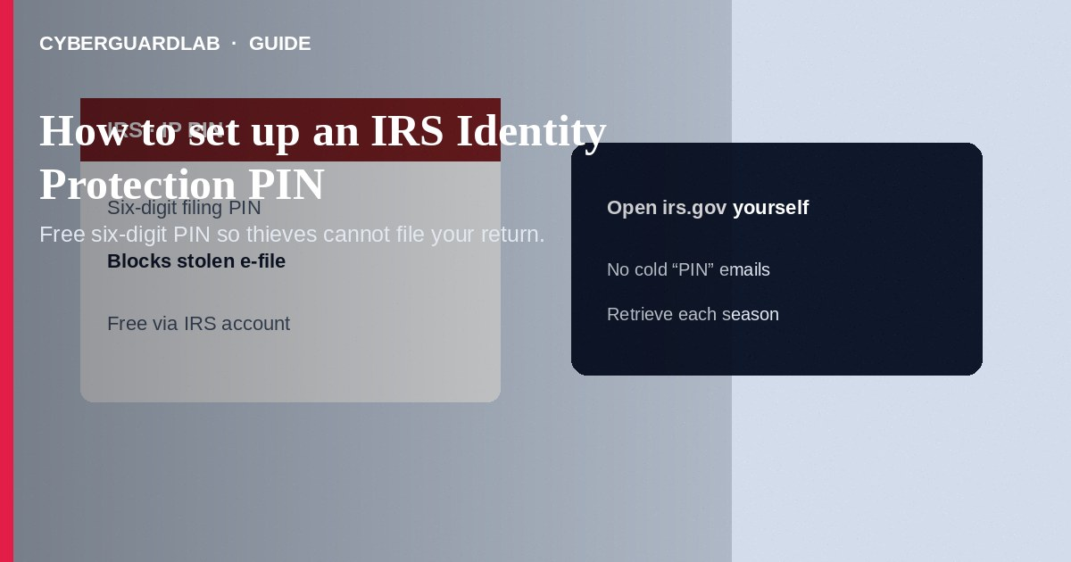
An IRS Identity Protection PIN (IP PIN) is a six-digit number known only to you and the IRS that must appear on your federal return so a thief cannot e-file or paper-file using your SSN or ITIN alone. Get one through your IRS Online Account (fastest), Form 15227 if you qualify, or an in-person Taxpayer Assistance Center appointment. Store it securely and retrieve the new PIN each year if you enrolled online. This how-to is about the IRS IP PIN for tax filing—not an Experian credit lock, not a three-bureau credit freeze, and not the recovery steps when a tax return was already filed by a thief.

1. When an IP PIN helps
Use an IP PIN if your SSN may be exposed, you want standing tax-file protection, or the IRS already assigned you one after identity-theft cases. Anyone with an SSN or ITIN who can verify identity can request a free IP PIN—including people who are not required to file this year. The PIN does not freeze credit or stop SIM swaps; it only blocks most fraudulent federal returns that omit your current IP PIN.
Paid link
Norton 360 | See the Norton first-year offer

See the Norton first-year offer
Offer page: https://cyberguardlab.com/norton
Scammers clone IRS branding and ask for SSN plus a fee to “unlock your IP PIN.” The IP PIN program is free through IRS channels. Type irs.gov yourself, complete identity proofing there, and never share the six digits with callers who claim to be collecting it for “verification.”

2. IP PIN vs credit tools
Tool | What it protects | Where you manage it
IRS IP PIN | Federal tax return filing in your SSN/ITIN | IRS Online Account / Form 15227 / TAC
Credit freeze | Most new-credit pulls of your bureau file | Equifax, Experian, and TransUnion separately (free)
Experian CreditLock | Experian file access via Experian’s lock product | Experian account (often tied to a membership)

3. Steps: get and use an IP PIN
- Open irs.gov yourself (bookmark it). Do not follow cold email or text links that claim to “issue your IP PIN.”
- Sign in to your IRS Online Account. If you lack one, complete IRS identity verification through the account-creation flow the IRS documents on its site.
- In your Profile, open the IP PIN section and enroll or retrieve your six-digit PIN. Copy it offline to a secure place—not a shared notes app tied to SMS recovery alone.
- If you cannot create an online account: eligible taxpayers with AGI below the IRS Form 15227 income limits may submit Form 15227 online; the IRS calls the phone number on the form to verify identity, then mails the PIN (often several weeks).
- If online and Form 15227 paths are unavailable, schedule an in-person appointment at a Taxpayer Assistance Center using the IRS locator or the scheduling number published on irs.gov.
- When you file Form 1040 (and the related 1040 variants the IRS lists for IP PIN use), enter the current six-digit IP PIN where your software or preparer prompts. Tax pros cannot request an IP PIN for you—they can only use the number you provide.
- If you retrieved the PIN online, plan to sign in again each filing season (typically after mid-to-late January) for the new annual PIN. Mailed PINs arrive on IRS notices for those on the mail path.
- After any tax phishing or device compromise, change passwords, enable stronger sign-in, and scan with a trusted tool such as Norton or Bitdefender. Keep one primary real-time antivirus—avoid stacking full suites. TotalAV, McAfee, and Avast are other on-site comparison options.

4. If something goes wrong
- Lost PIN before filing: retrieve it from your IRS Online Account or follow IRS “retrieve IP PIN” help—do not pay a third-party “PIN recovery” site.
- Software rejects the PIN: confirm you are using this year’s six digits and that every required person on the return who has an IP PIN includes theirs as IRS instructions require.
- You never enrolled but IRS mail says you have a PIN: treat unexpected mail carefully; verify through accounts you open yourself, not reply links.
- Someone already filed: see tax return filed by a thief and IdentityTheft.gov; still enroll in IP PIN after you resolve the case.
- Phishing texts ask for your IP PIN: the IRS does not demand your IP PIN by cold call, email, or text. Hang up; report at ReportFraud.ftc.gov.

FAQ

Is an IP PIN the same as a credit freeze?
No. An IP PIN is for IRS tax filing. Freezes restrict new-credit access at credit bureaus.

Can my tax preparer get an IP PIN for me?
No. Only you can obtain it after identity verification. You then give the six digits to your trusted preparer for that return.

Do I need an IP PIN if I do not file every year?
It can still protect your SSN/ITIN from someone filing in your name. IRS guidance allows voluntary enrollment for eligible people.

Will the IRS email me my IP PIN?
Do not trust cold email or text with “your PIN attached.” Use Online Account retrieval or official mail paths the IRS describes.

If you still want a paid suite
Avoiding how to set up an IRS Identity Protection PIN does not require paid antivirus. Careful habits and official support paths are a valid buy-nothing stack. If you want multi-device paid protection later, use only these on-site paid links: TotalAV (paid link), Norton (paid link), Bitdefender (paid link), McAfee (paid link), Avast (paid link).

Sources
- IRS: Get an Identity Protection PIN
- IRS: IP PIN FAQs
- IRS: Identity Protection PIN newsroom overview
- IdentityTheft.gov
- FTC ReportFraud

Also read
- What to do if your tax return was already filed by a thief
- How to place a credit freeze at all three bureaus
- How to lock or unlock your Experian credit file
- How to spot a fake IRS Form W-2 phishing email
- How to spot an IRS wage garnishment scam

