
How to turn on Stolen Device Protection on iPhone
https://cyberguardlab.com/blog/iphone-stolen-device-protection
Independent US household comparison site. Not the vendor. Paid links below may earn a commission. Confirm first-year price, renewal, device limit, and refund terms at checkout.
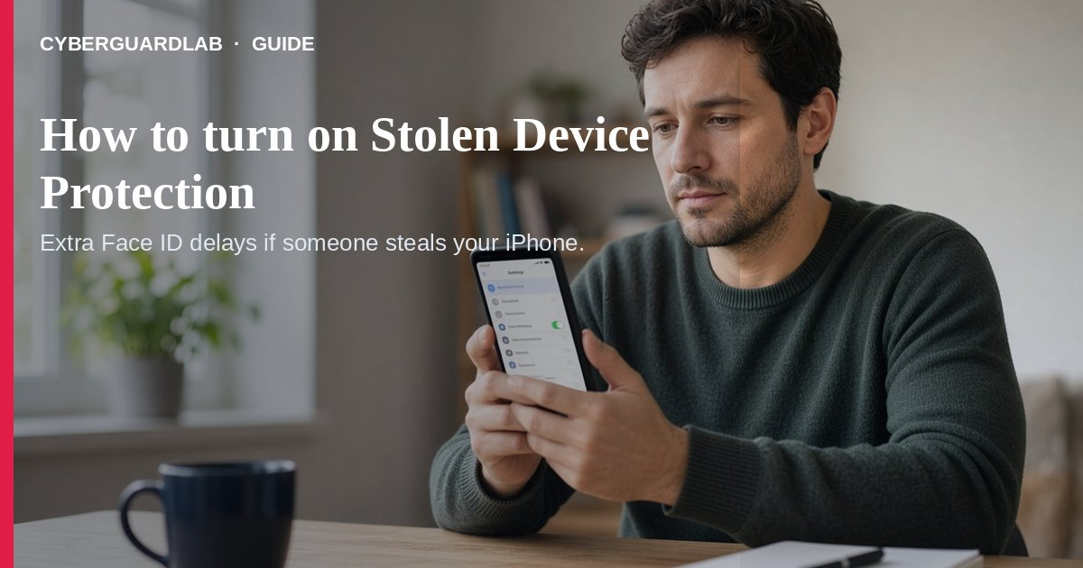
Stolen Device Protection adds extra Face ID / Touch ID checks (and sometimes a security delay) when your iPhone is away from familiar places like home or work — so a thief who knows your passcode has a harder time emptying Apple Account passwords, cards, or account settings. Apple says it is available with iOS 17.3 or later and must be turned on before the phone is lost or stolen. This guide is about turning the feature on, not the full lost-phone lock / Find My first-hour checklist and not SIM-swap recovery. No purchase required.

1. What it protects (Apple Support)
From Apple’s About Stolen Device Protection for iPhone:
Paid link
Norton 360 | See the Norton first-year offer

See the Norton first-year offer
Offer page: https://cyberguardlab.com/norton
Ad link: https://trysecurities.com/offer/norton?dtm=gg&cid=
- Away from familiar locations, some actions require biometric authentication with no passcode fallback (for example accessing stored passwords or credit cards).
- Some high-risk changes (such as changing your Apple Account password) also require waiting about an hour and authenticating again — the security delay is meant to give you time to mark the device lost.
- At familiar locations, you can usually use your passcode as usual unless you choose “always” require the extra measures.
- Find My must stay on while Stolen Device Protection is enabled.

2. Requirements before you enable it
- Two-factor authentication on your Apple Account.
- A device passcode.
- Face ID or Touch ID set up.
- Significant Locations (Location Services) available so familiar places can be learned.
- Find My turned on.
- iOS 17.3 or later.

3. Steps to turn it on
- Update iOS if needed — Settings → General → Software Update to iOS 17.3 or later.
- Open Face ID & Passcode — Settings → Face ID & Passcode (or Touch ID & Passcode).
- Enter your device passcode.
- Turn Stolen Device Protection on — Tap Stolen Device Protection, then turn it On.
- Optional: choose to always require the extra security measures, even at familiar locations.
- Confirm Find My — Settings → [your name] → Find My.
- Pair this with 2FA on email/bank and a password manager habit.

4. If the phone is already stolen
- Stolen Device Protection only helps if it was on beforehand — still mark the device lost on iCloud.com and follow Apple’s stolen-iPhone steps.
- Use our lost phone lock Apple / Google first-hour checklist.
- Watch for SIM-swap if texts stop arriving.
- Before selling a replacement later, wipe the old device when you recover it. Also review phone app permissions on the replacement.

FAQ

How do I turn on Stolen Device Protection on iPhone?
Settings → Face ID & Passcode → Stolen Device Protection → On (Apple Support). Needs iOS 17.3+, passcode, biometrics, Significant Locations, Find My.

Does it replace Find My?
No. Find My must stay enabled; Stolen Device Protection adds biometric gates and delays for sensitive actions away from familiar places.

Can I turn it on after the phone is stolen?
You need it enabled before loss. After theft, mark lost and secure the Apple Account from another device.

Will it lock me out at home?
By default, extra steps apply away from familiar locations. You can optionally require them everywhere.

Do I need paid security software for this?
No. It is built into iOS. Buy-nothing is valid.

If you still want a paid suite
Stolen Device Protection is free OS security. Microsoft Defender (on household Windows PCs) plus iPhone built-ins are a valid buy-nothing stack. If you want multi-device paid protection, use only these on-site paid links: TotalAV (paid link), Norton (paid link), Bitdefender (paid link), McAfee (paid link), Avast (paid link).

Sources
- About Stolen Device Protection for iPhone (Apple Support)

Also read
- Lost phone: lock Apple and Google accounts first
- How to wipe a device before selling
- SIM-swap and stolen phone number recovery
- Turn on 2FA for Gmail, Apple, and bank
- Password manager vs browser passwords
- How to review phone app permissions

