
How to check for configuration profiles on iPhone
https://cyberguardlab.com/blog/iphone-configuration-profiles-check
Independent US household comparison site. Not the vendor. Paid links below may earn a commission. Confirm first-year price, renewal, device limit, and refund terms at checkout.
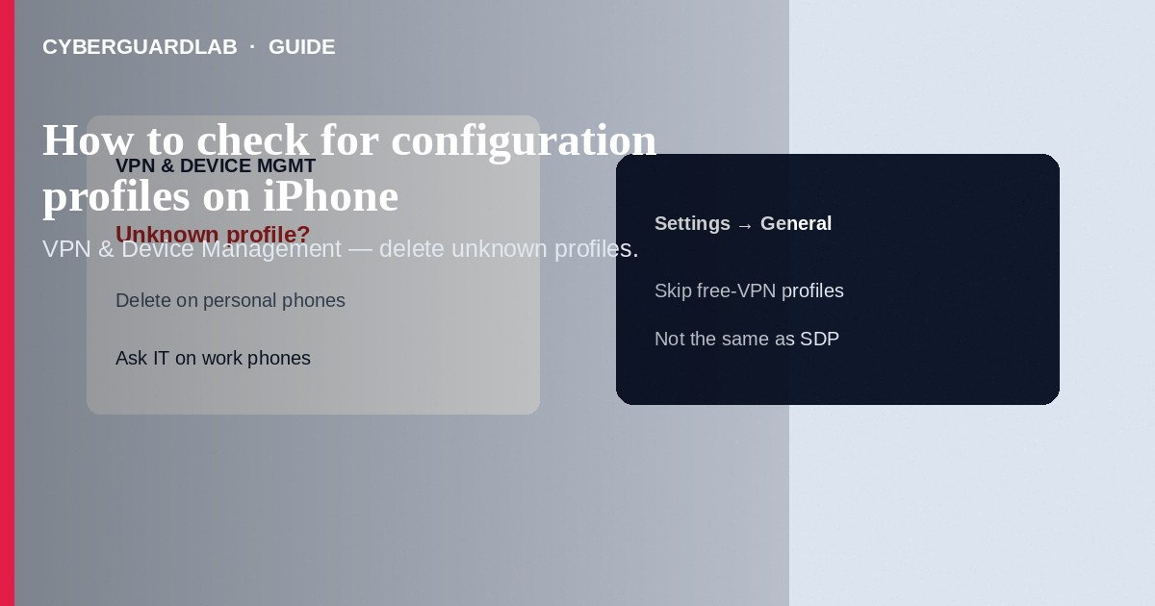
A configuration profile (or MDM enrollment) on iPhone can change VPN, Wi-Fi, certificates, accounts, and device management—useful for work or school, dangerous if installed from a phishing link or “free VPN” site. Check Settings → General → VPN & Device Management; remove unknown profiles you did not intend to install (ask IT first on employer/school phones). This how-to is about reviewing profiles on iPhone—not Stolen Device Protection and recovery contacts, not erasing a lost Apple Watch, and not fake App Store receipt phishing.

1. Why unknown profiles matter
Profiles can install roots of trust, force traffic through a VPN, or enroll the phone in mobile device management. Malicious or surprise profiles often arrive after you tap an email attachment, a “certificate required” pop-up on public Wi-Fi, or a site promising unlocks. Empty VPN & Device Management usually means no profiles—good for a personal phone.
Paid link
Norton 360 | See the Norton first-year offer

See the Norton first-year offer
Offer page: https://cyberguardlab.com/norton
Public networks that demand a configuration profile or root certificate before you get internet are high risk. Prefer personal hotspot or known networks. Never install a profile to “fix Apple ID security”—that is a common social-engineering script, not an Apple requirement.

2. Profile vs other Apple controls
Item | What it does | Where to check
Configuration profile / MDM | Pushes managed settings or enrollment | Settings → General → VPN & Device Management
Stolen Device Protection | Biometric + delay for sensitive changes away from familiar places | Settings → Face ID & Passcode (or Touch ID & Passcode)
Passkeys in Safari | Passwordless sign-in keys in iCloud Keychain | Settings → Passwords / Safari—see passkeys guide
Find My / Activation Lock | Locate and block reactivation | Settings → [Your Name] → Find My

3. Steps: review and remove profiles
- Update iOS. Unlock the phone yourself; do not share the passcode with anyone “helping” remotely.
- Open Settings → General → VPN & Device Management (wording may be Profiles & Device Management on older iOS).
- If the section lists nothing under Configuration Profile / Device Management, no profiles are installed—you are done.
- Tap each profile. Note the name, organization, description, and what it claims to manage (VPN, email, restrictions).
- For a personal phone: if you do not recognize it, tap Delete Profile, authenticate with Face ID / Touch ID / passcode, and restart the iPhone.
- For a work or school phone: contact IT before deleting—removal can break email, VPN, or apps and may violate policy.
- After removal, revisit the same Settings path to confirm the profile is gone. Change Apple Account password if you installed a profile after a phishing lure.
- Scan any Windows PC that was used in the same incident with a trusted suite such as Norton or Bitdefender. Keep one primary product—TotalAV, McAfee, and Avast are other on-site comparison options.

4. What to do if a profile reappears
- Do not reinstall profiles from cold email or SMS links.
- Check browsing history for the download source; treat look-alike Apple or carrier pages as phishing.
- Review Apple Account devices and recent security notifications at account.apple.com you type yourself.
- If MDM enrollment keeps returning and the phone is personal, you may need erase/restore after backing up—only after you understand work/school ownership.

FAQ

Is every VPN profile malicious?
No. Employers and schools issue legitimate ones. Unknown consumer “free VPN profile” downloads are the red flag.

Can I have profiles and Stolen Device Protection together?
Yes. Profiles manage settings; Stolen Device Protection hardens account changes. They solve different problems.

Settings shows Profile Downloaded but nothing installed.
You downloaded a profile that is waiting. Open Settings and either Install (only if trusted) or ignore until it expires—do not install unknown downloads.

If you still want a paid suite
Avoiding how to check for configuration profiles on iPhone does not require paid antivirus. Careful habits and official support paths are a valid buy-nothing stack. If you want multi-device paid protection later, use only these on-site paid links: TotalAV (paid link), Norton (paid link), Bitdefender (paid link), McAfee (paid link), Avast (paid link).

Sources
- Apple Support: Install or remove configuration profiles on iPhone
- Apple Support: Review and delete configuration profiles
- Apple Support: Install a configuration profile
- FTC: How to secure your devices

Also read
- How to turn on Stolen Device Protection recovery contacts
- How to erase an Apple Watch after it is lost
- How to spot a fake App Store receipt phishing email
- How to use Safari passkeys instead of passwords on iPhone
- How to turn on Find My and Activation Lock before travel

