
How to turn on Advanced Data Protection for iCloud
https://cyberguardlab.com/blog/icloud-advanced-data-protection
Independent US household comparison site. Not the vendor. Paid links below may earn a commission. Confirm first-year price, renewal, device limit, and refund terms at checkout.
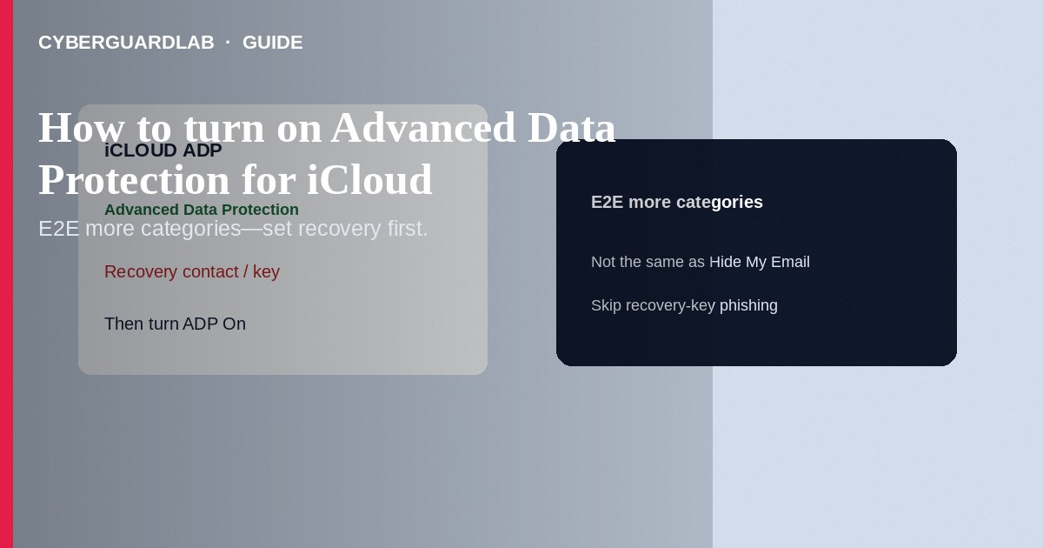
Advanced Data Protection (ADP) for iCloud extends end-to-end encryption to more categories (such as iCloud Backup, Photos, Notes, and others Apple lists for your OS version) so Apple cannot read that data in those categories—even in their data centers—while you hold the keys on trusted devices. Turn it on only after you set a recovery contact and/or recovery key you can truly store safely. This how-to is about enabling ADP—not Find My / Activation Lock, not Sign in with Apple reviews, and not Hide My Email.

1. Before you enable ADP
Update all devices that use the same Apple Account to versions that support ADP. Decide recovery: at least one recovery contact and/or a recovery key printed offline. If you lose all trusted devices and recovery methods, Apple cannot reset access to end-to-end data for you. ADP is optional; standard iCloud protection already encrypts data in transit and at rest with Apple-managed keys for many categories.
Paid link
Norton 360 | See the Norton first-year offer

See the Norton first-year offer
Offer page: https://cyberguardlab.com/norton
Do not send photos of recovery keys over iMessage to “helpers,” hotel business centers, or remote tech scammers. Print once, store offline, and keep Find My enabled so a lost phone does not become both a tracking and account-recovery disaster without a plan.

2. ADP vs related protections
Control | Protects | Tradeoff
Advanced Data Protection | More iCloud categories with end-to-end encryption | Recovery depends on you; Apple cannot help reset those keys
Standard iCloud encryption | Encryption with Apple-managed keys for many services | Apple can assist more account recoveries
Find My / Activation Lock | Device locate and reactivation lock | Not iCloud ciphertext policy
Hide My Email | Identity/email privacy for sign-ups | Not backup encryption

3. Steps: turn on Advanced Data Protection
- Update iPhone/iPad/Mac to a supported OS. Sign in with two-factor authentication enabled (required).
- Open Settings → [Your Name] → iCloud → Advanced Data Protection (Mac: System Settings → [Your Name] → iCloud → Advanced Data Protection).
- Follow prompts to add a recovery contact and/or create a recovery key. Store the recovery key offline—not in the same iCloud Notes you are about to protect exclusively via ADP assumptions.
- Ensure older devices are updated or removed from the account if they block enablement.
- Turn Advanced Data Protection on and wait for confirmation across devices.
- Periodically verify trusted devices at account.apple.com. Do not share recovery keys with “Apple Support” callers.
- ADP does not replace device passcodes or Find My. Keep those on for theft scenarios.
- Windows companions still need ordinary AV hygiene—Norton, Bitdefender, TotalAV, McAfee, or Avast as a single primary suite.

4. If you cannot turn ADP on
- Update or sign out unused old devices that lack support.
- Finish two-factor and account security notifications.
- Complete recovery contact/key setup—ADP will not enable without a recovery method Apple’s wizard accepts.
- If traveling soon, finish ADP at home on stable power/network—not in an airport rush.

FAQ

Does ADP encrypt everything in iCloud?
Apple documents which categories are end-to-end encrypted under ADP versus standard protection. Some services (for example certain collaboration or mail/contacts features depending on version) may differ—read Apple’s current ADP list for your OS.

Can Apple recover my Photos if I lose the recovery key and all devices?
Not for end-to-end categories under ADP. That is the deliberate tradeoff.

Is ADP the same as a device passcode?
No. Passcode protects the device locally; ADP changes how eligible iCloud cloud data is keyed.

Will phishing emails about “ADP renewal” be real?
Treat unexpected ADP emails with links as suspicious—enable or manage ADP only in Settings you open yourself. See also fake iCloud storage phishing.

If you still want a paid suite
Avoiding how to turn on Advanced Data Protection for iCloud does not require paid antivirus. Careful habits and official support paths are a valid buy-nothing stack. If you want multi-device paid protection later, use only these on-site paid links: TotalAV (paid link), Norton (paid link), Bitdefender (paid link), McAfee (paid link), Avast (paid link).

Sources
- Apple Support: Advanced Data Protection for iCloud
- Apple Support: Create a recovery key
- Apple Support: iCloud data security overview
- FTC: Protecting your privacy

Also read
- How to turn on Find My and Activation Lock before travel
- How to use Hide My Email for new sign-ups
- How to review Sign in with Apple app permissions
- How to spot a fake iCloud storage full phishing email
- How to recover an Apple ID without SMS access

