
How to secure home security cameras
https://cyberguardlab.com/blog/home-security-cameras
Independent US household comparison site. Not the vendor. Paid links below may earn a commission. Confirm first-year price, renewal, device limit, and refund terms at checkout.
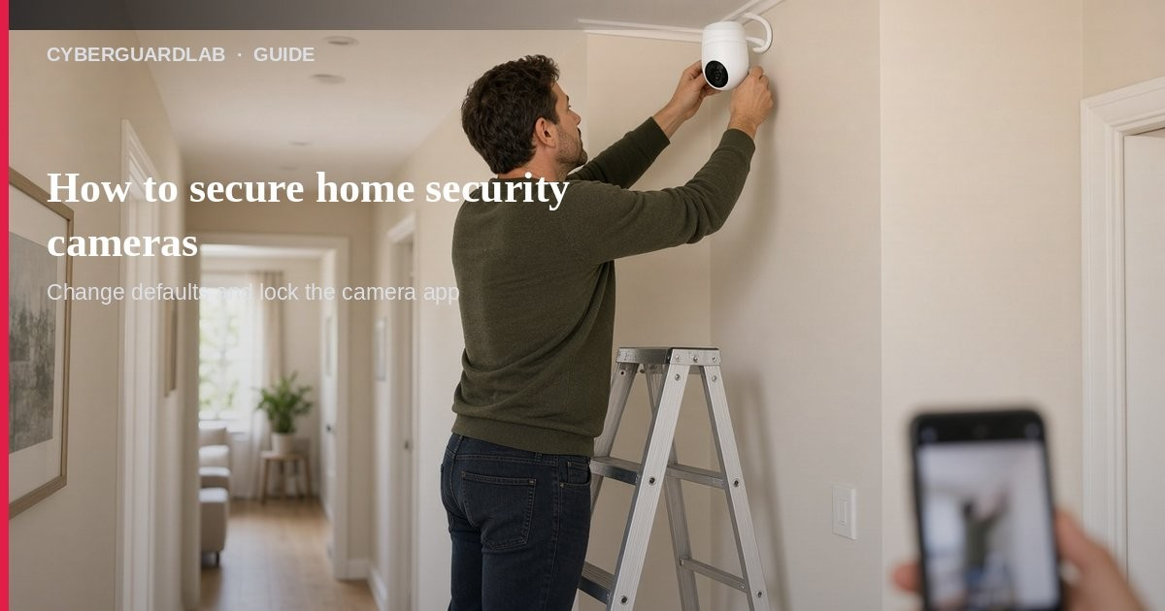
Home security cameras (doorbell cams, baby monitors, indoor/outdoor IP cameras) let you watch livestreams from a phone app — and they can be hacked if defaults stay weak. Per FTC camera guidance, start with encryption, unique passwords, updates, and a locked-down home Wi-Fi. This guide is about securing cameras you already own or plan to buy, not guest Wi-Fi setup alone or router firmware alone (those pages support this one). You do not need to buy antivirus to change a camera password.

1. Research before you buy (or audit what you have)
From FTC “How To Secure Your Home Security Cameras”:
Paid link
Avast Premium | See the Avast first-year offer
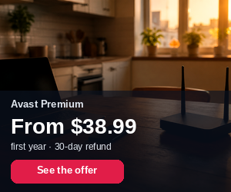
See the Avast first-year offer
Offer page: https://cyberguardlab.com/avast
Ad link: https://trysecurities.com/offer/avast?dtm=gg&cid=
- Look for built-in encryption for account info, livestreams, and archived video.
- Check the manufacturer site, box, or support for how encryption is enabled.
- Prefer cameras that support strong unique passwords and cloud MFA when video is stored online.
- Consider whether you need remote viewing at all for private rooms (bedrooms).
- Look for permission levels if you share the feed with a neighbor or sitter.

2. Lock down the home network first
Cameras usually sit on your Wi-Fi, so the router matters:
- Strong router password; firewall on; latest router software.
- Wi-Fi encryption set to WPA3 or WPA2 (FTC Wi-Fi advice).
- Put cameras on a separate network / guest Wi-Fi from laptops and phones when your router allows it — so a compromised PC is less likely to reach the cams. See guest Wi-Fi and router firmware.
- Review how to check if your home Wi-Fi is safe.

3. Numbered camera setup checklist
- Change the default username and password — Never leave factory credentials.
- Use a unique strong password — Not one reused from email or banking. See password manager vs browser passwords.
- Turn on encryption / HTTPS — If the camera has a web login, the page should stay on https before and after login.
- Enable MFA on the cloud account when available (CISA MFA guidance). See turn on 2FA.
- Update camera firmware and the phone app — Check the maker’s site or auto-update; keep the viewing app current.
- Tighten remote viewing — Encrypt the feed; limit which devices can watch; disable remote viewing if you do not need it.
- Share carefully — Use admin vs viewer roles; time-limit a friend’s access when you are traveling.
- Review access logs when the camera offers them (odd IPs or odd hours).

4. Privacy habits that do not require new software
- Aim cameras away from bathrooms and private spaces when possible.
- Know who has account access after a roommate moves out; rotate passwords.
- Unplug or power off indoor cams when you want a hard off switch.
- Before buying, check how long the maker promises software updates.
- Pair camera hygiene with ordinary PC habits — Defender is enough for many households.

FAQ

How do I secure home security cameras?
Change defaults, unique passwords, MFA on cloud accounts, encrypt livestreams, update firmware/apps, harden Wi-Fi, and prefer a separate camera network.

Do I need paid antivirus for my camera?
No. Cameras are secured mainly through passwords, updates, encryption, and network separation. Antivirus on a PC does not replace those steps.

Is guest Wi-Fi enough?
It helps isolate cameras from daily devices. Still change camera passwords and keep firmware updated.

What if I think someone is watching my feed?
Change passwords, revoke shared users, update firmware, review logs, and contact the manufacturer. Report account takeover patterns at ReportFraud.ftc.gov when money or identity is involved.

Should bedroom cameras stay remote-viewable?
FTC urges extra caution for private rooms; consider disabling remote viewing if encryption and access controls are weak.

If you still want a paid suite
Camera privacy is mostly configuration, not a new antivirus subscription. Microsoft Defender is a valid buy-nothing choice for many Windows households. What actually helps is unique passwords, MFA, updates, and network separation. If the household later wants multi-device paid protection, use only these on-site paid links: TotalAV (paid link), Norton (paid link), Bitdefender (paid link), McAfee (paid link), Avast (paid link).

Sources
- How To Secure Your Home Security Cameras (FTC)
- Securing Your Internet-Connected Devices at Home (FTC)
- How To Secure Your Home Wi-Fi Network (FTC)
- Turn On MFA (CISA)
- Update Software (CISA)
- ReportFraud.ftc.gov (FTC)
- Windows security overview (Microsoft)

Also read
- Set up a guest Wi-Fi network at home
- Update your home router firmware
- How to check if your home Wi-Fi is safe
- Turn on 2FA for Gmail, Apple, and bank
- Password manager vs browser passwords

