
How to spot an HOA dues payment portal scam
https://cyberguardlab.com/blog/hoa-dues-payment-portal-scam
Independent US household comparison site. Not the vendor. Paid links below may earn a commission. Confirm first-year price, renewal, device limit, and refund terms at checkout.
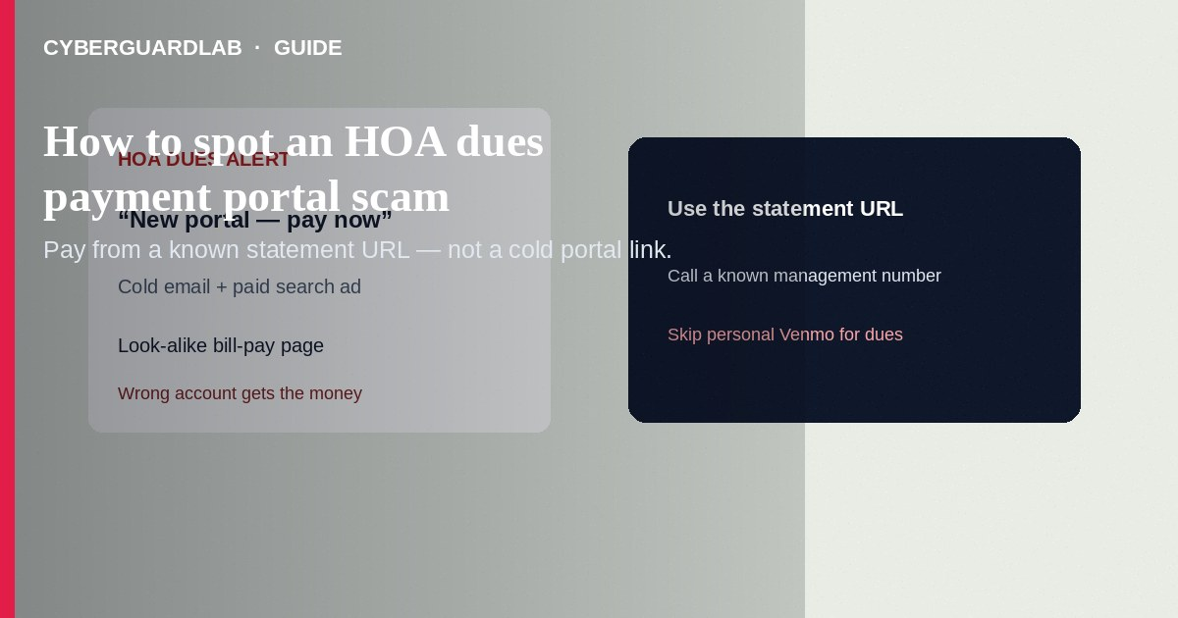
An HOA dues payment portal scam uses a fake management email, search ad, or cloned “resident portal” so you pay assessments to the wrong place—or hand over bank login details. Pay only through the portal or remittance details printed on a statement you already trust, or a URL your management company confirmed out-of-band. This guide is HOA / condo association bill-pay impersonation—not utility shutoff scripts alone, and not general phishing without the dues angle.

What this scam looks like
Messages claim “dues past due—pay in the new portal,” “board updated the bank account—wire today,” “special assessment: click to avoid a lien,” or “your HOA app needs re-login.” Search ads for “[your HOA name] pay dues” may open a third-party look-alike that adds surprise fees or never forwards the payment. Some pages harvest routing numbers, portal passwords, or driver’s license uploads “for verification.”
Paid link
Norton 360 | See the Norton first-year offer

See the Norton first-year offer
Offer page: https://cyberguardlab.com/norton

Legitimate vs scam cues
Cue | Likely legitimate | Likely scam
How you found the portal | URL/app from a prior statement, welcome packet, or management letter | Cold email link or top paid search ad you clicked in a hurry
Payment change | Written notice on letterhead + confirmation via a phone number you already had | “New ACH only” with urgency; wire/gift card/crypto
Fees | Known portal convenience fee disclosed by your association | Unexpected “delivery” or subscription add-ons on an unfamiliar site
Tone | Matches past HOA notices; allows normal grace periods | Lien/foreclosure threats in hours; “board emergency”
Login | Same portal domain you used last quarter | New domain asking for bank credentials or full SSN to “unlock dues”

What to do before you pay
- Open last month’s HOA statement or welcome packet. Use the printed portal URL, coupon, or lockbox address—do not trust a new link in email alone.
- If search is your only option, scroll past paid ads. Prefer typing a known management-company domain. FTC guidance on bill-pay impersonators: check the bill, not the ad.
- Any “new bank account / new portal” instruction: call the management company or board treasurer using a number from an old statement or the community website you bookmarked—not the number in the suspicious email.
- Prefer a credit card when the real portal offers one; cards usually give stronger dispute rights than ACH or wire if something goes wrong.
- Turn on MFA on the real resident portal if available; use a unique password (password manager is fine).
- If you already paid the wrong site: contact your bank/card issuer immediately; tell the real HOA so they do not treat you as delinquent; save screenshots; report at ReportFraud.ftc.gov.
- If you typed portal or bank passwords on a fake page: change them on the real sites from a clean device; watch accounts.
- Scan the PC/phone with Norton or Bitdefender if you opened a shady attachment; or stick with Defender + habits. Optional compares: TotalAV, McAfee, Avast.

Extra caution on “pay the board member’s personal Venmo”
Legitimate associations use documented lockboxes, management portals, or association accounts. Personal peer-to-peer apps for dues—especially after a cold email—are a red flag. Confirm with management using a known phone number before sending.

FAQ

Our management company really did change portals—what then?
Expect a mailed or previously used-channel notice. Confirm by calling a number you already had. Do not approve the change only from the announcement email’s button.

Is every third-party bill-pay site a scam?
Not automatically—but FTC cases show search ads and look-alike bill-pay pages can add fees or fail to post payment. Your HOA’s stated channel wins.

Can I pay by paper check instead?
Often yes, using the remittance address on the statement. That can be safer when a “new portal” feels off.

Someone emailed new wiring instructions for a special assessment.
Treat like business email compromise: out-of-band verify before any wire. Urgent wire + new account is a classic fraud pattern.

Will antivirus stop an HOA portal scam?
It may catch malware on a fake page, but social-engineering payment diversion is mostly stopped by how you navigate and verify—not by a product score.

If you still want a paid suite
HOA bill-pay hygiene is mostly verification, not a product purchase. Buy-nothing is valid. If you still want a paid suite, use only these on-site paid links: Norton (paid link), Bitdefender (paid link), TotalAV (paid link), McAfee (paid link), Avast (paid link).

Sources
- FTC: Searching online — bill pay impersonators (Aug 2026)
- FTC: Pay your bills, not impersonators
- FTC: How to recognize and avoid phishing scams
- CISA: Recognize and report phishing
- FTC: ReportFraud.ftc.gov

Also read
- How to spot a utility shutoff scam
- How to spot a phishing email
- How to spot an apartment rental application scam
- Credit card fraud: first hour
- How to report a scam to the FTC
- How to spot a fake check scam

