
How to use Hide My Email for new sign-ups
https://cyberguardlab.com/blog/hide-my-email-new-signups
Independent US household comparison site. Not the vendor. Paid links below may earn a commission. Confirm first-year price, renewal, device limit, and refund terms at checkout.
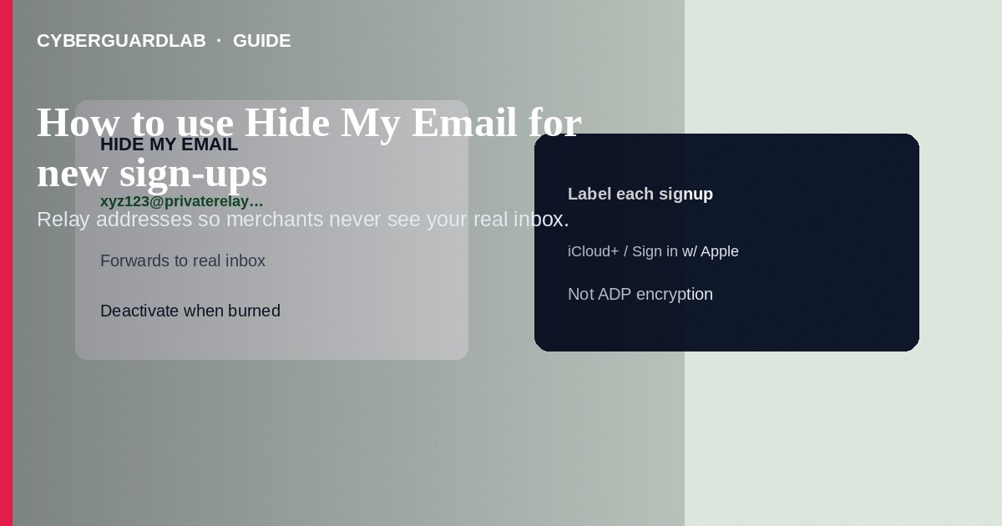
Hide My Email creates a unique, random relay address that forwards to your real inbox so new apps, newsletters, and merchants never learn your primary email—reducing spam and breach correlation. Use it via Sign in with Apple or iCloud+ settings when registering accounts. This how-to is about Hide My Email for new sign-ups—not Advanced Data Protection, not Find My, and not ignoring fake iCloud phishing that pretends to be Apple billing.

1. When to use Hide My Email
Prefer a relay for shopping sites, travel bookings, free trials, forums, and any service that does not need your lifelong personal address. Keep your real address for banks, employers, and medical portals that must reach you reliably. iCloud+ is required for creating addresses outside some Sign in with Apple flows—confirm your subscription features.
Paid link
Norton 360 | See the Norton first-year offer

See the Norton first-year offer
Offer page: https://cyberguardlab.com/norton
Messages that claim your Hide My Email address will be deleted unless you sign in are often fake. Manage relays in Apple Account settings you navigate to manually, and treat storage/billing panic mail using the fake iCloud storage phishing checklist.

2. Hide My Email vs neighboring tools
Tool | Job | Limitation
Hide My Email | Relay addresses for sign-ups | Does not encrypt iCloud backups (see ADP)
Sign in with Apple | Login without sharing a password to each app | Still review app list over time
Advanced Data Protection | Stronger iCloud encryption model | Not an email-alias tool
Find My | Device location / Activation Lock | Not identity privacy for web forms

3. Steps: create and use Hide My Email for a new account
- Confirm iCloud+ (or use Sign in with Apple’s Hide My Email option during app login).
- On iPhone/iPad: Settings → [Your Name] → iCloud → Hide My Email (path may appear under iCloud+ features). On Mac: System Settings → [Your Name] → iCloud → Hide My Email.
- Tap Create New Address, label it (e.g., “Airline-2026”), and copy the address into the site’s sign-up form—or choose Hide My Email when an app offers Sign in with Apple.
- Complete registration. Mail to that relay arrives in your real inbox via Apple’s forwarding.
- If a merchant starts spamming, open Hide My Email, select that address, and Deactivate or turn off forwarding—future mail stops without changing your real address everywhere.
- Periodically review the list; deactivate abandoned trials. Pair with a Sign in with Apple permissions review for apps that used Apple login.
- Do not type Hide My Email addresses into phishing pages reached from “storage full” emails—manage them only in Settings.
- For Windows browsing elsewhere in the household, keep one primary AV (Norton, Bitdefender, TotalAV, McAfee, or Avast).

4. If a relay is burned or leaking spam
- Deactivate that address in Hide My Email settings.
- Create a fresh labeled address for a replacement account if you still need the service.
- If the real inbox is flooded, check whether forwarding rules or other aliases are involved.
- Never “confirm your Hide My Email” through a cold email link—assume phishing until you open Settings yourself.

FAQ

Do I need iCloud+?
Creating and managing Hide My Email addresses is an iCloud+ feature; Sign in with Apple can still offer a hidden relay in supported app flows. Check Apple’s current feature list for your plan.

Will the merchant see my real email?
With Hide My Email, they should see the relay. If you later reveal the real address inside the app’s profile settings, that protection ends for that merchant.

Is this the same as ADP?
No. ADP changes encryption for eligible iCloud data categories. Hide My Email only relays mail.

Can Apple read my forwarded mail?
Apple’s privacy documentation describes Hide My Email forwarding. For broader iCloud ciphertext policy, read ADP and iCloud security overviews—do not assume Hide My Email alone equals ADP.

If you still want a paid suite
Avoiding how to use Hide My Email for new sign-ups does not require paid antivirus. Careful habits and official support paths are a valid buy-nothing stack. If you want multi-device paid protection later, use only these on-site paid links: TotalAV (paid link), Norton (paid link), Bitdefender (paid link), McAfee (paid link), Avast (paid link).

Sources
- Apple Support: What is Hide My Email?
- Apple Support: Sign in with Apple
- Apple Support: iCloud+
- FTC: Protecting your privacy

Also read
- How to review Sign in with Apple app permissions
- How to turn on Advanced Data Protection for iCloud
- How to spot a fake iCloud storage full phishing email
- How to turn on Find My and Activation Lock before travel
- How to spot a phishing email

