
How to spot a health insurance marketplace scam
Read online: https://cyberguardlab.com/blog/health-insurance-marketplace-scam
Published September 24, 2026 · Updated September 24, 2026
Short answer
During open enrollment or any “confirm your subsidy” contact, ignore cold calls, texts, and look-alike ads; compare and enroll only at HealthCare.gov or your official state Marketplace, and never share an SSN or payment method with someone who reached out first.
Advertising disclosure: CyberGuardLab is an independent comparison site. We are not TotalAV, Norton, Bitdefender, McAfee, or Avast. If you buy through our links, we may earn a commission, which can affect ranking and placement.
Independent US household comparison site. Not the vendor. Paid links below may earn a commission. Confirm first-year price, renewal, device limit, and refund terms at checkout.
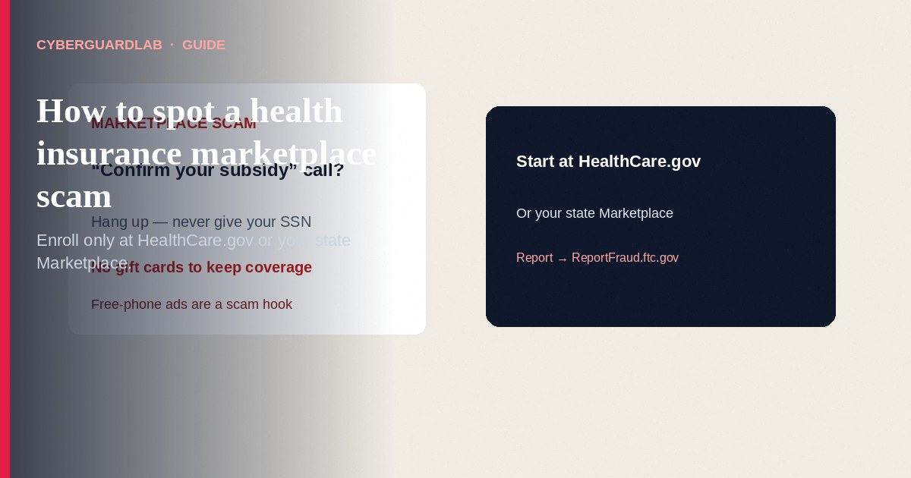
A health insurance Marketplace scam copies open-enrollment urgency — “confirm your subsidy,” “your plan will be canceled,” “free phone if you enroll today” — so you share a Social Security number, bank card, or gift-card payment with someone who is not HealthCare.gov or your state Marketplace. Official guidance from HealthCare.gov, CMS, HHS OIG, and the FTC is consistent: use HealthCare.gov (or your state’s official Marketplace), call the Marketplace Call Center at 1-800-318-2596 when you need phone help, never pay cash/crypto/gift cards to “keep” coverage, and never give an SSN or card number to a cold caller, text, or look-alike ad. This is not the same beat as a Medicare scam — Medicare has different official sites and numbers — though scammers sometimes blur the brands on purpose. CyberGuardLab is independent. Referral fees may affect product placement on other pages. Enrolling with free official tools only is a valid outcome. We do not invent enrollment statistics or “best broker” ranks.

The short answer
During open enrollment or any “confirm your subsidy” contact, ignore cold calls, texts, and look-alike ads; compare and enroll only at HealthCare.gov or your official state Marketplace, and never share an SSN or payment method with someone who reached out first.
Paid link
Norton 360 | See the Norton first-year offer

See the Norton first-year offer
Offer page: https://cyberguardlab.com/norton
Ad link: https://trysecurities.com/offer/norton?dtm=gg&cid=

Marketplace vs Medicare (do not mix the playbooks)
US households get hit with both themes. The official doors are different.
Topic | Health Insurance Marketplace (this page) | Medicare (separate guide)
Who it is for | People shopping ACA Marketplace plans (and related Medicaid/CHIP paths via the Marketplace application) | People with or approaching Medicare coverage
Official web start | HealthCare.gov or your state’s Marketplace site | Medicare.gov
Main official phone (general help) | Marketplace Call Center 1-800-318-2596 | 1-800-MEDICARE (1-800-633-4227)
Common scam bait | “Confirm subsidy,” fake open-enrollment ads, paid “navigators,” look-alike .com sites | Fake cards, “Medicare is calling,” medical equipment pitches
Our deeper guide | This article | Medicare scam
HHS OIG notes that if you are a Medicare beneficiary, you do not need to buy insurance in the Health Insurance Marketplace for that Medicare coverage. Scammers still dial Medicare households with Marketplace scripts — hang up and use the right official site for the program you actually have.

What Marketplace scams usually look like
HealthCare.gov’s fraud page and FTC open-enrollment alerts describe the same pressure patterns year after year. Dates for open enrollment change; the habits do not.
Typical lures:
- Cold call / robocall: “This is the Marketplace — confirm your premium tax credit or lose coverage tomorrow.”
- Text or email with a short link to “update your subsidy” on a misspelled domain.
- Social or search ads promising free phones, gas cards, or grocery money if you enroll — the FTC has warned that those gift hooks are often scams, including deepfake celebrity endorsements.
- Door knock or unsolicited visit from someone claiming to be a government assister who needs your SSN on the spot.
- Fake website that looks like HealthCare.gov but is not a .gov address, or that skips the official “An official website of the United States government” banner.
- Someone who charges a fee to “get you into Obamacare” or to keep Medicaid/CHIP — HealthCare.gov and HHS OIG state that legitimate enrollment assisters / Navigators do not ask you to pay them for that help.
- Unauthorized plan changes after you shared data with a pushy broker ad — CMS has publicly tightened broker rules over time; your household habit stays the same: start at the official site and review your account there.
Payment red flags from HealthCare.gov / CMS materials include demands for gift cards, cash, prepaid debit, cryptocurrency, or a card number so you can “apply” or “keep” coverage when you did not start the contact.

Official vs fake contact (scan table)
Signal | Safer read | What to do
You typed HealthCare.gov yourself and see the official U.S. government banner | You are on the federal Marketplace door | Compare plans / apply there or use Find Local Help
Your state runs its own Marketplace and you used that state’s official site | Correct door for your state | Stay on that official site; do not pivot to a random ad
Unexpected call asks for SSN, bank login, or gift cards | Classic scam pattern (HealthCare.gov / FTC) | Hang up; call 1-800-318-2596 yourself if needed
Ad offers cash card / free phone for enrolling | FTC: treat as likely scam | Ignore; use HealthCare.gov
Person claims to be Navigator but demands payment to help | Not how official help works | Use Find Local Help on HealthCare.gov
Caller ID says “Marketplace” so it must be real | Caller ID is easy to spoof | Do not share data; place your own call to the official number
HealthCare.gov documents that the Marketplace may sometimes call to confirm application information, will not ask for payment to apply or keep coverage, and publishes specific callback-related numbers for those confirmation calls. Even then, the household rule that survives every season is: you look up HealthCare.gov or 1-800-318-2596; you do not obey a surprise payment request. If you are unsure, hang up and dial the official center yourself.

How to enroll or check a subsidy without feeding a scam (US household steps)
- Start only from official doors. Open a browser and go to https://www.healthcare.gov/ or your state’s official Marketplace site. Bookmark it. Do not use a link from a text, cold email, or sponsored “free phone” ad. Look for .gov and the official government site banner on the federal site.
- Create or sign in to your own Marketplace account. Review your application, plan, and messages there. If someone claims your subsidy will vanish today, verify that claim inside your account — not on a stranger’s form.
- Use free official help when you want a human. On HealthCare.gov, use Find Local Help to reach Navigators / assisters who provide free help, or call the Marketplace Call Center at 1-800-318-2596 (TTY 1-855-889-4325 per HealthCare.gov materials). Licensed agents and brokers can also help, but you should still understand what you enroll in; nobody legitimate needs gift cards to “activate” a plan.
- Never share SSN, bank, or card details on a cold contact. The FTC’s health-insurance scam article is explicit: HealthCare.gov asks limited information for a simple price quote path; do not hand sensitive financial identifiers to someone who contacted you out of the blue for a “quote.” If a phishing page already captured something, follow Clicked a phishing link — first hour, watch bank/credit activity, and consider steps at IdentityTheft.gov.
- Pay premiums only through the insurer / official billing path you chose. Do not pay a caller who claims to be “the government Marketplace” and needs immediate payment to stop a cancellation. HealthCare.gov’s scam page: do not give money to anyone saying you must pay them to keep Marketplace, Medicaid, or CHIP coverage.
- Report the contact. File at ReportFraud.ftc.gov, tell the Marketplace Call Center what happened, and contact local police if you sent money or sensitive data. Walk-through: How to report a scam to the FTC. The same reporting habit shows up in other seasonal government-themed scams such as Student loan forgiveness scam — different program, same “official urgency” script structure.

Open enrollment timing without the panic
Open enrollment windows are real; scammer calendars copy them. When ads spike each fall and winter, slow down:
- Confirm dates on HealthCare.gov, not on a stranger’s flyer.
- Special enrollment periods exist after qualifying life events — verify those rules on the official site, not on a Facebook comment.
- A real deadline is not a reason to skip checking the URL.
We do not hard-code a single enrollment end date in this evergreen guide; windows change. The verification habit does not.

What this page is not
This page is not an insurance brokerage, not medical advice, and not a ranking of Marketplace plans.
It does not tell you to avoid all agents or brokers — it tells you to start from official sites and never pay gift-card “activation” fees. It is not a Medicare guide (use the Medicare scam article for that audience). It does not invent CMS enforcement statistics. Official rules and help remain on HealthCare.gov, CMS, HHS OIG, and FTC pages in Sources.

If you decide a paid extra is a real job
Spotting a Marketplace scam is free: official URLs, official phone numbers, no cold-call SSN. Pay for a security product only if you already named a separate job — for example device antivirus after a malware download from a fake “enrollment” site, or identity monitoring after you exposed an SSN — and you will use it.
- Identity / suite option households often compare after data exposure: Norton plans (paid link; confirm what identity features are included and the renewal).
- PC suite path: Bitdefender plans (paid link).
- Household suite shopping: TotalAV plans (paid link).
- Multi-device vendor: McAfee plans (paid link; confirm device limit).
- Another suite path: Avast plans (paid link).
Buying nothing beyond free official enrollment habits is still valid. A credit freeze and IdentityTheft.gov recovery plan remain free federal tools if identity theft is already in play. Paid links above are on-site only.

FAQ

Someone called to “confirm my Marketplace subsidy.” Should I give my Social Security number?
Not on a cold call. Hang up. Sign in at HealthCare.gov (or your state Marketplace) or call 1-800-318-2596 yourself. HealthCare.gov warns against sharing personal information or paying people who contact you to “keep” coverage.

Is HealthCare.gov the only real site?
It is the federal Marketplace door. Some states run their own official Marketplaces. Start from known official government sites — not from a sponsored ad that promises a free phone for enrolling. The FTC has specifically warned about those gift-hook ads.

How is this different from a Medicare scam?
Different program, different official site and phone number. Medicare households should use Medicare.gov / 1-800-MEDICARE. See Medicare scam. HHS OIG notes Medicare beneficiaries do not need to buy Marketplace insurance for their Medicare coverage.

Can a Navigator charge me to enroll?
Official consumer materials say legitimate Navigators / assisters help for free and should not ask you to pay them for Marketplace enrollment help. Use Find Local Help on HealthCare.gov.

I already paid a caller with gift cards. What now?
Stop contact. Keep receipts. Report at ReportFraud.ftc.gov, notify the Marketplace Call Center, and contact local police. If you shared an SSN or bank access, use IdentityTheft.gov and monitor accounts. Our FTC reporting steps: Report a scam to the FTC.

Do I need paid antivirus to shop the Marketplace safely?
No. The core control is where you enroll and whom you pay. Antivirus is optional hygiene for the PC you browse on; it does not replace typing HealthCare.gov yourself.

Sources
- Protect yourself from Marketplace fraud & scams (HealthCare.gov)
- Spot Health Insurance Scams (FTC)
- Looking for Marketplace health insurance this open enrollment season? Avoid scammers. (FTC)
- Consumer Fraud in the Health Insurance Marketplace (HHS OIG)
- HealthCare.gov (official Marketplace)
- ReportFraud.ftc.gov
- IdentityTheft.gov

Also read
- Medicare scam
- Student loan forgiveness scam
- How to report a scam to the FTC
- Report identity theft at IdentityTheft.gov
- Social Security scam

