
How to use a hardware security key for your main accounts
https://cyberguardlab.com/blog/hardware-security-key-main-accounts
Independent US household comparison site. Not the vendor. Paid links below may earn a commission. Confirm first-year price, renewal, device limit, and refund terms at checkout.
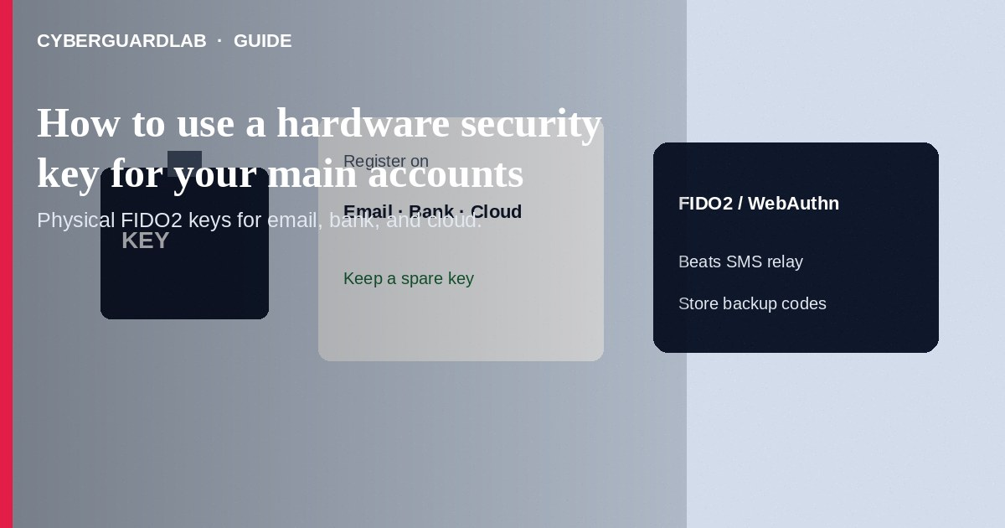
A hardware security key (FIDO2/WebAuthn or older U2F) is a physical USB, NFC, or Lightning device you tap or insert to prove a sign-in—harder to phish than SMS codes or push prompts alone. Register at least one key (ideally two) on your email, Apple, Google, Microsoft, and password-manager accounts; keep a backup key offline. This how-to is about physical keys for main accounts—not Google Prompt instead of SMS, not moving authenticator apps, and not spotting an OTP relay scam call.

1. Why a key for main accounts
Email and cloud IDs recover everything else. SMS 2FA can be stolen via SIM swap or relay calls; push prompts can be rushed through under pressure. A security key tied to the real site origin blocks many look-alike phishing pages that harvest passwords and OTP digits. Pair the key with a unique password and a recovery plan (second key, printed backup codes stored offline).
Paid link
Norton 360 | See the Norton first-year offer

See the Norton first-year offer
Offer page: https://cyberguardlab.com/norton
Scammers sell cloned or pre-registered devices and “setup services” that keep a copy of recovery codes. Buy sealed keys from known sellers, enroll them yourself on official sites, and never email photos of backup codes.

2. Key vs prompt vs SMS
Method | What it is | Main residual risk
Hardware security key | Physical FIDO device registered to the account | Loss/theft of all keys without backups; some sites still lack support
Google Prompt / push | Approve on a signed-in phone | Approval fatigue; malware on the phone
Authenticator app TOTP | Rotating codes on a phone app | Phishing sites that ask you to type the code
SMS OTP | Text codes | SIM swap, OTP relay calls, spoofed texts

3. Steps: set up keys on priority accounts
- Buy two reputable FIDO2 keys from a vendor you trust. Label them “daily” and “backup.” Do not buy used keys.
- Start with your primary email. Open the account’s security / 2-Step Verification / passkeys & security keys page from a bookmark—not a search ad.
- Add the first key while signed in on a computer. Follow the browser prompt to touch the key. Then immediately register the second (backup) key.
- Save backup codes the service offers in a sealed offline place—not only in SMS Notes.
- Repeat for Google, Apple (security keys where supported for Advanced/ account protection), Microsoft, and your password manager. Prefer passkeys plus a hardware key where both exist.
- Test sign-out and sign-in with the daily key. Confirm the backup key works once, then store it separately from the laptop bag.
- Remove weak SMS as the only second factor when the service allows stronger methods—keep SMS only as a last-resort recovery if you must.
- After any phishing scare, review registered keys/devices and scan with a trusted tool such as Norton or Bitdefender. Keep one primary real-time antivirus—avoid stacking full suites. TotalAV, McAfee, and Avast are other on-site comparison options.

4. If a key is lost
- Sign in with the backup key or backup codes as soon as you notice the loss.
- Remove the lost key from every account’s security settings.
- Register a replacement key; update your inventory list.
- If both keys and codes are gone, use each service’s account-recovery flow and tighten recovery email/phone afterward.
- Do not ship your only remaining key with luggage; keep geographic separation when traveling.

FAQ

Is a hardware key the same as Google Prompt?
No. Prompt is a software push on a phone already signed in. A hardware key is a separate physical authenticator bound to the site.

Do I still need a password?
Many sites still require password + key, or offer passkeys. Follow each service’s current enrollment flow; never reuse passwords.

Can phishing sites trick a FIDO2 key?
Modern FIDO2/WebAuthn ties the key response to the real origin. Classic look-alike domains generally fail—still type URLs carefully and avoid installing malware.

Should every account get a key first day?
Prioritize email, financial, Apple/Google/Microsoft IDs, and the password manager. Expand as time allows.

If you still want a paid suite
Avoiding how to use a hardware security key for your main accounts does not require paid antivirus. Careful habits and official support paths are a valid buy-nothing stack. If you want multi-device paid protection later, use only these on-site paid links: TotalAV (paid link), Norton (paid link), Bitdefender (paid link), McAfee (paid link), Avast (paid link).

Sources
- CISA: Multi-factor authentication
- Google Account Help: Use a security key
- Apple Support: About two-factor authentication
- Microsoft: Passwordless / security key overview
- FTC: Protect your personal information

Also read
- How to spot a one-time passcode relay scam call
- How to turn on Google Prompt instead of SMS codes
- How to move authenticator apps to a new phone safely
- How to spot a fake two-factor authentication text
- How to recover an Apple ID without SMS access

