
How to spot a grandparent emergency money scam
https://cyberguardlab.com/blog/grandparent-emergency-money-scam
Independent US household comparison site. Not the vendor. Paid links below may earn a commission. Confirm first-year price, renewal, device limit, and refund terms at checkout.
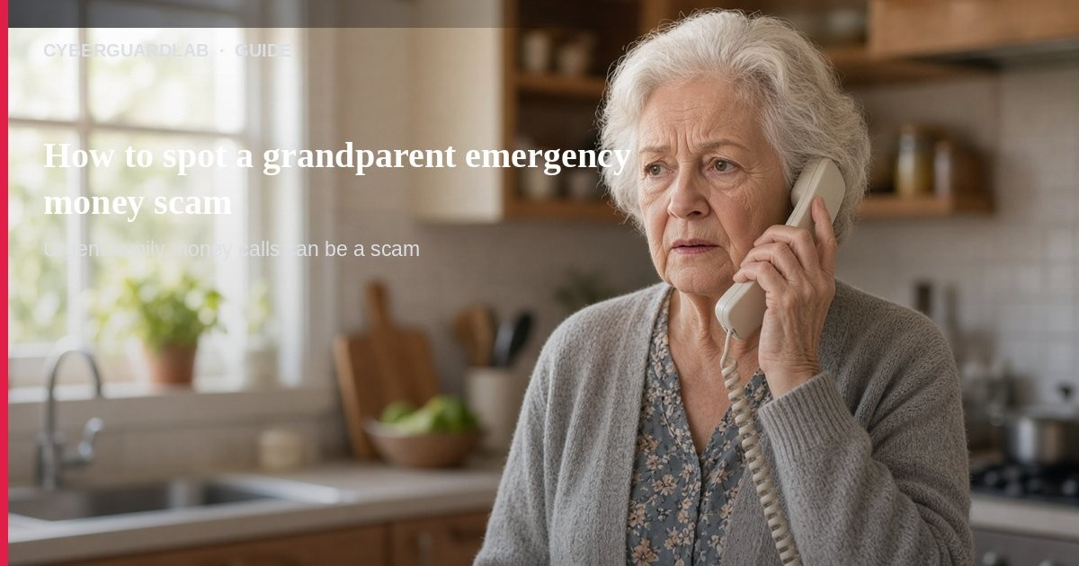
A grandparent emergency money scam (also called a family emergency or “grandkid in trouble” scam) is when someone pretends a loved one needs cash right now — bail, a hospital bill, a wrecked car — and pressures you to pay in a hard-to-reverse way. Per the FTC, scammers may already know names or details from social media, may pretend to be a lawyer/police/doctor, and some use AI voice cloning so the call sounds like your relative. This guide is about urgent family-money calls and messages, not gift card pressure, tech support phone scams, romance asks, or lottery prizes. You do not need to buy antivirus to hang up and verify.

1. How the scam usually works
From FTC family-emergency guidance:
Paid link
Norton 360 | See the Norton first-year offer

See the Norton first-year offer
Offer page: https://cyberguardlab.com/norton
Ad link: https://trysecurities.com/offer/norton?dtm=gg&cid=
- “I’m in trouble — send money” — The caller claims to be a grandchild or close friend who wrecked a car, got arrested, or needs medical help.
- Urgency + secrecy — You’re told you’re the only one who can help, and not to tell other family members.
- Hard-to-reverse payment — Wire (Western Union / MoneyGram), cryptocurrency, a payment app, or gift cards with the numbers read back.
- Authority add-on — A second voice may claim to be a lawyer, officer, or doctor “helping” your relative.
- Voice cloning — FTC alerts note scammers can clone a short audio clip from public posts so the voice sounds real.

2. What to do in the first 5 minutes
- Resist the rush — Do not send money while still on the call.
- Hang up (or say you’ll call back) — FTC: don’t trust the voice alone, even if it “sounds like” them.
- Ask a private question — Something only the real person would know (pet name, last holiday).
- Call back on a number you already know — Look up your relative’s real number yourself; do not use a callback number the caller gives you.
- Call another trusted family member — Especially if you can’t reach the person who is supposedly in trouble — even if the caller said to keep it secret.
- Never pay with gift cards, wires, or crypto for “emergencies” — Those payment types are classic scam tells on FTC pages. See also gift card scam.

3. If you already sent money
- Act as soon as you can — FTC: sooner is better for recovery attempts.
- Contact the payment company, bank, or card issuer and explain it was a scam.
- Follow FTC steps for getting money back after a scam.
- Report at ReportFraud.ftc.gov and your state attorney general.
- Warn other relatives so the same script doesn’t hit them next.

4. Household habits that cut risk (no software purchase required)
- Agree on a family code word for real emergencies.
- Remind older relatives you’ll never ask them to wire money or buy gift cards in secret.
- Limit public family details (kids’ names, travel plans) on social posts that strangers can scrape.
- Keep phone and email accounts on MFA so a hacked inbox is harder to use for impersonation (see turn on 2FA).
- Teach the “hang up and call back on a known number” pause to everyone in the house.

FAQ

How do I spot a grandparent emergency money scam?
Urgent trouble + secrecy + pressure to wire, crypto, payment-app, or gift-card numbers — often with a voice that “sounds like” family — matches FTC family-emergency scam patterns.

What if the voice really sounds like my grandchild?
FTC voice-cloning alerts say AI can fake that. Still hang up and verify on a number you already trust.

Is Microsoft Defender required here?
No. This is a phone/social-engineering problem. Defender is optional later if you also clicked a weird link on a PC — see Is Microsoft Defender enough?.

How is this different from a romance scam?
Romance scams build a long fake relationship. Family-emergency scams hit with one urgent “help me now” story, often aimed at older relatives. See romance scam.

Where do I report it?
ReportFraud.ftc.gov.

If you still want a paid suite
Stopping a fake emergency call does not require paid antivirus. Microsoft Defender is a valid buy-nothing choice for many Windows households. What actually helps is verifying on a known number and refusing irreversible payments. If the household later wants multi-device paid protection, use only these on-site paid links: TotalAV (paid link), Norton (paid link), Bitdefender (paid link), McAfee (paid link), Avast (paid link).

Sources
- Scammers Use Fake Emergencies To Steal Your Money (FTC)
- Fighting back against harmful voice cloning (FTC)
- Scammers use AI to enhance their family emergency schemes (FTC)
- Grandkid and Family Scams (FTC Pass It On)
- How To Avoid a Scam (FTC)
- ReportFraud.ftc.gov (FTC)
- Turn On MFA (CISA)

Also read
- How to spot a gift card scam
- How to spot a tech support scam phone call
- How to spot a romance scam
- How to spot a lottery or prize scam
- Turn on 2FA for Gmail, Apple, and bank

